What is TypeScript

Thursday, November 30, 2023

11:52 AM

Add new Features + Advantages to JS

Browser does NOT execute TypeScript

A Superset to JS, offering:

Types checking for:

number

string

object

Nested objects

Arrays

Tuples ['Hi', 123]

Enums

Any

Union => type ComplexTypeAlias = { name: string; age: number; } | string;

Literals

====

TS => Compiled to JS

Featrues are compiled from .ts to .js through 'tsc ./app.ts' as "workarounds", possible errors are thrown

**Extra errors catching & alerts** before actually compiling into a bundle

JS:

const add = (num1, num2) => {

return num1 + num2;

}

// Unwanted Behaviour at Runtime

console.log(add('2','3'));

Mitigation Strategies:

Add if check to add function

Validate & sanitize user input

Dev can still write invalid code, yet TS helps validating code

TypeScript:

index.html:

<!DOCTYPE html>

<html lang="en">

  <head>

    <meta charset="UTF-8" />

    <meta name="viewport" content="width=device-width, initial-scale=1.0" />

    <meta http-equiv="X-UA-Compatible" content="ie=edge" />

    <title>Understanding TypeScript</title>

    <script src="js-only.js" defer></script>

  </head>

  <body>

    <input type="number" id="num1" placeholder="Number 1" />

    <input type="number" id="num2" placeholder="Number 2" />

    <button>Add!</button>

  </body>

</html>

js-only.js:

const button = document.querySelector("button");

const input1 = document.getElementById("num1");

const input2 = document.getElementById("num2");

function add(num1, num2) {

  return num1 + num2;

}

button.addEventListener("click", function() {

  console.log(add(input1.value, input2.value));

  console.log(`${typeof document.getElementById("num1").value}`);

});

// document.getElementById("num1").value = always a TEXT

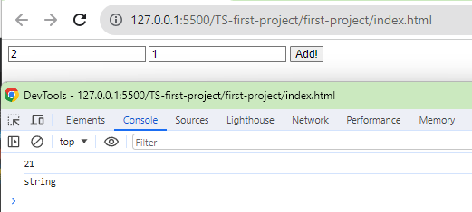

***

add(2, 1) should be 3 (typeof: number)

Instead of '2'+'1' => '3' (typeof: text)

***

Installing TypeScript

Thursday, November 30, 2023

11:57 AM

**// Installation**

**npm install -g typescript;**

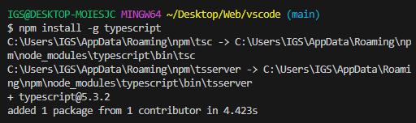

// To compile a .ts => .js

tsc ./test.js

previously

js-only.js:

const button = document.querySelector("button");

const input1 = document.getElementById("num1");

const input2 = document.getElementById("num2");

function add(num1, num2) {

  return num1 + num2;

}

button.addEventListener("click", function() {

  console.log(add(input1.value, input2.value));

  console.log(`${typeof document.getElementById("num1").value}`);

});

// document.getElementById("num1").value = always a TEXT

using-ts.ts:

// ! = This will always find an HTMLButtonElement & NOT yield NULL

const button = document.querySelector("button")! as HTMLButtonElement;

// ! = This will always find an element & NOT yield NULL

const input1 = document.getElementById("num1")! as HTMLInputElement;

// ! = This will always find an element & NOT yield NULL

const input2 = document.getElementById("num2")! as HTMLInputElement;

const add = (num1: number, num2: number) => {

  return num1 + num2;

}

button.addEventListener("click", function() {

  // Adding +input1.value => Make sure it's a number !string

  console.log(add(+input1.value, +input2.value));

  //console.log(`typeof input1.value: ${typeof document.getElementById("num1").value}`);

});

// document.getElementById("num1").value = always a TEXT

==== Compile .ts to .js:

tsc ./using-ts.js;

Will still get a .js file with errors

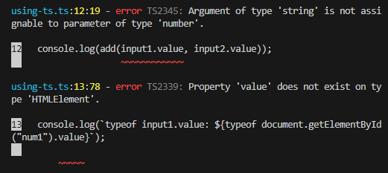

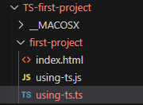

Overview

Thursday, November 30, 2023

12:21 PM

TypeScript adds....

Types

Next-gen JS Features (compiled down for older Browsers)

[e.g. babel]

Non-JS Features like **interfaces** or **Generics**

Meta-Programming Features like **Decorators**

Rich **Configuration** Options

Modern Tooling that helps even in non-TypeScript Projects

Outline

Thursday, November 30, 2023

12:24 PM

1. Getting Started

2. TypeScript basics

3. Compiler & Configuration Deep Dive

4. Next-gen JS code (ES6+)

5. Classes & Interfaces

6. Advanced Types & TypeScript Features

7. Generics

8. Decorators

9. Practice (all TypeScript features learnt in action)

10. Namespaces & Modules

11. Webpack & TypeScript

12. Third-Party Libraries & TypeScript

13. Integrating TypeScript into React, Node, Express

lite-server

Thursday, November 30, 2023

1:18 PM

Package.json:

{

  "name": "understanding-ts",

  "version": "1.0.0",

  "main": "app.js",

  "scripts": {

    "test": "echo \"Error: no test specified\" && exit 1",

    "start": "lite-server"

  },

  "author": "Maximilian Schwarzmüller",

  "license": "ISC",

  "devDependencies": {

    "lite-server": "^2.5.4"

  },

  "keywords": [],

  "description": ""

}

npm init -y;

Types (number, string)

Thursday, November 30, 2023

1:23 PM

number = int, bigint, floats

string = text ('Hi', "Hi", `Hi`)

boolean = true, false

==== **Types assignment**

app.ts:

// Using Type inference

const add = (n1: number, n2: number, showResult: boolean, phrase: string) => {

    // in the past...

    // if (typeof n1 !== 'number' || typeof n2 !== 'number') {

    //     throw new Error('Incorrect input!');

    // }

    // Only numbers are involved

    let result = n1 + n2;

    if (showResult) {

        console.log(phrase + result);

    } else {

        return n1 + n2;

    }

}

const number1 = 5;

const number2 = 2.8;

const printResult = true;

const resultPhrase = 'Result is: ';

add(number1, number2, printResult, resultPhrase);

Type (object)

Thursday, November 30, 2023

1:54 PM

app.ts:

const person = {

    name: 'Max',

    age: 30

};

console.log(person.nickname);

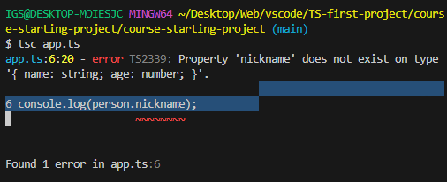

app.ts:

// Traditional js object

const person = {

name: 'Max',

age: 30

};

console.log(person.name);

// Adding **object types** to 'person'

const person: **{}** = {

name: 'Max',

age: 30

};

// Expanding the object type {}

const person: **{**

**name: string;**

**age: number;**

**}** = {

name: 'Max',

age: 30

};

console.log(person.name);

Types (Nested Objects)

Thursday, November 30, 2023

2:07 PM

// Let's say having a JS object

const product = {

id: 'abc1',

price: 12.99,

tags: **['great-offer', 'hot-and-new']**;

details: {

title: 'Red Carpet',

description: 'A great carpet - almost brand new!'

}

}

// Adding Nested **type** to 'product'

const product = {

id: string;

price: number;

tags: **string[]**;

details: {

title: **string**;

description: **string**;

}

} = {

id: 'abc1',

price: 12.99,

tags: ['great-offer', 'hot-and-new'];

details: {

title: **'Red Carpet'**,

description: **'A great carpet - almost brand new!'**

}

}

Types (Arrays)

Thursday, November 30, 2023

2:10 PM

// Flexible OR Strict

app.ts:

const person: {

    name: string;

    age: number;

    hobbies: string[];

} = {

    name: 'Max',

    age: 30,

    hobbies: ['Sports', 'Cooking'],

};

// Type for array of strings

let favActivities: string[];

// Will ERR if ! array

//favActivities = 'Sports';

favActivities = ['Sports', 'Cooking'];

//console.log(person.name);

// From JS

for (const hobby of person.hobbies) {

    console.log(hobby.toUpperCase());

    // will NOT get .map() because hobby !array

    //console.log(hobby.map());

}

Types (Tuple - not in JS)

Thursday, November 30, 2023

2:16 PM

Tuple [number, string];

Tuple [1, 'Hi'];

Added by TypeScript:

Fixed-length array

Tuple [1, 2]

Tuple ['Hi', 2]

app.ts:

const person: {

    name: string;

    age: number;

    hobbies: string[];

    role: **(string|number**)[]; //Tuple

} = {

    name: 'Max',

    age: 30,

    hobbies: ['Sports', 'Cooking'],

    role: [2, 'author'],

};

// Type for array of strings

let favActivities: string[];

// Will ERR if ! array

//favActivities = 'Sports';

favActivities = ['Sports', 'Cooking'];

//console.log(person.name);

// From JS

for (const hobby of person.hobbies) {

    console.log(hobby.toUpperCase());

    // will NOT get .map() because hobby !array

    //console.log(hobby.map());

}

const person: {

    name: string;

    age: number;

    hobbies: string[];

    //role: (string|number)[];

    role: [number, string]; //Tuple

} = {

    name: 'Max',

    age: 30,

    hobbies: ['Sports', 'Cooking'],

    role: [2, 'author'],

};

// Pushing an extra string to Tuple 'role'

person.role.push('admin');

// Switching an obj.key to another value

person.role[1] = 10; // This checks for Type of role[1] => string

Types (Enum - not in JS)

Thursday, November 30, 2023

2:39 PM

enum name { NEW, OLD }

Added by TypeScript:

Automatically enumerated global constant identifiers

app.ts:

enum Role {

ADMIN = 'ADMIN',

READ_ONLY = 100,

AUTHOR = 200

};

const person: {

name: string,

age: number,

hobbies: string[],

role: string

} = {

    name: 'Max',

    age: 30,

    hobbies: ['Sports', 'Cooking'],

    role: Role.ADMIN,

};

if (person.role === Role.ADMIN) {

    console.log(`person is admin`);

}

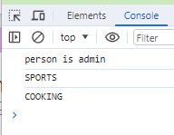

Types (Any *)

Thursday, November 30, 2023

3:02 PM

Any:

Strips off the advantages of using TypeScript

Ignore all Type limits

let favActivities: any[];

favActivities = ['Sports', 'Cooking'];

Types (Union |)

Thursday, November 30, 2023

3:08 PM

**Commonly used when multiple types of Data can be inputs of a function**

app.ts:

// 22. Union Types

// =========== Union ===================

const combine = (

    input1: number | string,

    input2: number | string

    ) => {

    let result: number | string;

    if (typeof input1 === 'number' && typeof input2 === 'number') {

        result = input1 + input2;

    } else {

        result = input1.toString() + input2.toString();

    }

    return result;

}

const combinedAges = combine(30, 26);

console.log(`combinedAges: ${combinedAges}`);

const combinedNames = combine('Max', 'Anna');

console.log(`combinedNames: ${combinedNames}`);

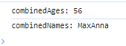

Types (Literals) & custom aliases

Friday, December 8, 2023

3:40 PM

// =========== Literals ===================

// Creating custom aliases

type Combinable = number | string;

type ConversionDescriptor = 'as-number' | 'as-text';

const combine = (

input1: Combinable,

input2: Combinable,

//resultConversion: string

// Limiting resultConversion types to a Union type

resultConversion: ConversionDescriptor

) => {

//let result: Combinable;

let result;

if (typeof input1 === 'number' && typeof input2 === 'number' || resultConversion === 'as-number') {

// Adding + in front of input1 to force type coersion to number

result = +input1 + +input2;

} else {

result = input1.toString() + input2.toString();

}

return result;

// if (resultConversion === 'as-number') {

// return parseFloat(result);

// } else {

// return result.toString();

// }

}

const combinedAges = combine(30, 26, 'as-number');

console.log(`combinedAges: ${combinedAges}`);

const combinedStringAges = combine('30', '26', 'as-number');

console.log(`combinedStringAges: ${combinedStringAges}`);

const combinedNames = combine('Max', 'Anna', 'as-text');

console.log(`combinedNames: ${combinedNames}`);

Type aliasing1

Thursday, January 11, 2024

5:49 PM

type-aliases.ts:

// 24. && 25.

// Type Aliases

type Combinable = number | string;

type ConversionDes = 'as-number' | 'as-text';

// =========== Union ===================

const combine = (

    // Union Type

    input1: Combinable,

    input2: Combinable,

    //resultConversion: string,

    // Literal Type

    resultConversion: ConversionDes

    ) => {

    let result: Combinable;

    if (

        typeof input1 === 'number' &&

        typeof input2 === 'number' ||

        resultConversion === 'as-number'

        ) {

        // Adding +var to ensure = number

        result = +input1 + +input2;

    } else {

        result = input1.toString() + input2.toString();

    }

    return result;

    // if (resultConversion === 'as-number') {

    //     return parseFloat(result);

    // } else {

    //     return result.toString();

    // }

}

const combinedAges = combine(30, 26, 'as-number');

console.log(`combinedAges: ${combinedAges}`);

const combinedStringAges = combine(30, 26, 'as-text');

console.log(`combinedStringAges: ${combinedStringAges}`);

const combinedNames = combine('Max', 'Anna', 'as-text');

console.log(`combinedNames: ${combinedNames}`);

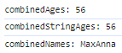

Type aliasing2

Friday, December 8, 2023

3:56 PM

// Creating own custom type alias

type User = {

name: string;

age: number;

};

// Can also create complex type aliases e.g.

type Complex = { name: string; age: number; } | string | number;

const greet = (user: User) => {

console.log(`Hi, I am ${user.name}`);

};

const isOlder = (user: User, checkAge: number) => {

return checkAge > user.age;

}

// Rather than

// const gree = (user: {

// name: string;

// age: number;

// }) => {

// console.log(`Hi, I am ${user.name}`);

// }

// const isOlder = (user: { name: string; age: number; }, checkAge: number) => {

// return checkAge > user.age;

// }

=== Func return Types & void

Thursday, January 11, 2024

4:19 PM

Functions Types

Saturday, March 2, 2024

9:32 PM

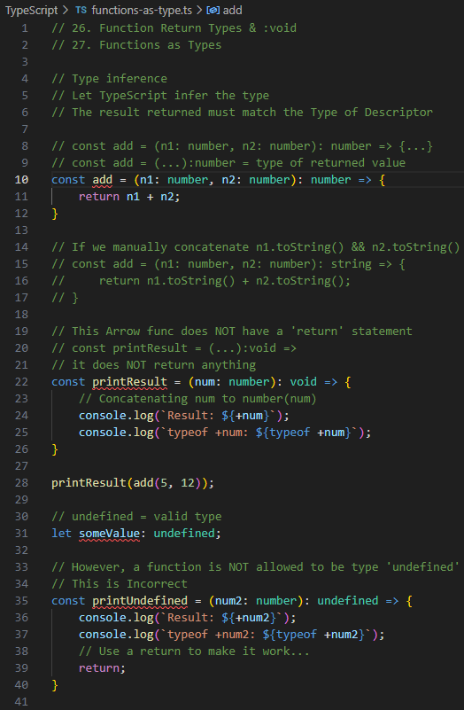

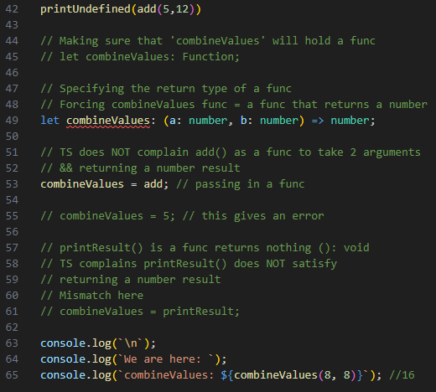

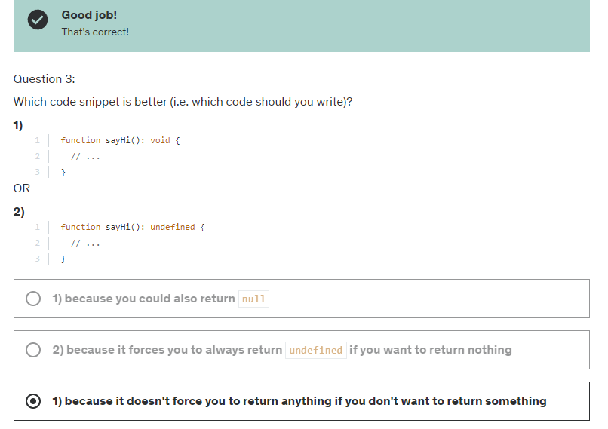

unknown type

Tuesday, March 12, 2024

2:37 PM

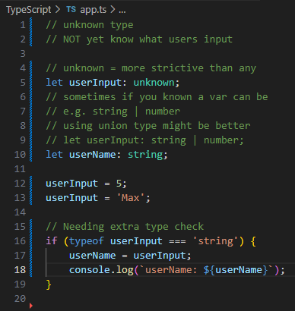

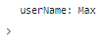

never type

Tuesday, March 12, 2024

3:44 PM

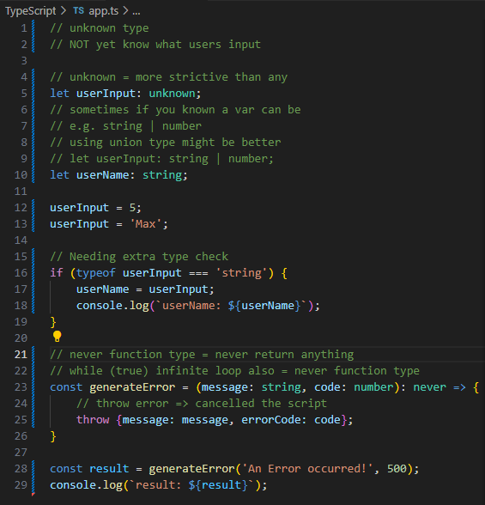

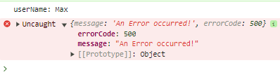

=== TSC (TypeScript Compiler)

Friday, March 15, 2024

10:45 AM

watch mode

Friday, March 15, 2024

10:48 AM

tsc app.ts -w;

// Compiling entire project or multiple files

tsc --init;

tsconfig.json comes up

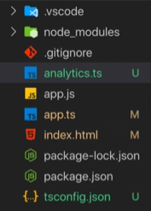

// Excluding a .ts from tsconfig.json

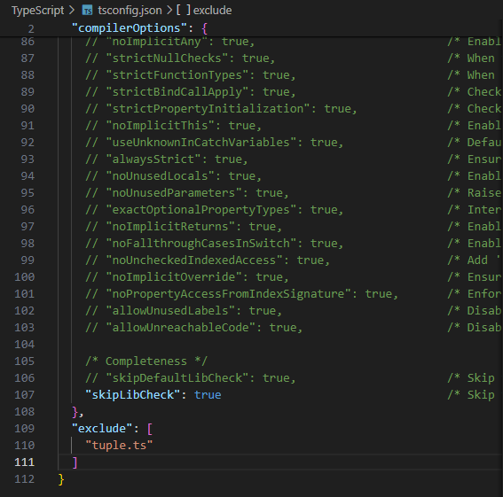

// ignoring any folders *.dev.ts files

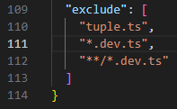

// If using "include" key

// need to include everything for "include" to work

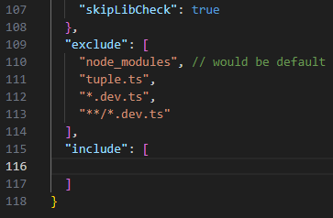

// CompilerOptions

"target": "es5",

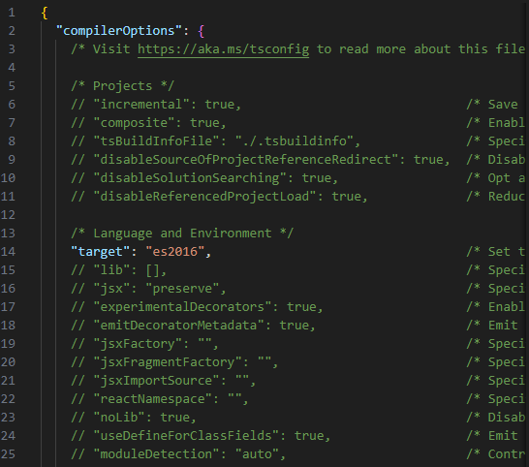

// "lib"

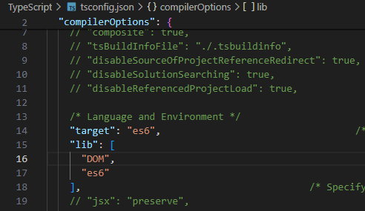

source maps

Friday, April 5, 2024

1:32 PM

// Sources of our live-server

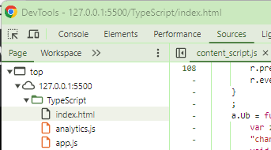

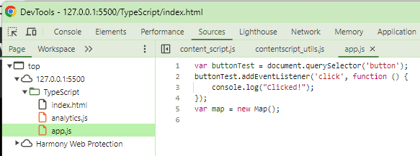

Uncommenting sourceMap in tsconfig.json

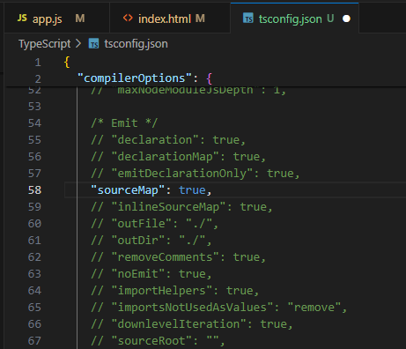

terminal:

tsc

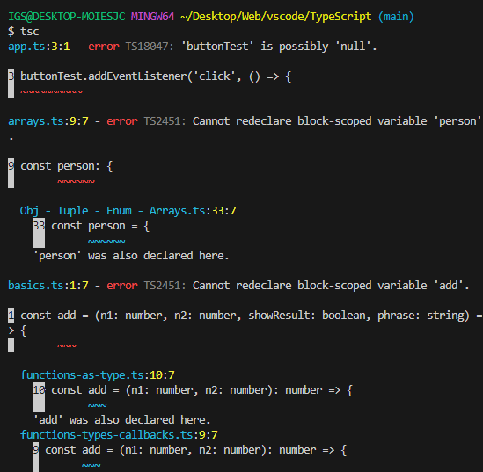

we'll get a bunch of .js.map files

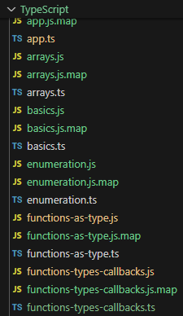

these wierd .js.map files act as a bridge between modern browsers and devtool to connect javascript files to input files

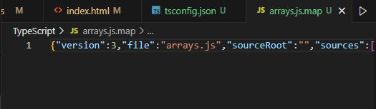

now we can see .ts files are also in our browser devtool

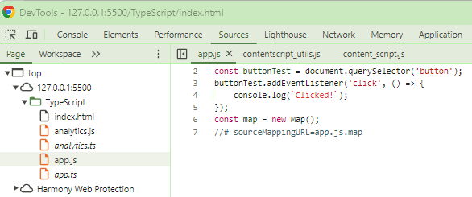

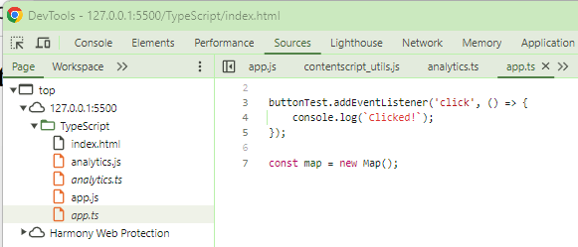

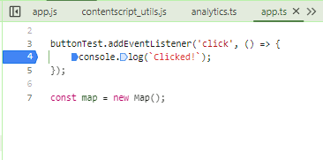

rootDir & outDir

Friday, April 5, 2024

1:48 PM

projectFolder/dist = outDir

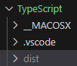

projectFolder/src = ts files

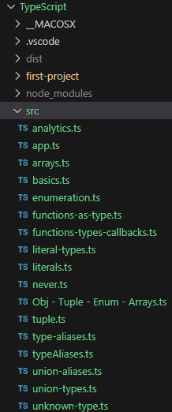

Specify rootDir for input files (.ts files) to ./src

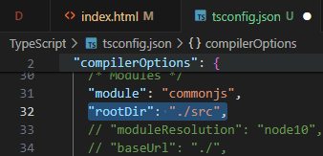

Specify outDir (.js files) to ./dist

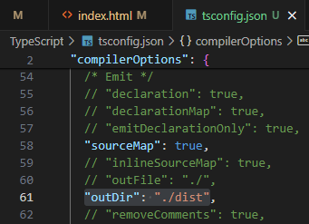

tsc to test compile & see whether .js files are in ./dist

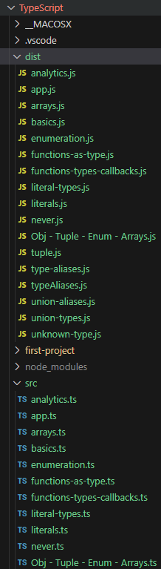

remeber to edit index.html

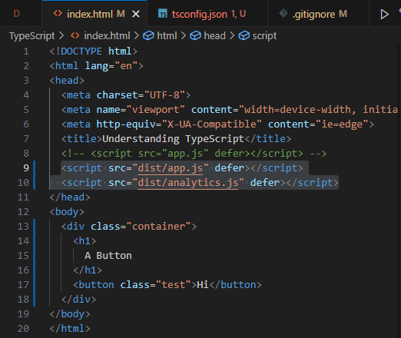

If loops are looking strange in compiled output files,

try to enable "downlevelIteration": "true" in tsconfig.json

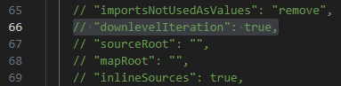

Do not compile .ts files with errors

Uncomment "noEmitOnError": "true"

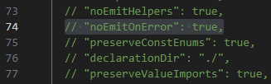

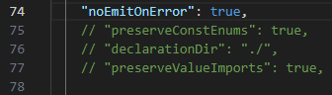

strict mode

Friday, April 5, 2024

5:12 PM

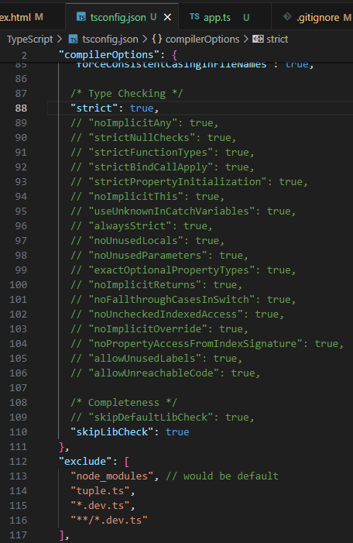

either setting "strict": true,

OR

setting all others separately

===

**Error out any types variables**

"noImplicitAny": true,

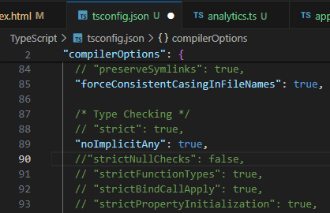

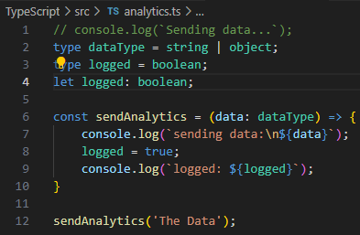

===

**Potentially Null value will NOT prompt error even without !**

**"strictNullChecks": false,**

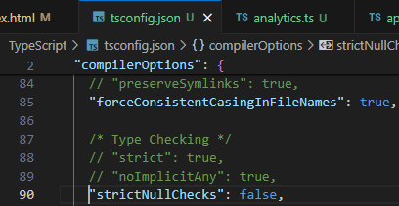

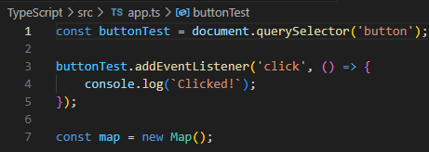

**"strictNullChecks": true,**

wrapping **DOM elements** with **if () {...}**

to make sure callbacks get called only if a DOM element exists

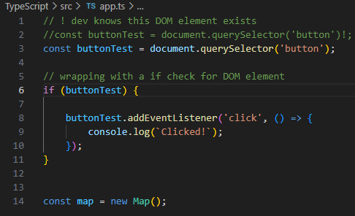

using an ES6 callback to listen to click events

callback.bind(input);

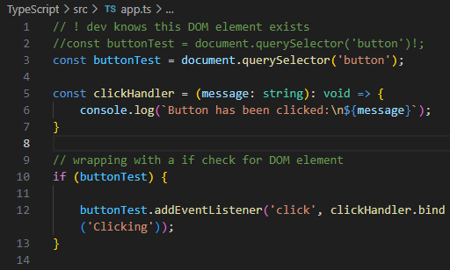

**strict-bind call checking**

**"strictNullChecks": true**

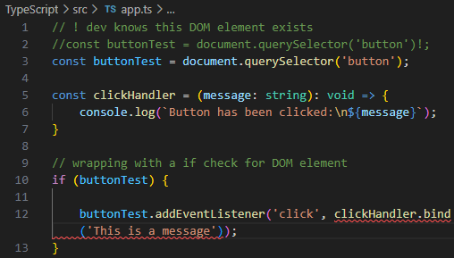

callback.bind(null) will trigger a strict-bind call error

**"strictNullChecks": false**

will ignore callback.bind(null) errors

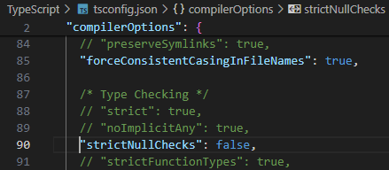

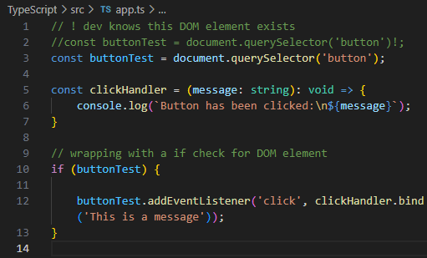

using **"strictBindCallApply": true**

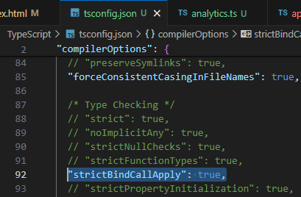

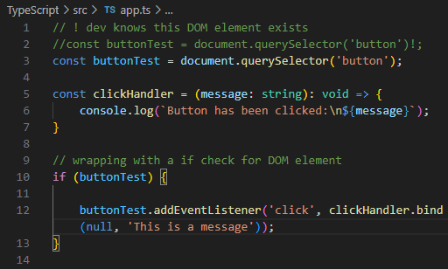

code quality options

Friday, April 5, 2024

5:48 PM

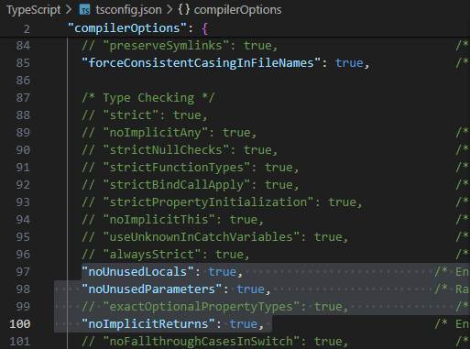

**"noUnusedLocals": true** =>

checks for **unused declared var in functions**

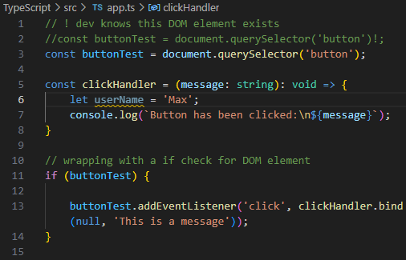

**"noUnusedParameters": true**

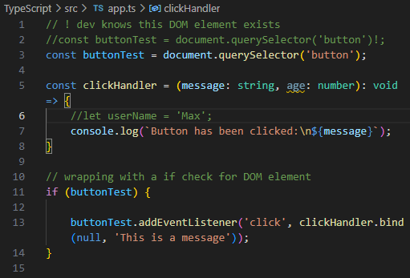

vscode debugging

Saturday, April 6, 2024

6:48 PM

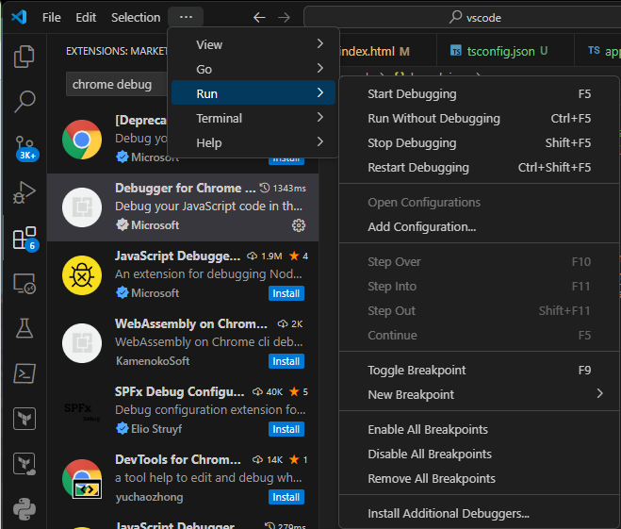



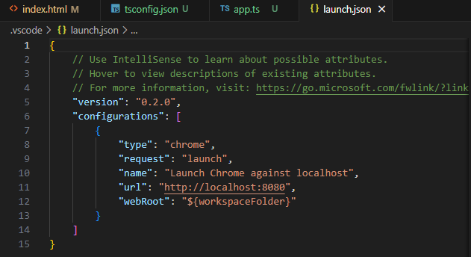

point to dev server port 5500 (live-server)

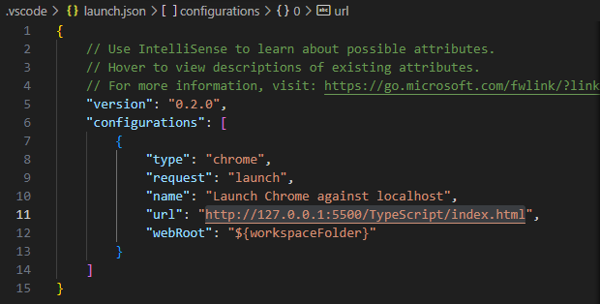

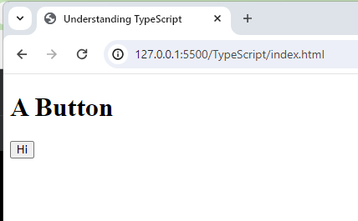

click step into



We'll have access to Script > this & Global

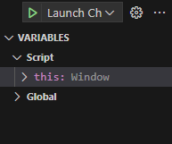

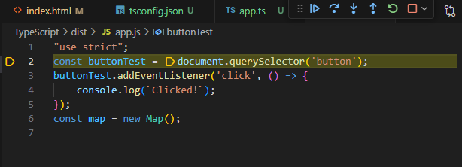

tsconfig.json

Saturday, April 6, 2024

8:06 PM

<https://www.typescriptlang.org/docs/handbook/tsconfig-json.html>

=== Next-gen JavaScript & TypeScript

Saturday, April 6, 2024

9:58 PM

Module introduction

Saturday, April 6, 2024

9:58 PM

let

const

const var = () => {...}

const copiedPerson = { ...person }

[...]

ret parameters

Arrays & Object Destructuring

ES6 tables

<https://compat-table.github.io/compat-table/es6/>

=== Classes & interfaces

Saturday, April 6, 2024

10:02 PM

creating a Class in ts

Saturday, April 6, 2024

10:02 PM

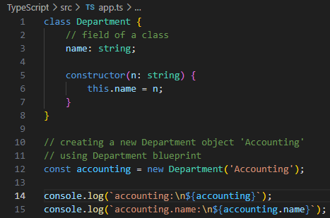

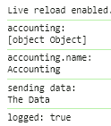

constructor functions & "this" keyword

// Creating another class accountingCopy

// using class destructuring

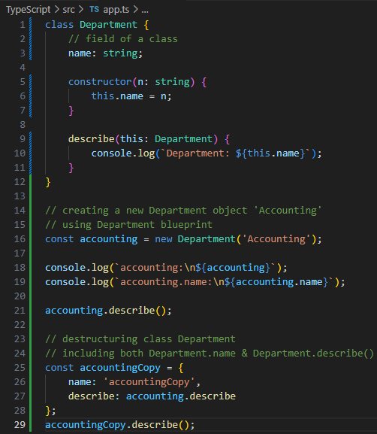

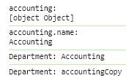

// Adding more keys & methods to class Department

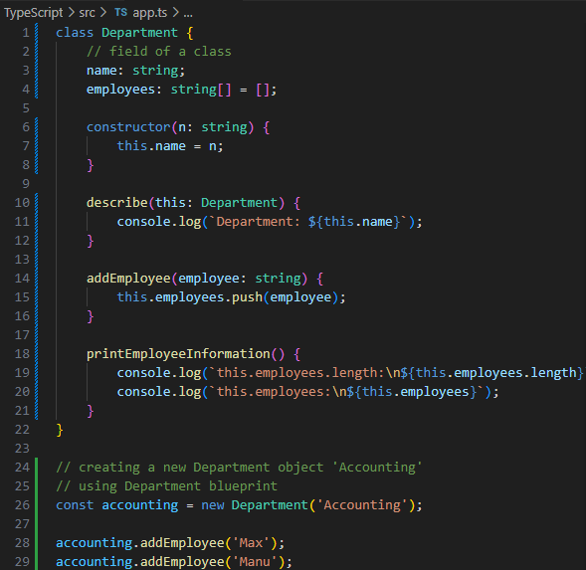

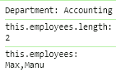

// Restricting access to accounting.employees

// using private keys

// accounting.employees[2] = 'Anna';

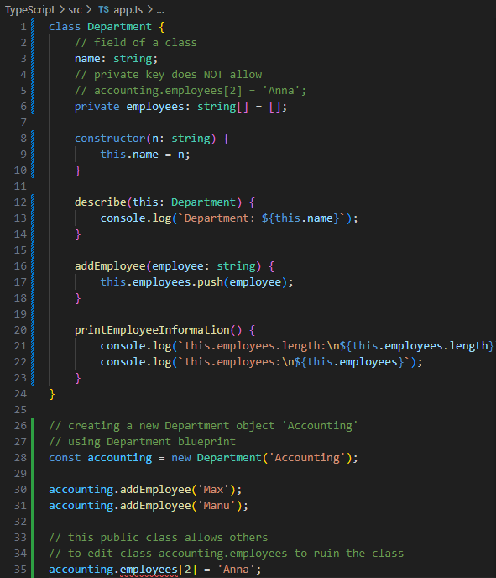

short initialization of class fields

Sunday, April 7, 2024

1:15 AM

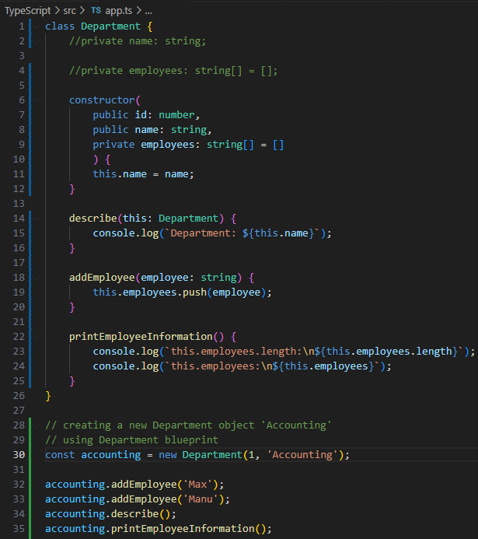

declaring public/private fields using constructor(...) {}

class className {

constructor(

public id: number,

public name: string,

private employees: string[] = []

) {

this.name = name;

}

}

// **readonly** class keys

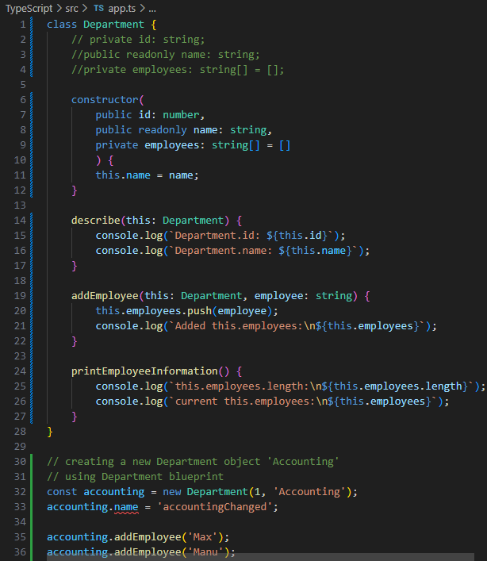

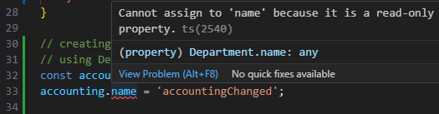

Inheritance

Sunday, April 7, 2024

1:32 AM

// blueprint

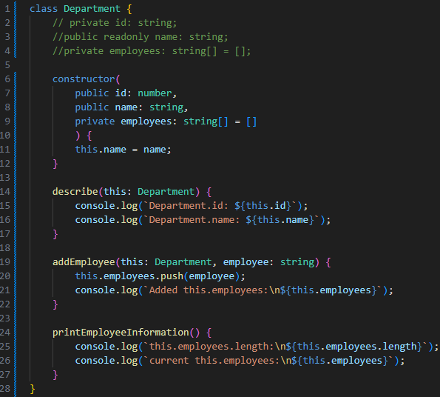

// creating another department 'IT'

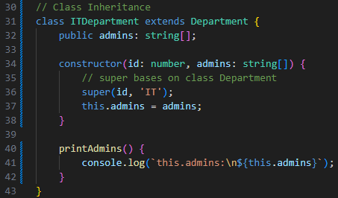

// creating it by concatenating new ITDepartment (class)

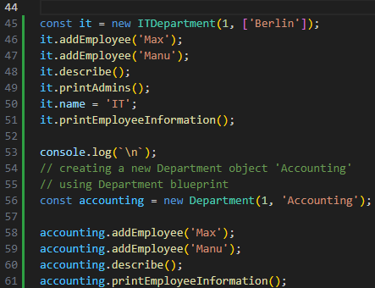

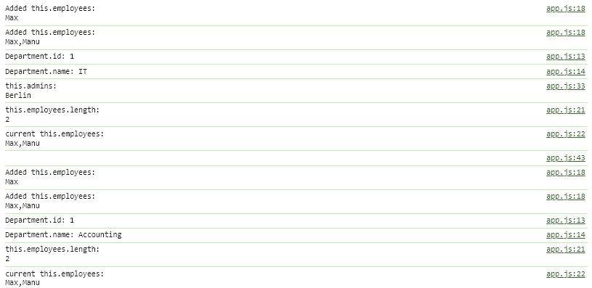

// re-creating accounting department using AccountingDepartment (class)

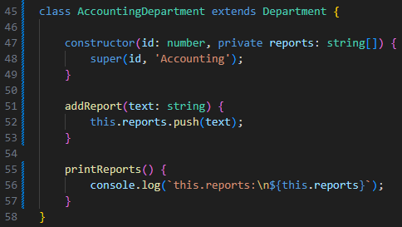

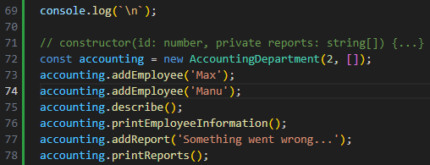

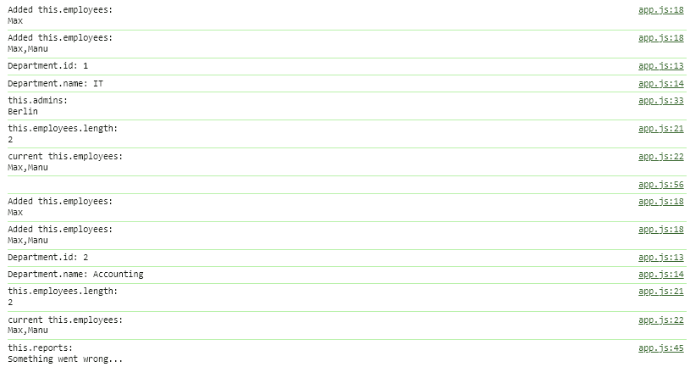

overriding properties & "protected" modifier

Monday, April 8, 2024

10:42 AM

// trying to add a method 'addEmployee' to class AccountingDepartment

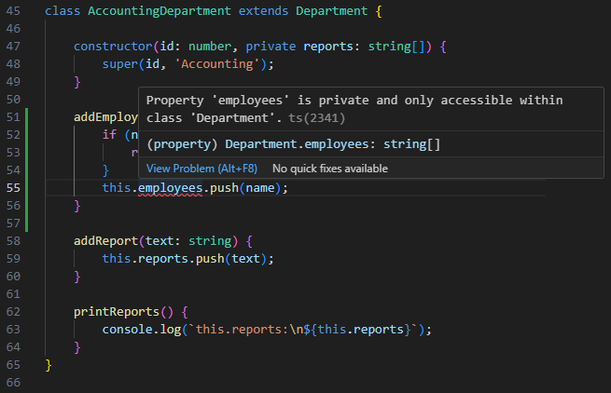

// because class AccountingDepartment **extends Department (inheritance)**

// and class Department's constructor(..., private employees: string[] = []) {...}

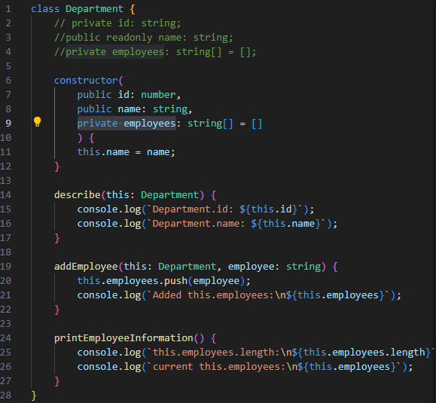

// using **protected** instead of **private**

// will allow other classes inheriting this class Department

// to amend this.employees

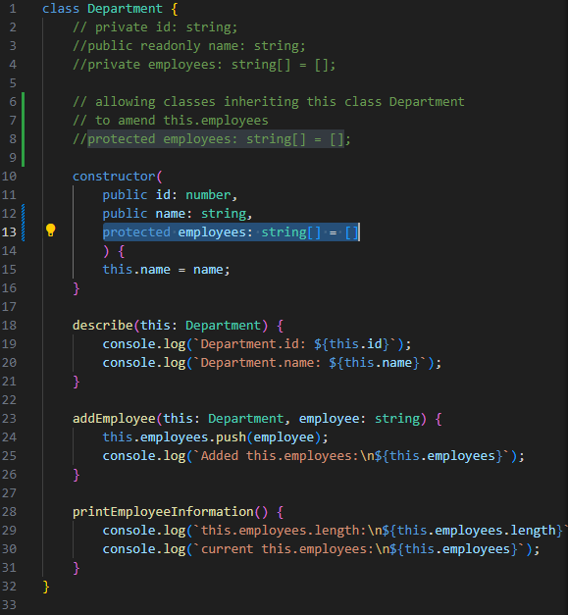

// now class AccountingDepartment extends Department {...}

// can amend this.employees

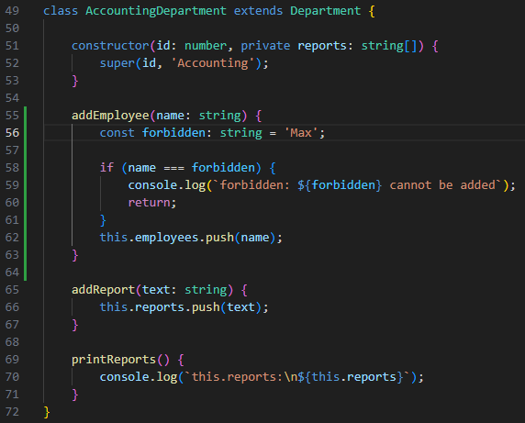

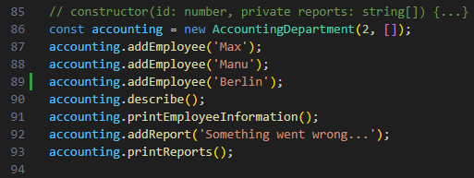

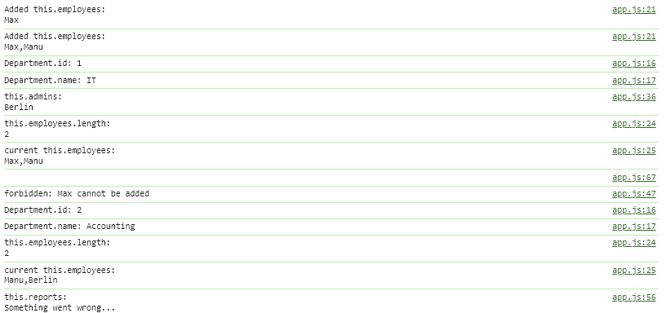

// getter method to gain access to private fields in a class

// by returning this.privateField to this class

// through closures hoisting

// just like writing a normal method before declaring constructor() {...}

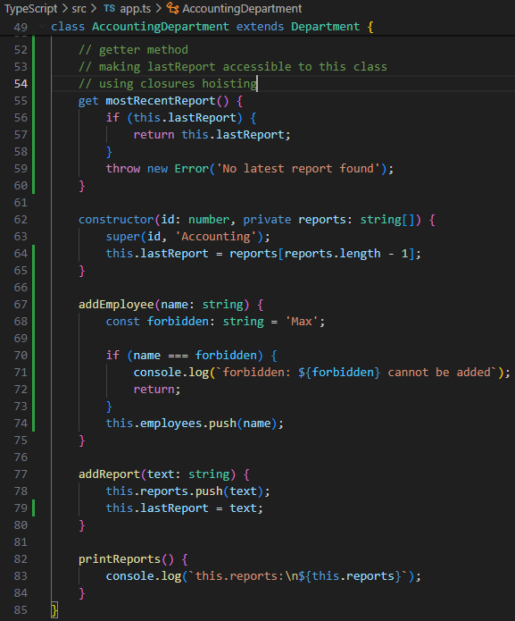

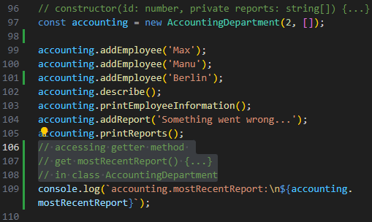

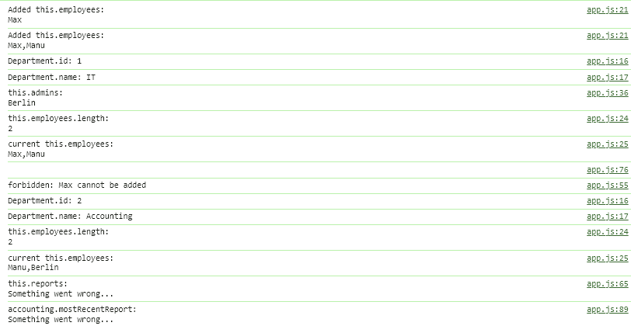

// setter method to gain access to amend class.fieldValue

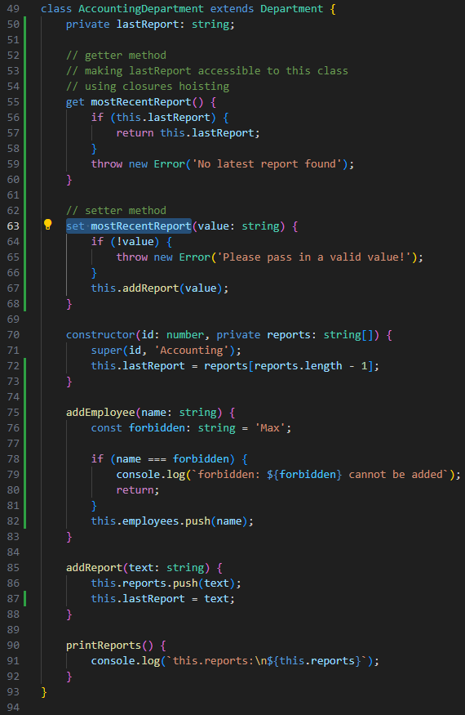

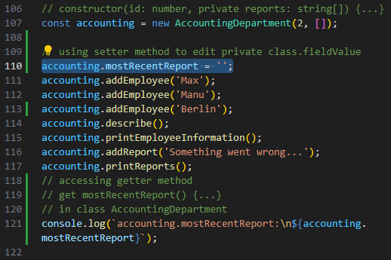

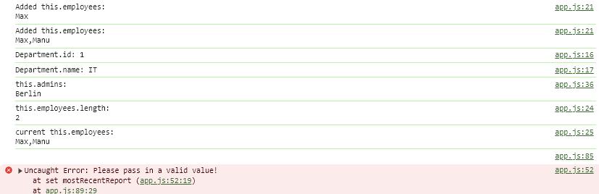

// using setter method in class

// to set class.fieldValue in class AccountingDepartment

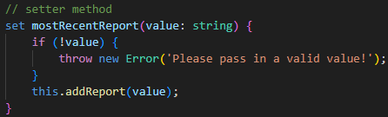

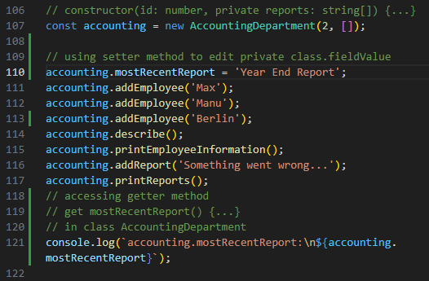

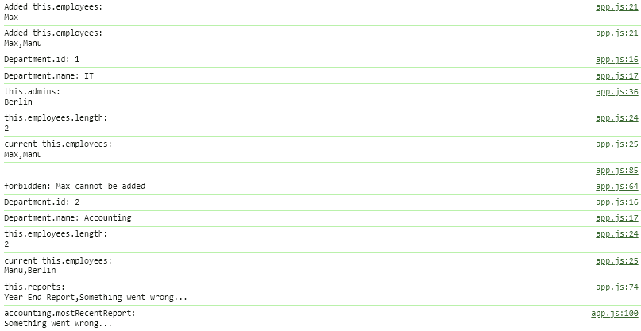

static methods & properties

Monday, April 8, 2024

11:49 AM

// a **static method** allows all **inheriting** sub-**classes** to call **class.method()**

// **without instantiating** our custom class

// e.g.

// const itEmployee1 = ITDepartment.createEmployee('itEmployee1');

// const accountingEmployee1 = AccountingDepartment.createEmployee('acEmployee1');

// usage

// const itEmployee1 = ITDepartment.createEmployee('name1');

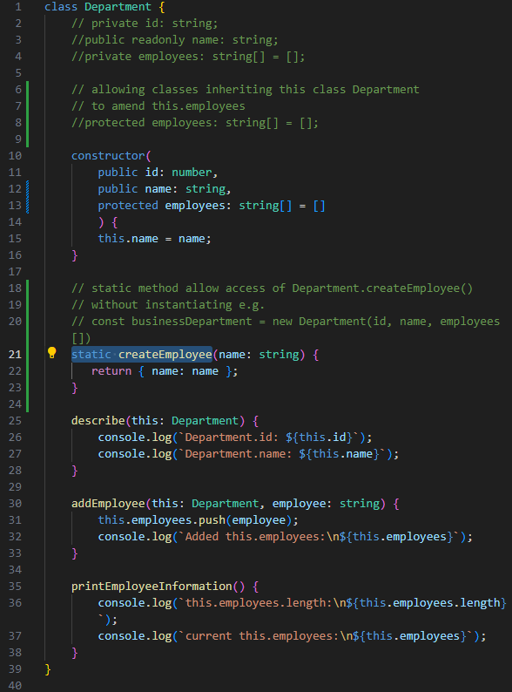

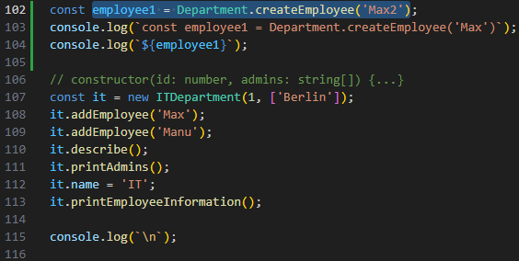

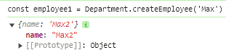

// adding a static field fiscalYear to class Department {...}

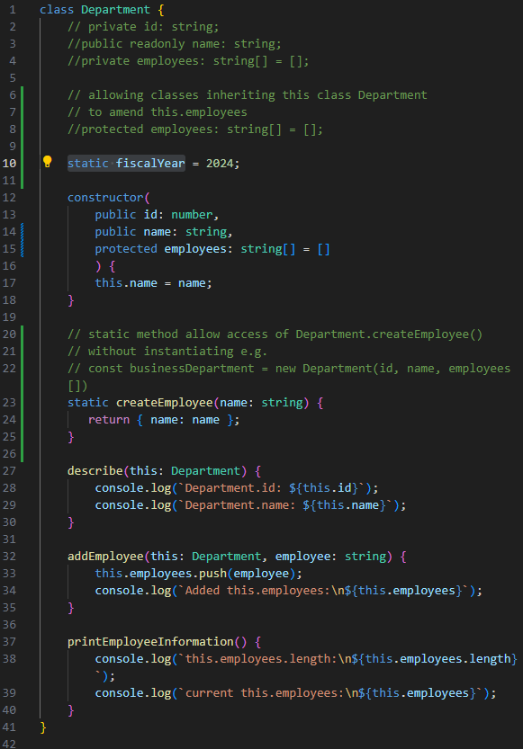

// then we can access Department.fiscalYear without instantiating

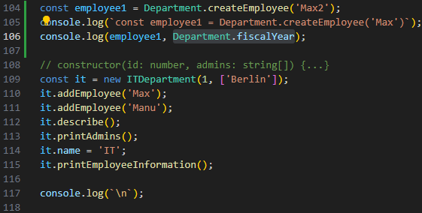

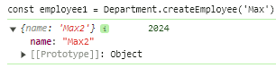

// all static properties & static methods are detached from instances

// cannot use this.fiscalYear to access a static property

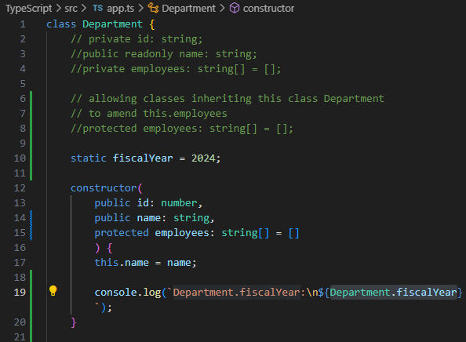

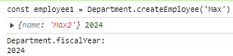

// example2 **static property**

// inheriting classes (sub-classes) calling static field from base class

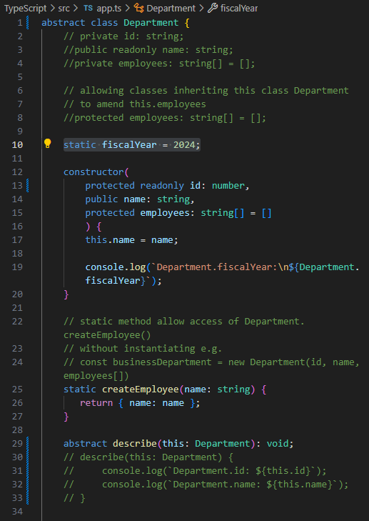

// sub-class ITDepartment extends Department

// also inherits static fiscalYear = 2024;

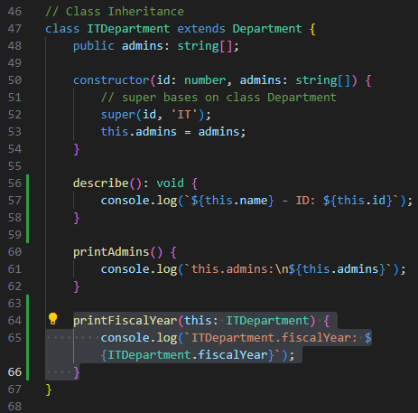

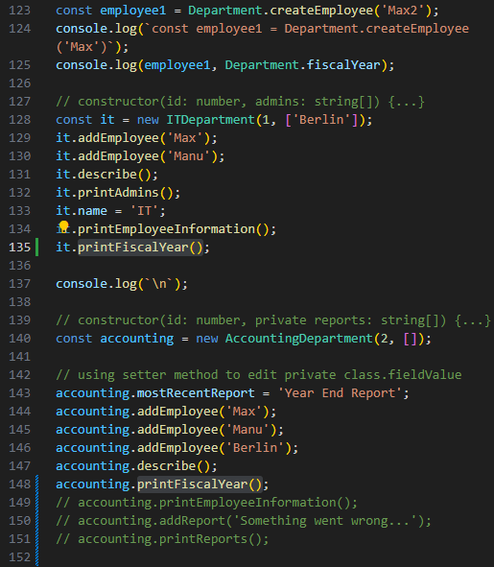

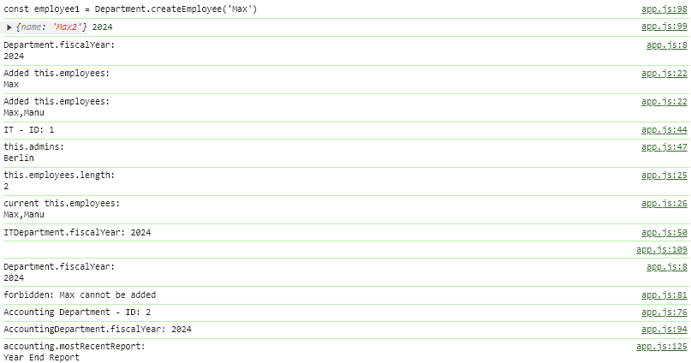

// example3 **static method**

// **do NOT need to instantiate a class**

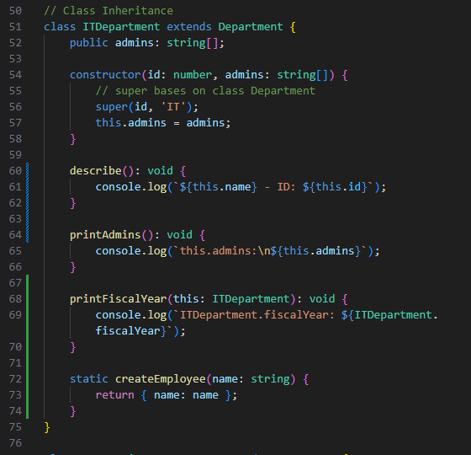

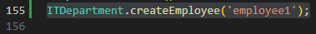

abstract class

Monday, April 8, 2024

2:15 PM

// allow sub-classes to inherit abstract properties/methods from base class

// NO explicit abstract properties' values should be made

// NO explicit abstract method () { code } should be made

// sub-classes to declare explicit values/code in abstract class.properties/class.method

// **abstract class cannot be instantiated itself**

// e.g. const ITDepartment = new Department(id, 'name', employees[]);

// **No explicit code** in **abstract properties/methods**

// abstract describe(this: Department): void;

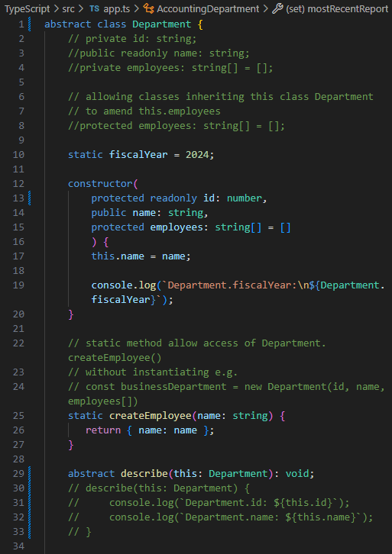

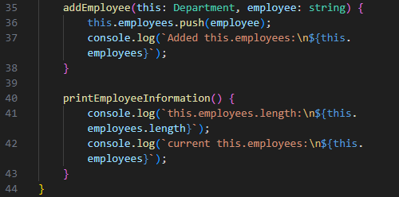

// correct usage of abstract class

class ITDepartment extends Department

// inheriting classes **must implement abstract method** from base class

e.g.

describe(): void { code... }

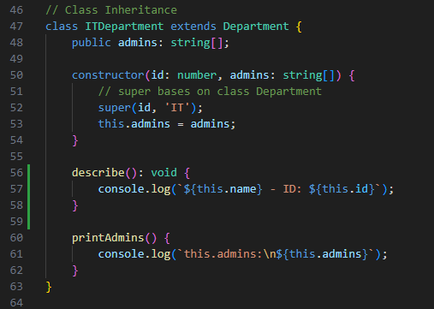

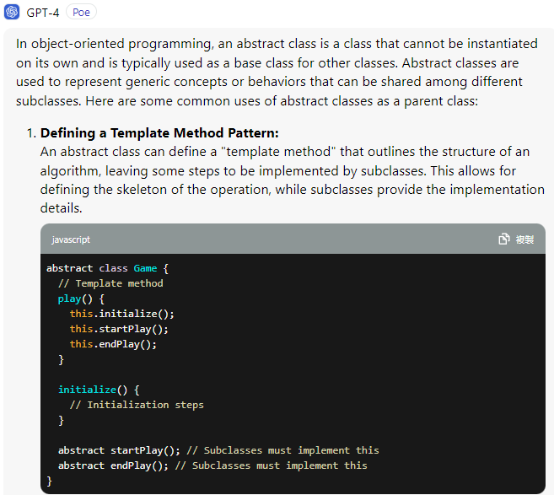

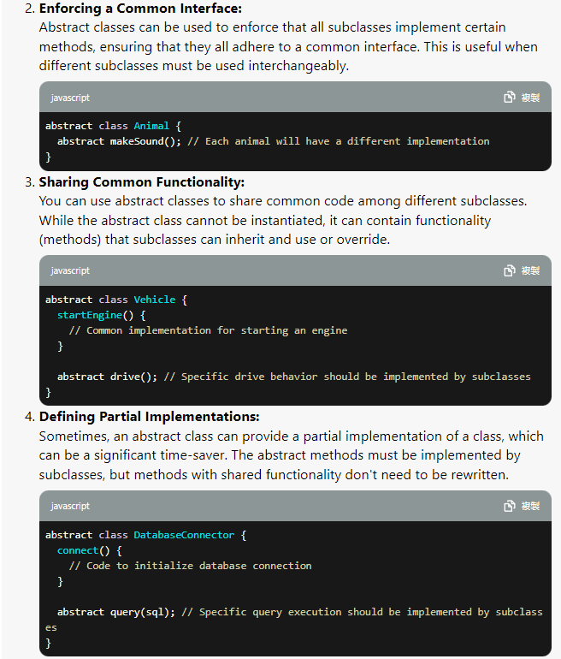

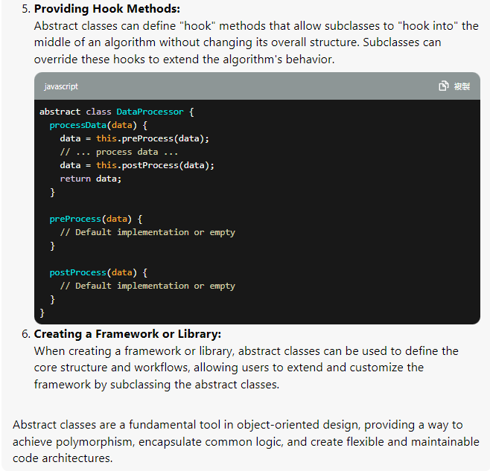

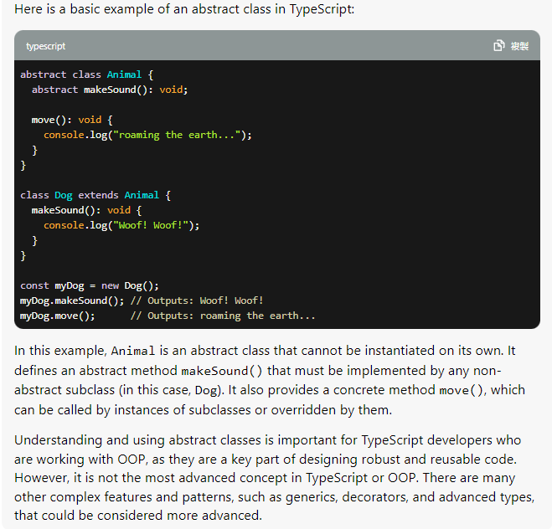

// parent abstract class Department

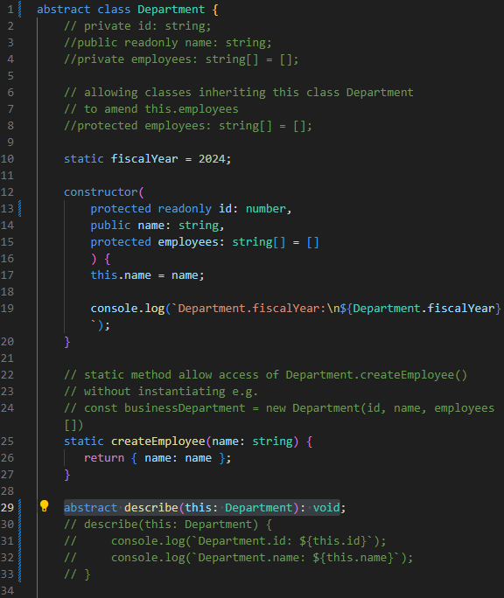

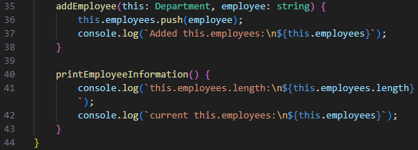

// children class ITDepartment extends Department

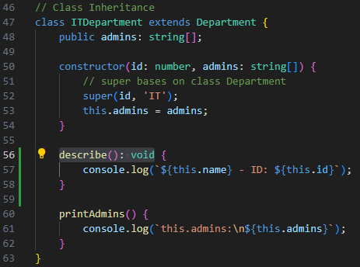

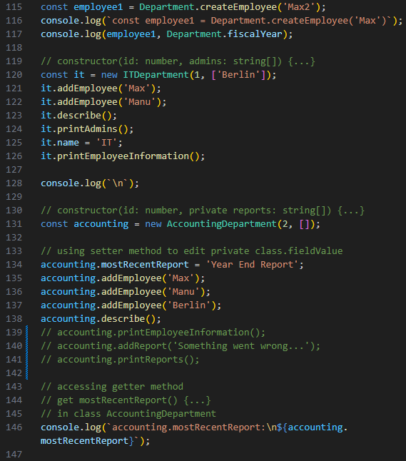

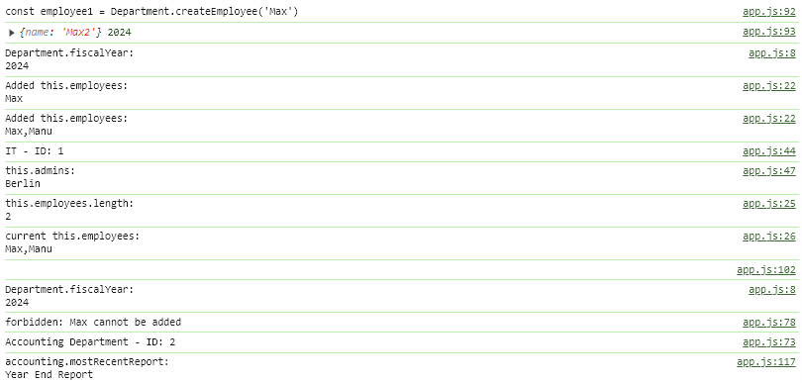

Singleton design pattern & private constructors

Monday, April 8, 2024

5:19 PM

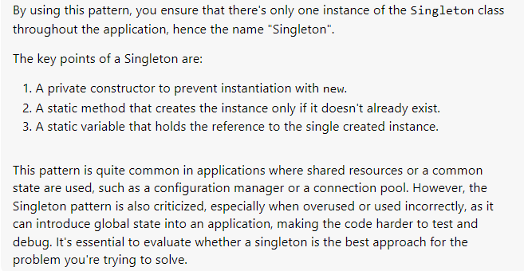

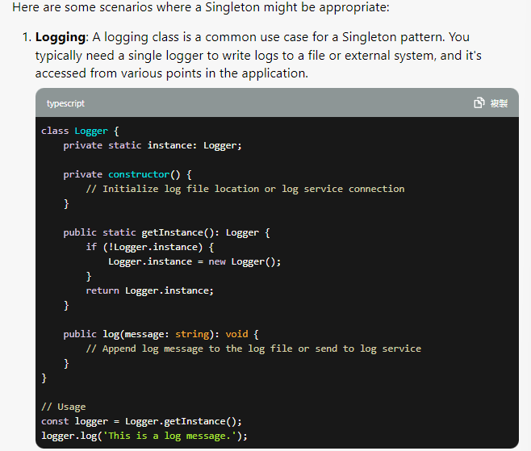

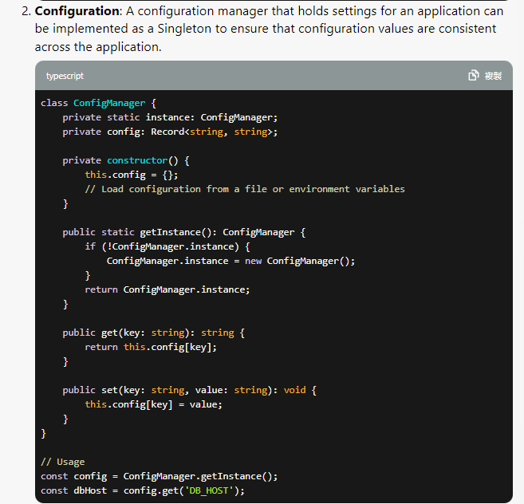

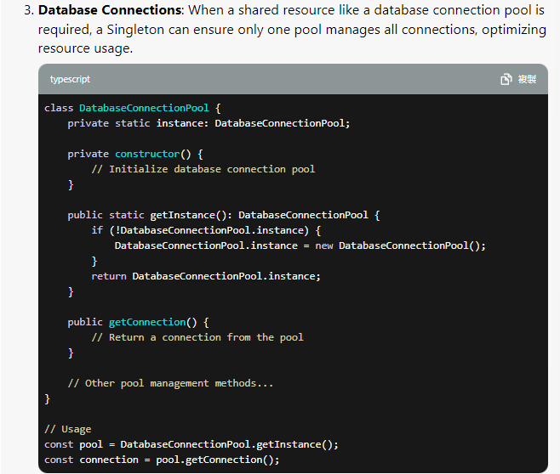



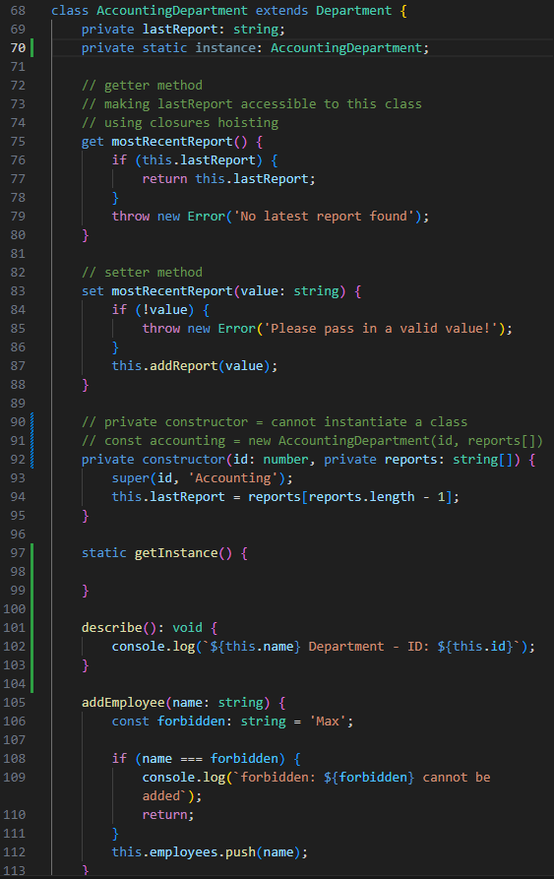

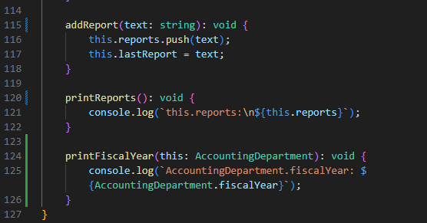

// cannot instantiate outside the class AccountingDepartment

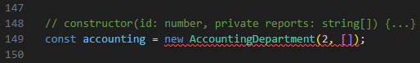

// check if AccountingDepartment.instance property is declared

// if true => return this.instance;

// otherwise, instantiate class AccountingDepartment within itself

// return this.instance to class

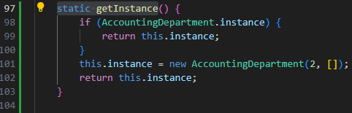

// use class.staticMethod(); to instantiate class AccountingDepartment

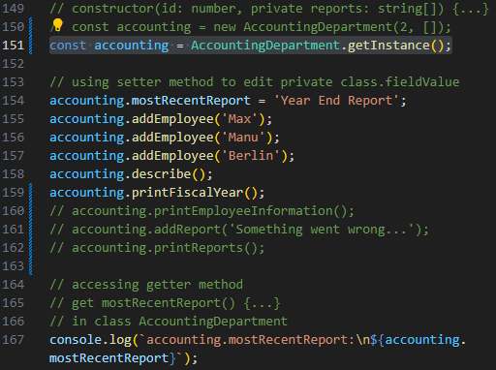

Interfaces

Tuesday, April 9, 2024

10:55 AM

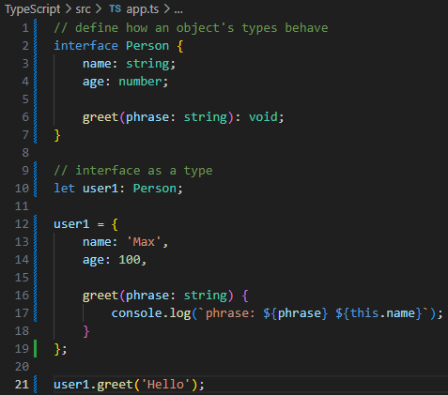

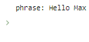

Implementing an interface inside a Class

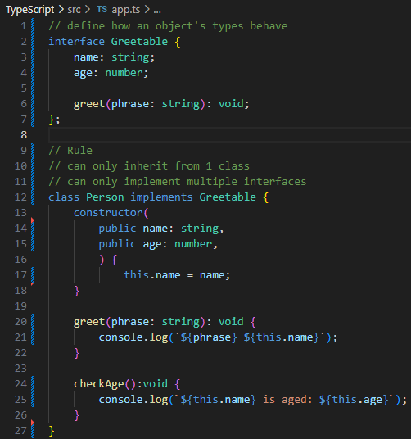

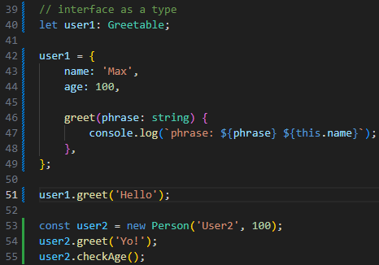

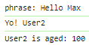

// comparing user1 & user2

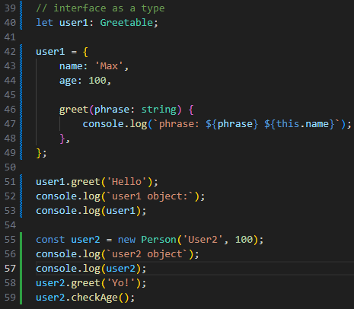

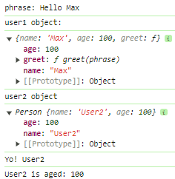

Why Interfaces?

Useful when we have a certain set of functionalities

e.g.

We wanna ensure class Person also has a greet(phrase: string): void

declared in interface Greetable

& other class might also have this greet(phrase: string): void too

which can force the existence of greet(phrase: string): void

**To share common functionality among classes safely**

**each sub-class must implement all methods stated in interface**



**readonly modifier**

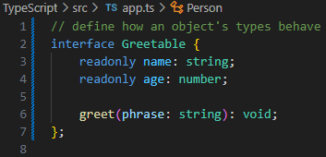

**interfaces cannot use public/private properties**

sub-classes implementing interface Greetable can **only initialize readonly properties** (name & age) **once upon class instantiation**

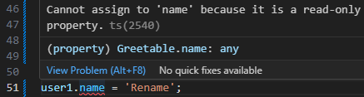

**Extending Interfaces**

interface Greetable extends Aged, Named {...}

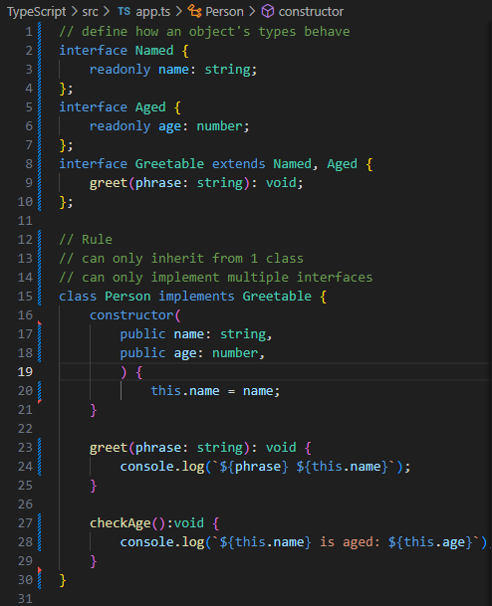

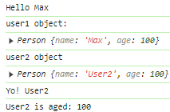

**Interfaces as Function Types**

// using interface to define structures of a function

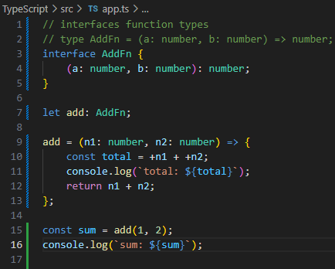

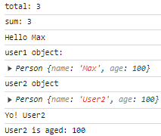

**Optional parameters & properties**

**deep-dive continue next slide**

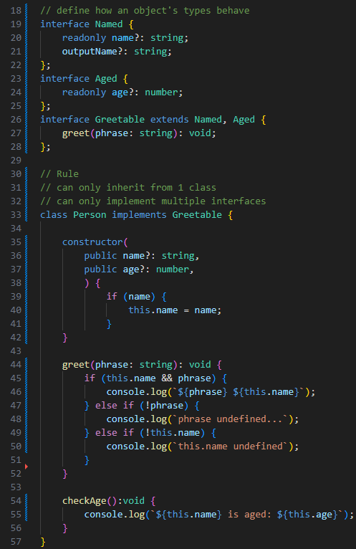

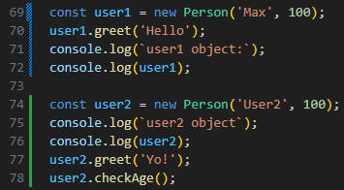

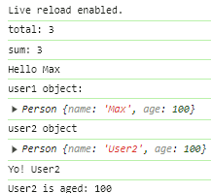

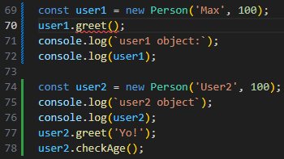

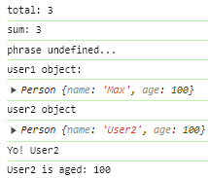

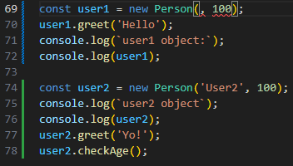

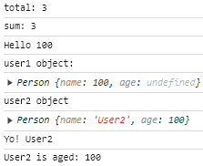

optional parameters & optional properties

Tuesday, April 9, 2024

8:13 PM

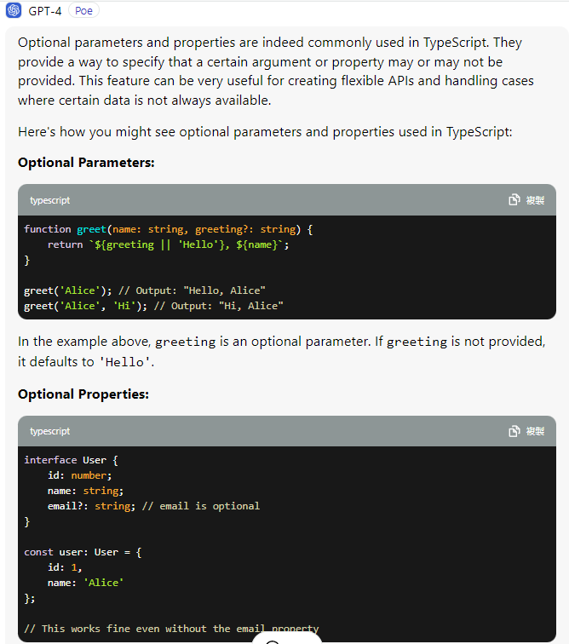

// example1

// all parameters are parsed

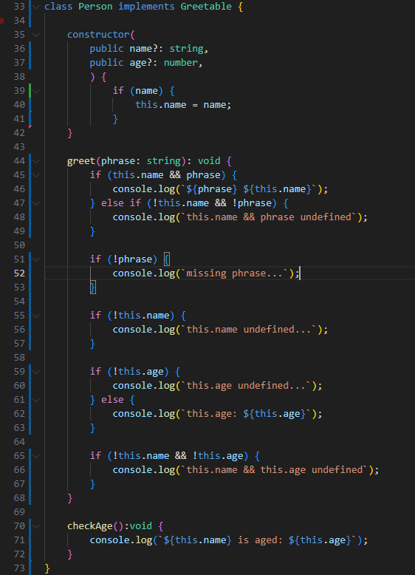

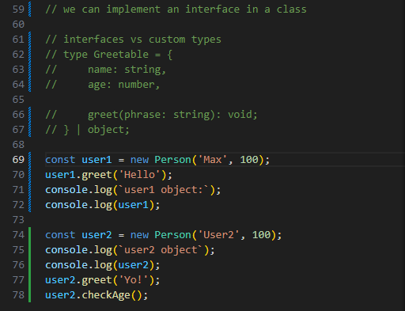

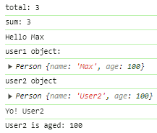

// example2

// missing parsed name & age

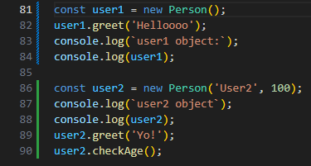

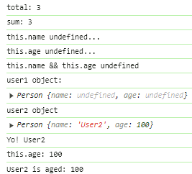

// example3

// missing parsed age

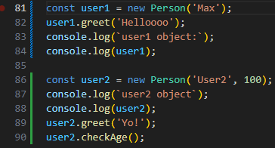

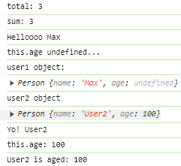

// example4

// missing parsed name

// parsed age becomes name

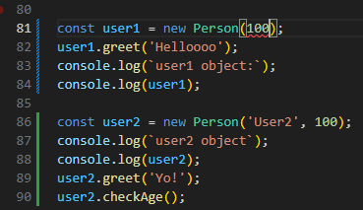

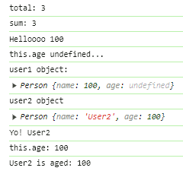

// example5

// missing parsed phrase

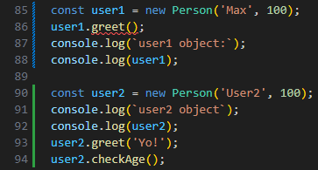

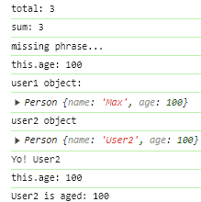

compiling interfaces to JavaScript

Tuesday, April 9, 2024

10:07 PM

**TypeScript interfaces are NOT compiled at runtime to Javascript**

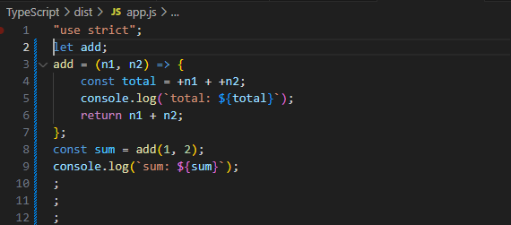

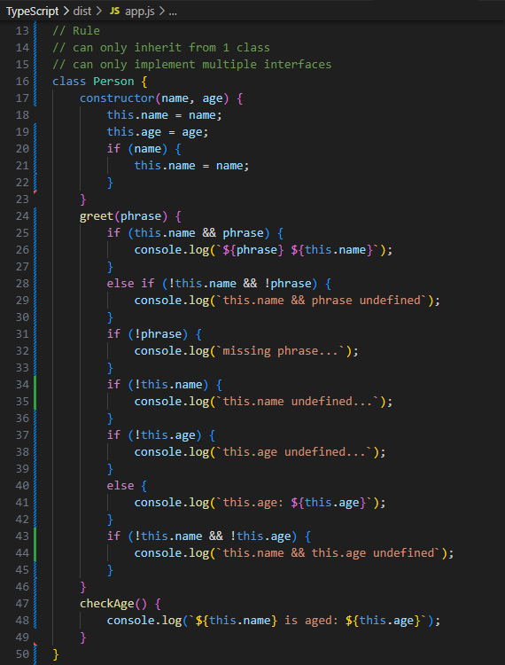

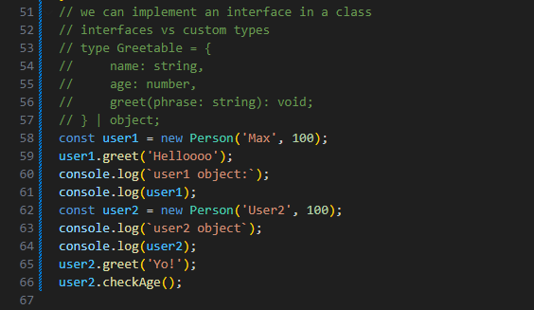

<https://www.typescriptlang.org/docs/handbook/2/objects.html>

=== Adv. Types

Wednesday, April 10, 2024

10:13 AM

i. Intersection Types

ii. Type Guards

iii. Discriminated Unions

iv. Type Casting

v. Function Overloads

Intersection Types

Wednesday, April 10, 2024

10:55 AM

// Approach1

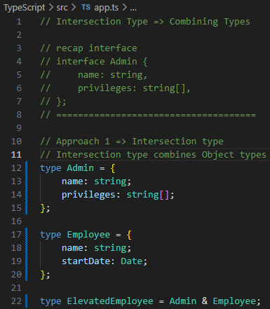

// Approach2

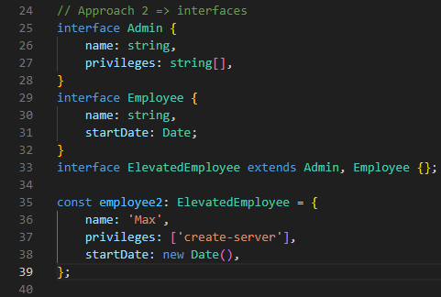

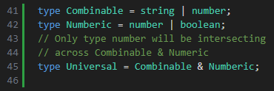

type guard

Wednesday, April 10, 2024

12:13 PM

**Type Guards**

**to check whether a property(s) or a method(s) exist in an Object**

example1

if typeof a === 'string' || typeof b === 'string'

force coersion +a + +b => number;

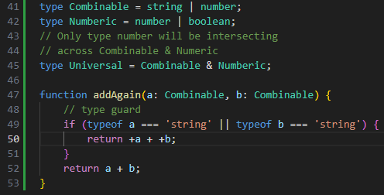

example2

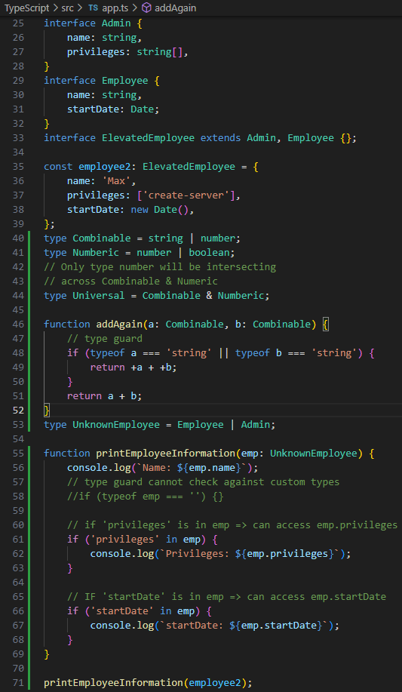

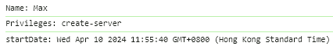

example3

creating employee2 on the fly without declaring an Object

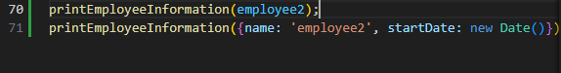

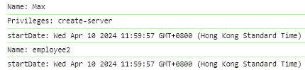

practice2

type guard **checks against** 'loadCargo' **method** in vehicle

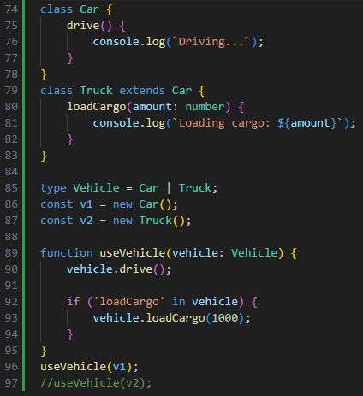

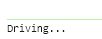

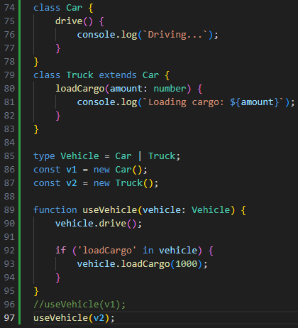

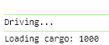

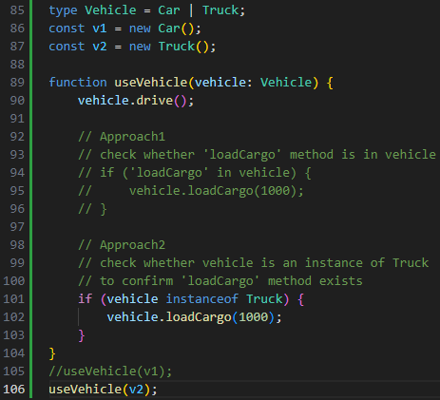

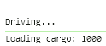

** discriminated unions

Wednesday, April 10, 2024

12:27 PM

// a **special type of type guard**

// pattern used to make implementation of type guards easier

// using 1 common property across interfaces

// that makes up the union (common property)

// as **interfaces are NOT compiled at runtime**

// we **cannot check against** whether parsed animal is an **instance** of

// any interfaces

// e.g.

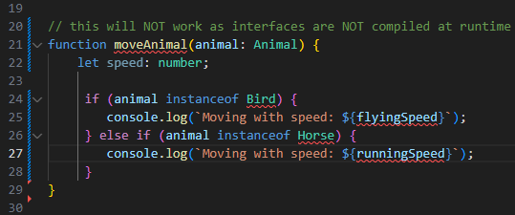

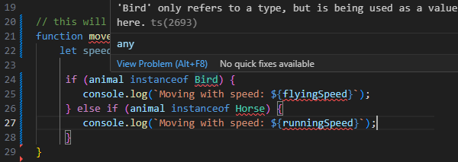

// using a **switch operator** to **check against** animal.type **common property**

// across multiple interfaces

// this **determines** which **interface.differentProperty** should be **used** animal.flyingSpeed / animal.runningSpeed

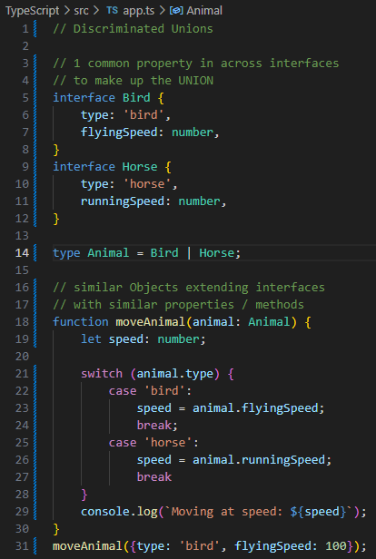



type casting

Wednesday, April 10, 2024

5:37 PM

// need Type Casting to edit HTMLElement object.properties

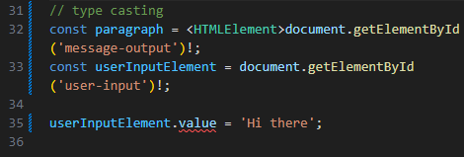

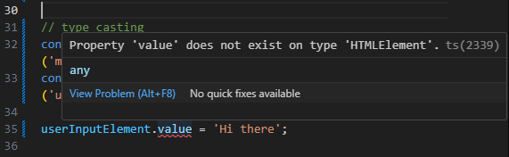

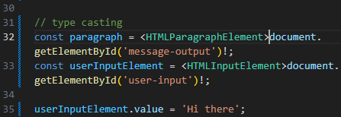

// Approach 1

// document.getElementById('')! as HTMLParagraphElement;

// Approach 2

// <HTMLInputElement>document.getElementById('')!;

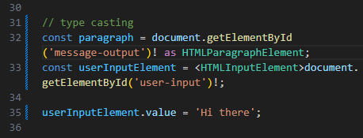

// Approach 3

// use object checking => type casting in if () {...}

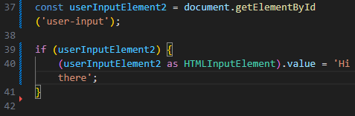

index type & index property

Thursday, April 11, 2024

10:17 AM

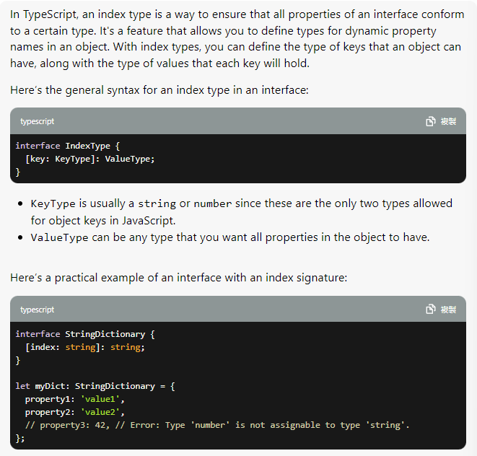

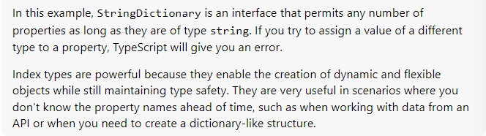

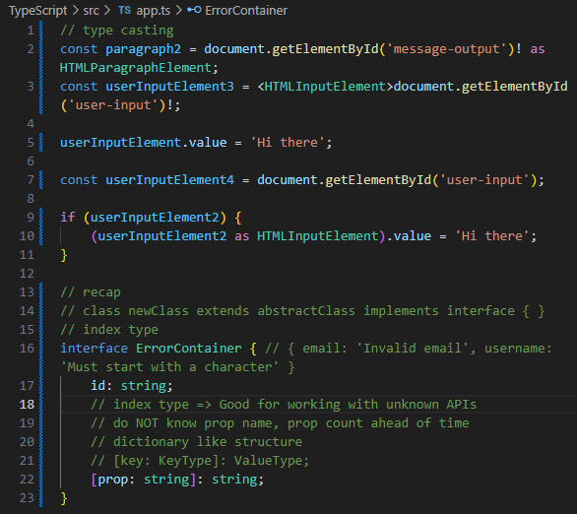

// declared index type limits the id: valueType

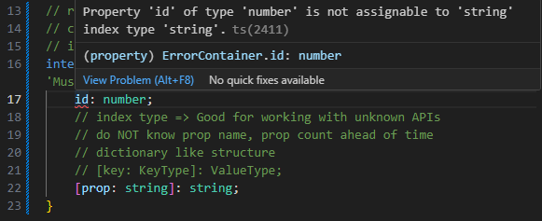

Syntax

[key: keyType]: keyValue

if changing keyType to number, string key => NOT work

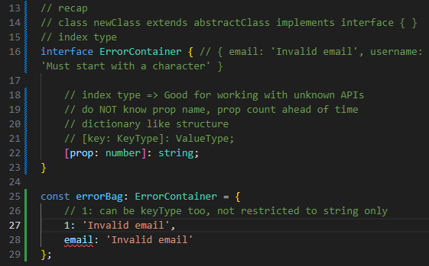

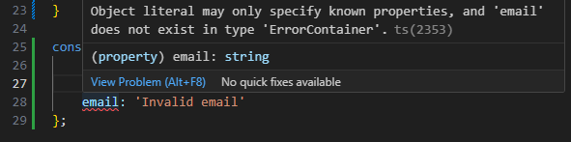

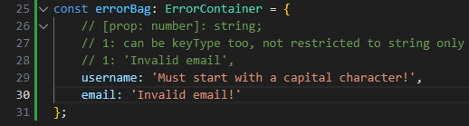

** function overloads

Thursday, April 11, 2024

11:52 AM

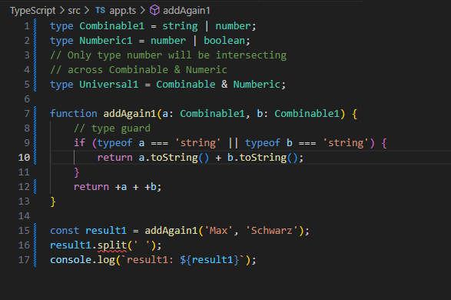

// const result: **number** => addAgain1('Max' ,'Schwarz');

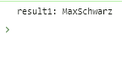

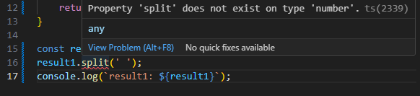

// adding type casting to allow result1.split();

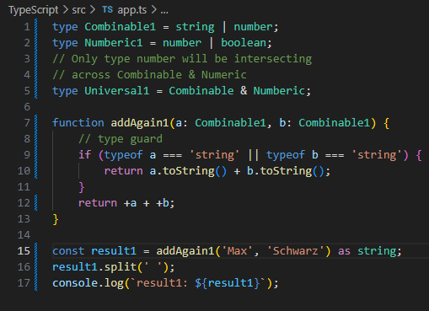

// **Function Overloading**

**// combining the powers of multiple knowledge bases of same function**

**// with different function types**

**// to allow a variety of parsed data into a function**

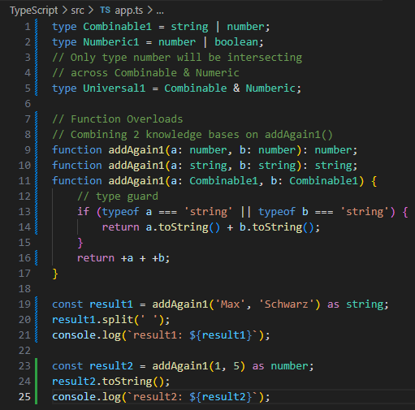

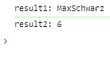

**// Function Overloading with 4 function types**

function addAgain1(a: **number**, b: **number**): **number**;

function addAgain1(a: **string**, b: **string**): **string**;

function addAgain1(a: **string**, b: **number**): **string**;

function addAgain1(a: **number**, b: **string**): **string**;

function addAgain1(a: **Combinable1**, b: **Combinable1**) {...}

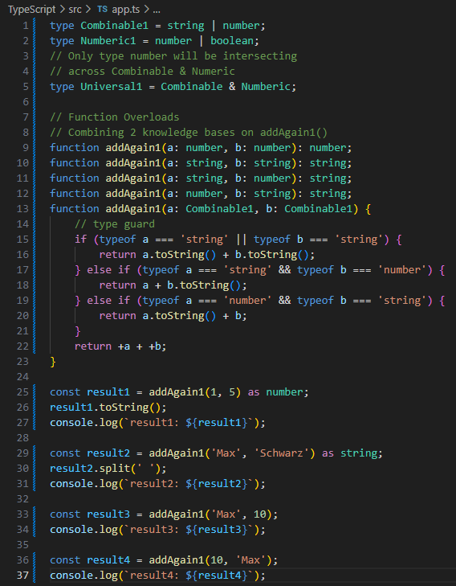

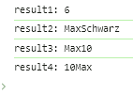

optional chaining ?.

Thursday, April 11, 2024

2:23 PM

// ?. useful when dealing with fetching database unknown object.properties

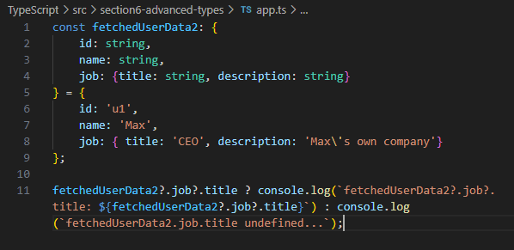



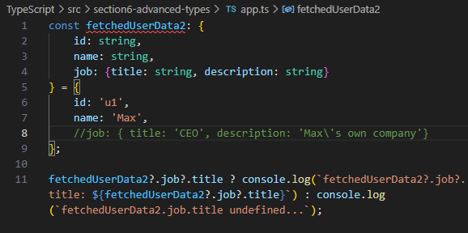

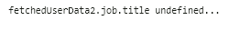

**Nullish Coalesing**

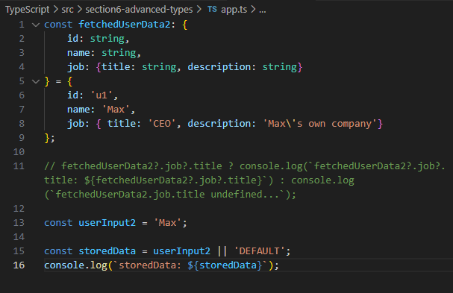

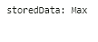

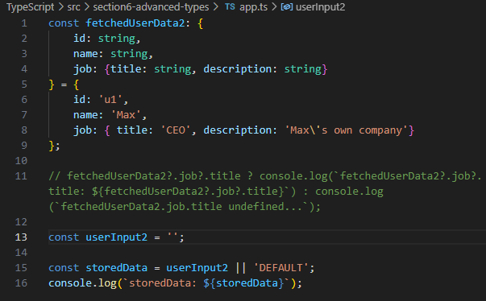

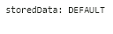

Nullish Coalesing

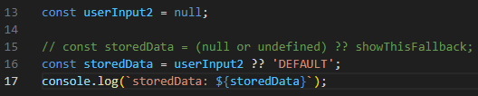

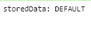

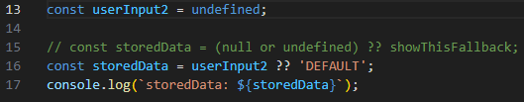



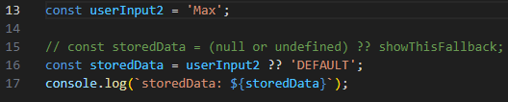

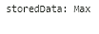

Adv. Type quiz

Thursday, April 11, 2024

2:54 PM

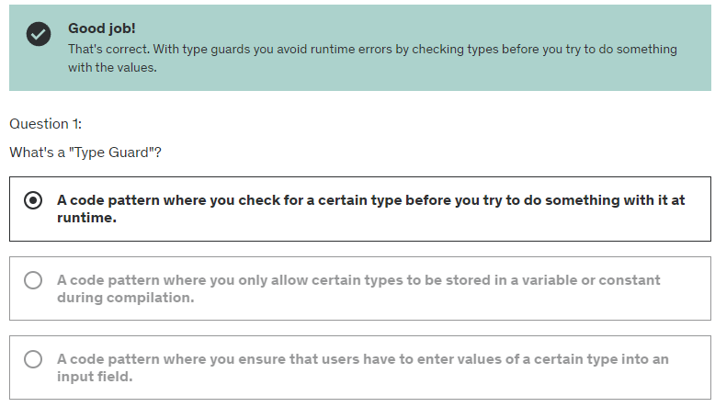

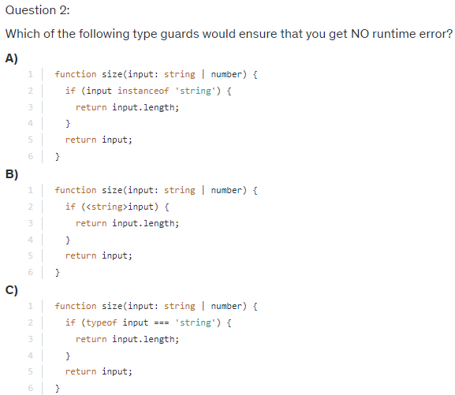

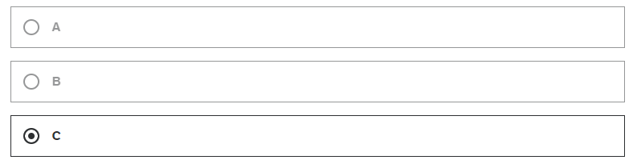

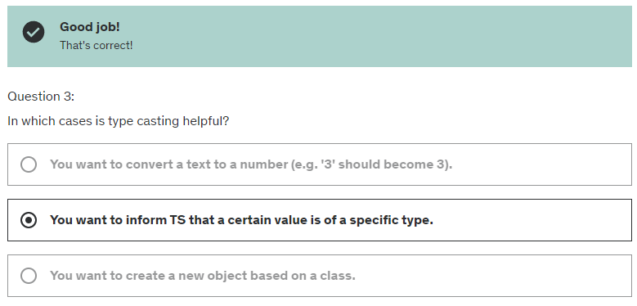

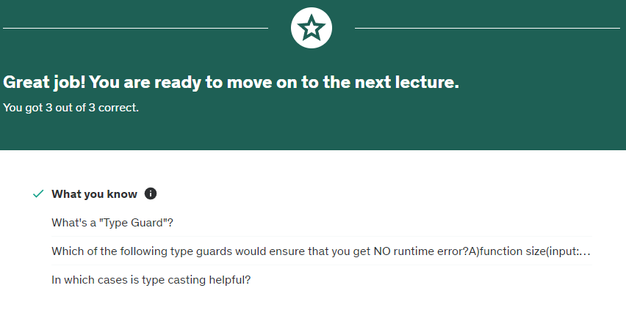

<https://www.typescriptlang.org/docs/handbook/2/types-from-types.html>

=== Generics

Thursday, April 11, 2024

2:59 PM

Only exists in TypeScript

- Generic Functions & Classes

- Constraints

- Special TypeScript Types

<https://developer.mozilla.org/en-US/docs/Web/JavaScript/Reference/Global_Objects/Promise>

explaining Generic built-in function

Friday, April 12, 2024

12:00 PM

// traditionally

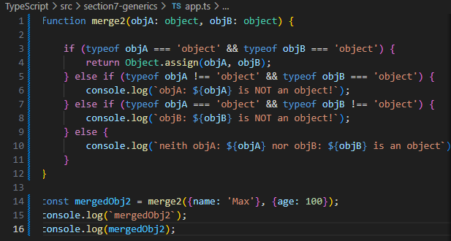

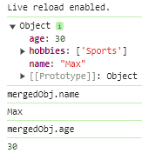

Creating a Generic function

Thursday, April 11, 2024

3:51 PM

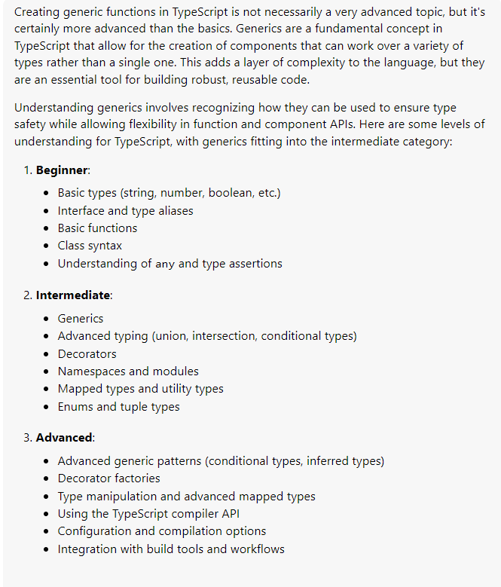

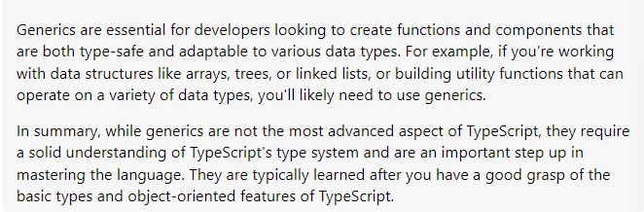

// **Creating** a **Generic** function to merge objects

// **Objects = highly unspecific types => any objects**

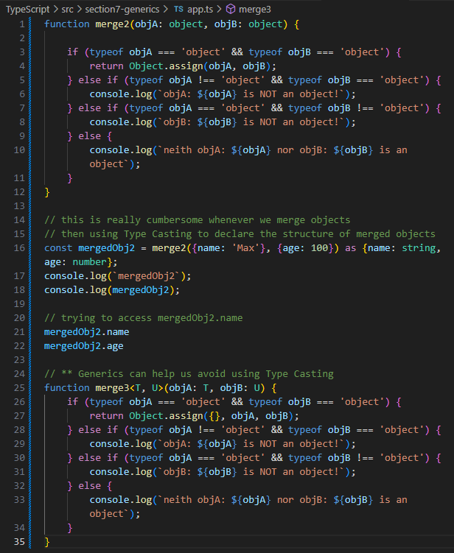

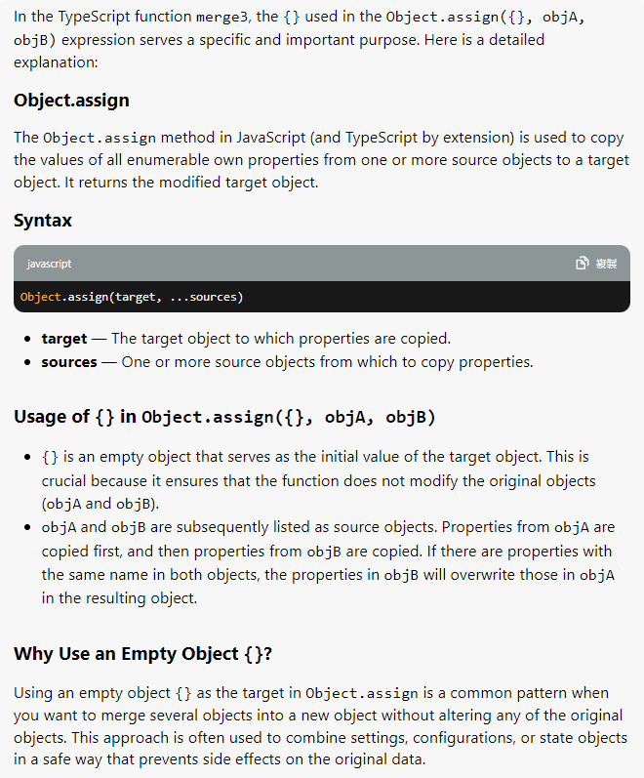

// if NO Type Casting => cannot access mergedObj.properties

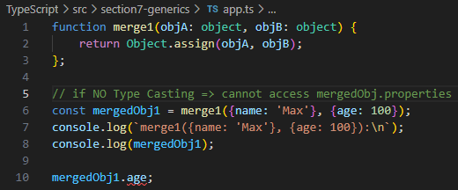

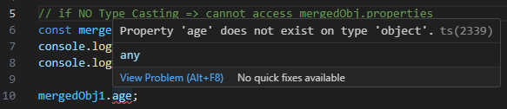

// however, using Type Casting is too cumbersome

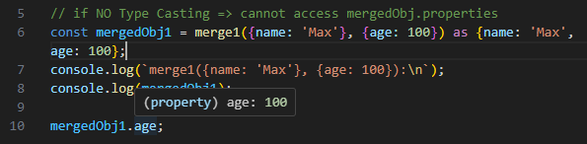

// creating our own Generic Function using Generic Types

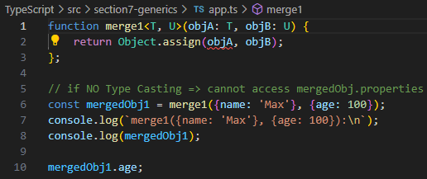

// reflecting the **Intersection of T & U**

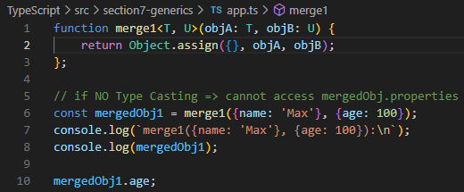

// TypeScript understands **objA will always be of different type to objB**

// by understanding the **intersection of T & U**

**// objA = a very specific Type**

**// objB = another very specific Type**

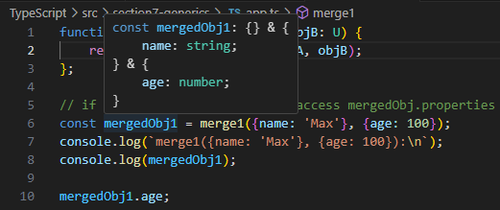

// **object is a highly unspecific type**

// the **intersection** of **2 unknow objects** = a **new unknown object**

// which does **NOT offer** any additional **info**rmation to **TypeScript**

// function merge1<T, U>(objA: **object**, objB: **object**): **object & object** {

return Object.assign({}, objA, objB);

};

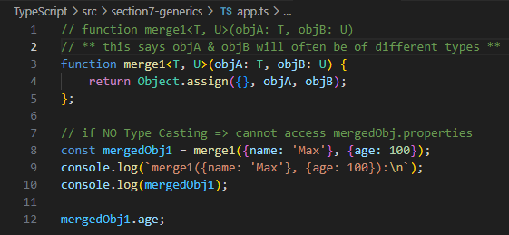

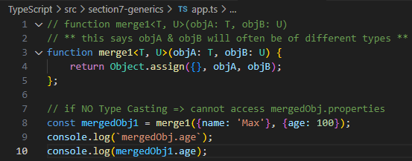



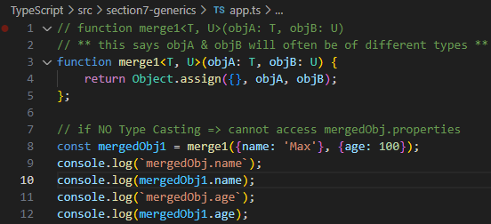

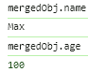

// objA || objB can be dynamically defined as of any Object Structures

// **very useful when dealing with dynamic Object assignments**

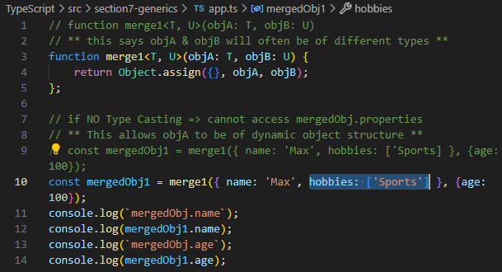

// T => { name: 'Max', hobbies: ['Sports'] }

// U => { age: 100 }

**Working with Constraints**

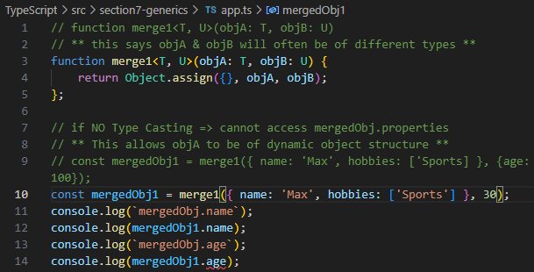

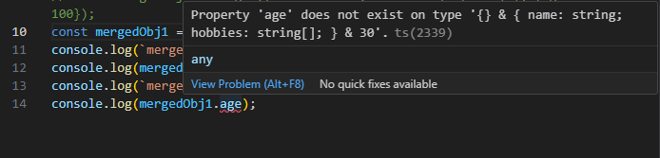

// age: 30 will be missing from mergedObj1

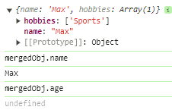

// ** adding type constraints

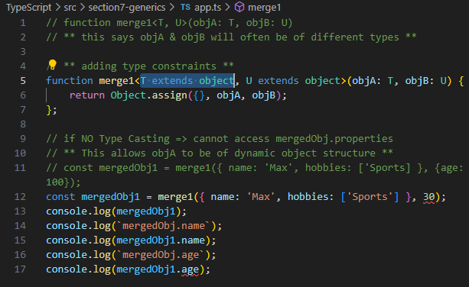

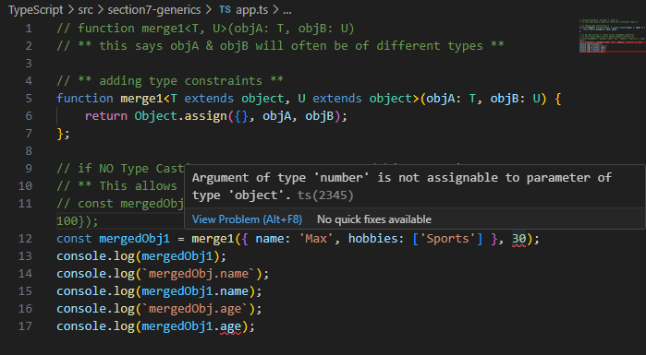

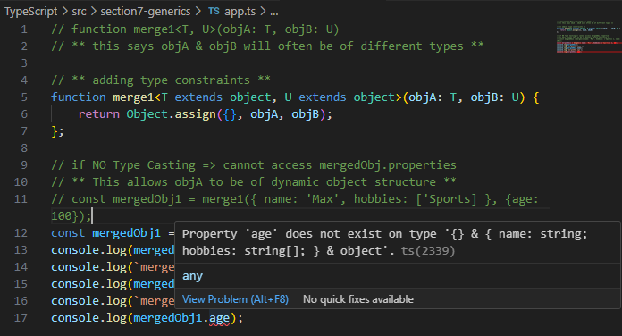

// this ensures we get 2 objects here

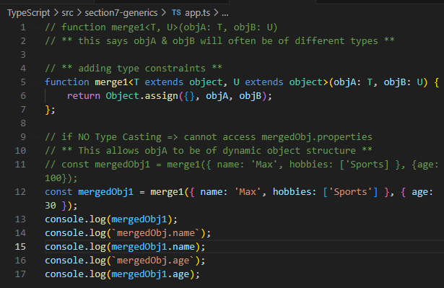

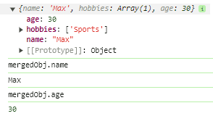

// thus now, we **can access mergedObj.name & mergedObj.age**

// **without Type Casting**

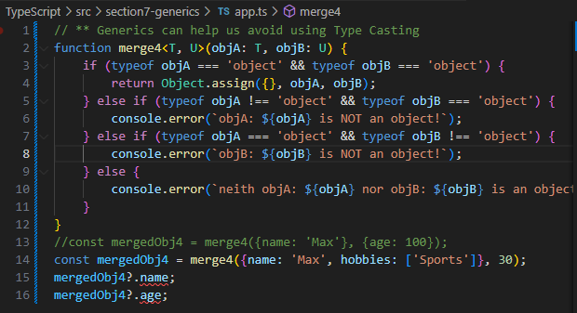

Generics

Thursday, April 11, 2024

3:13 PM

example1

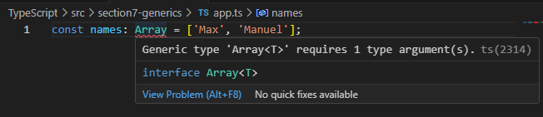

// a type connected to another type

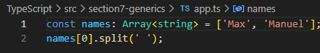

Main type: Array

return type: <string>

===

example2

main type: Promise

return type: <string>

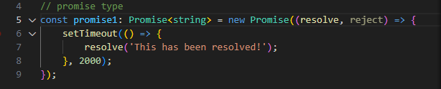

example3

main type: Promise

return type: <string> vs <number>

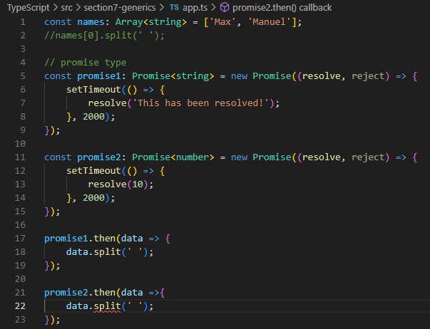

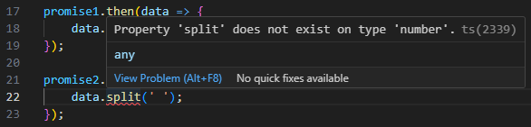

constraints

Friday, April 12, 2024

12:26 PM

// if we parse any non-object inputs to our Generic merge4<T, U>(objA: T, objB: U) {...}

// we'll receive errors



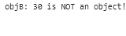

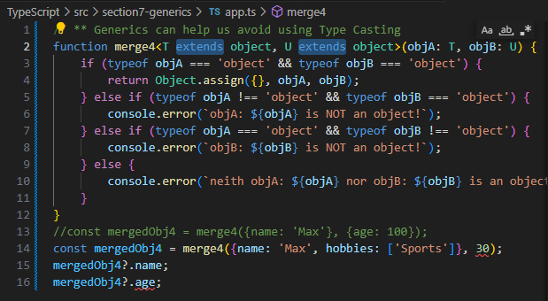

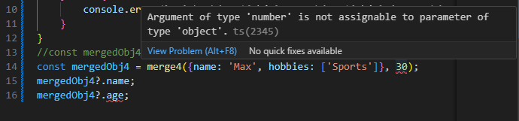

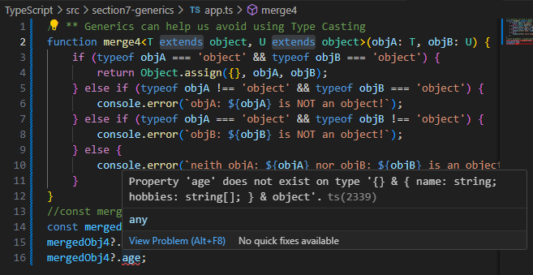

generic function types

Friday, April 12, 2024

1:00 PM

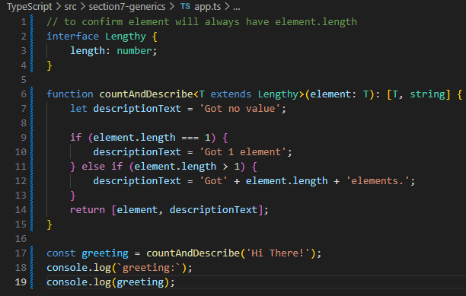

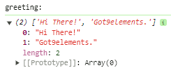

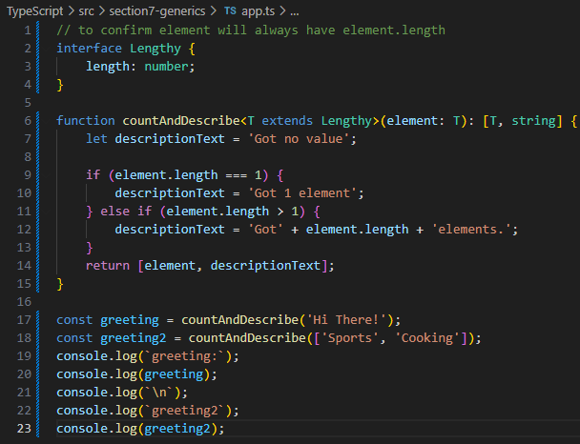

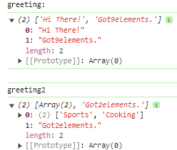

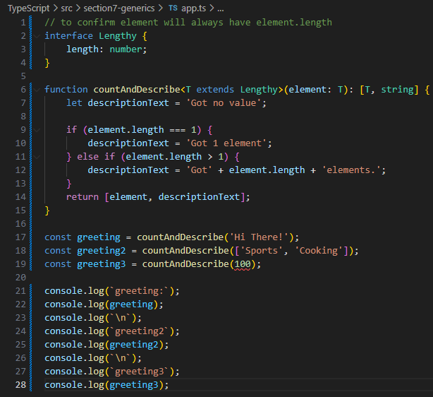

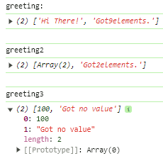

keyof constraint

Friday, April 12, 2024

11:53 AM

// trying to access an object's key value

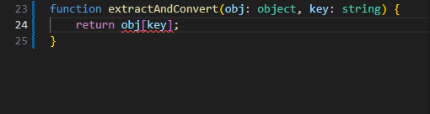

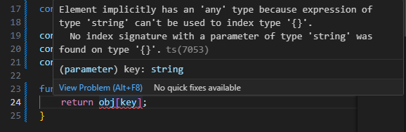

// creating a Generic function with <T extends object, U extends keyof T>

// **U has to be a key of T object**

function extractAndConvert<T extends **object**, U extends **keyof T**>(obj: T, key: U) {

return 'Value: ' + obj[key];

}

// an empty object {} will catch errors

extractAndConvert({}, 'name');

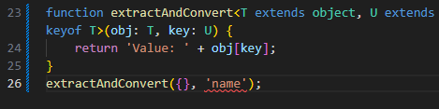

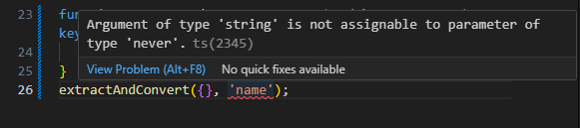

// this ensures a valid object {}, key are parsed to our custom Generic function

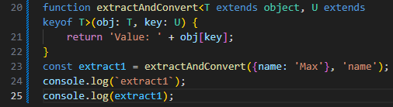

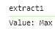

Generic Class

Friday, April 12, 2024

4:27 PM

// a Generic class ensures all parsed arguments in class.method() are Generic

// along with typeGuard => type safety

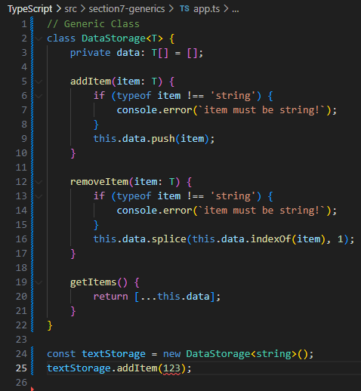

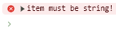

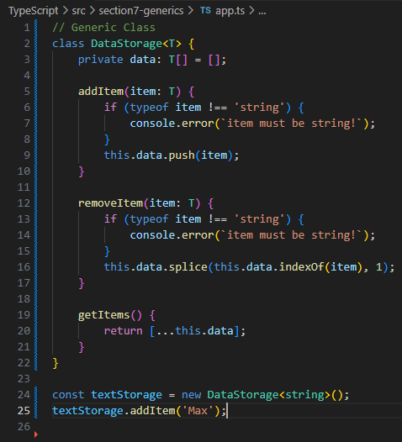

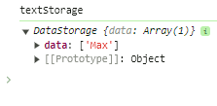

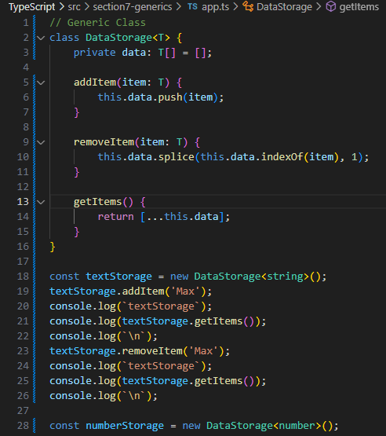

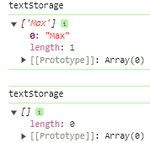

// removing object {name: 'Manu'}

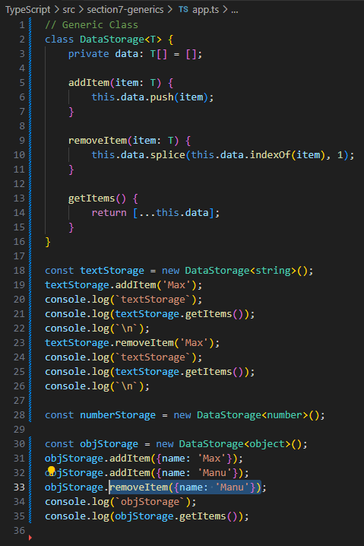

// this seems fine but...

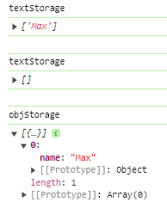

// if removing obj {name: 'Max'}

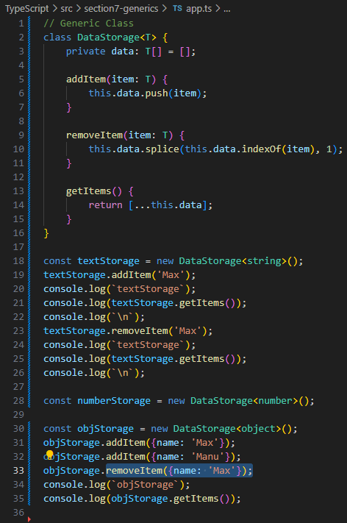

// object {name: 'Max'} is still there...

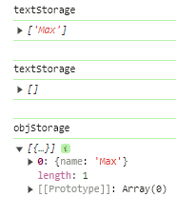

// Workaround is to **confirm** removeItem(item: T) has an **index check**

// of parsed Object

// original **removeItem(item: T)** will **always removes** the **last element** in an **array**, this is due to **JavaScript behaviour**

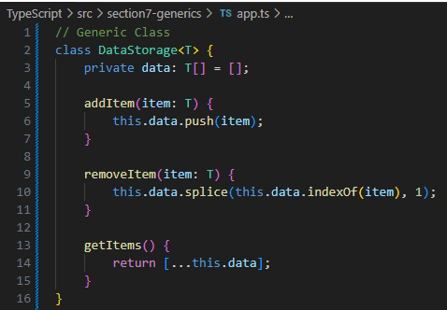

// this **indexOf(item) === -1 guard** will **break** the method of how **JavaScript always remove** the **last element** by **returning nothing**

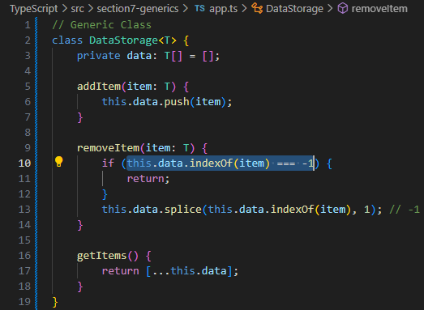

// objStorage.**addItem({name: 'Max')};**

// objStorage.**addItem({name: 'Max')};**

// this **will add 2 objects sharing same key** - name: 'Max' to textStorage object, **each object** {name: 'Max'} **looks** the **same but each object** will **have a unique Memory Address**

// hard to manage object operations

// **const maxObj = {name: 'Max'};**

// this will create a unique object to be stored in textStorage object by assigning a **unique Memory Address**

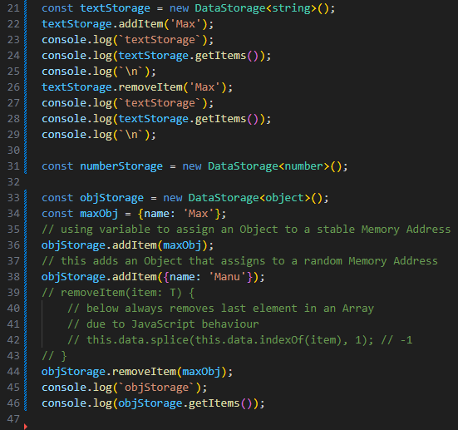

// now {name: 'Max'} can be successfully removed by addressing its unique Memory Address

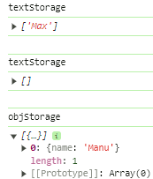

Utility Types

Friday, April 12, 2024

5:45 PM

<https://www.typescriptlang.org/docs/handbook/utility-types.html>

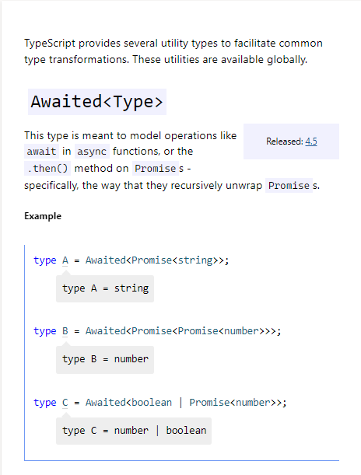

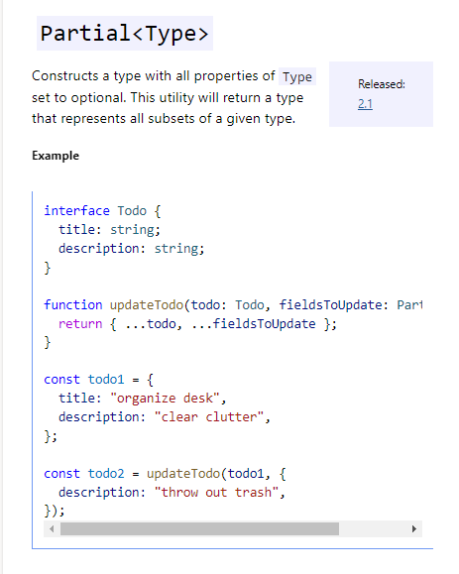

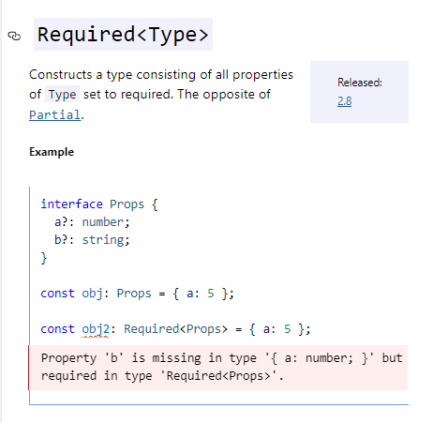

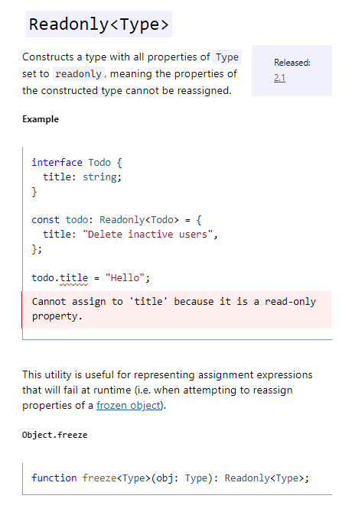

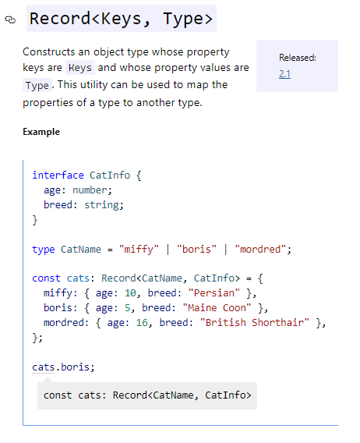

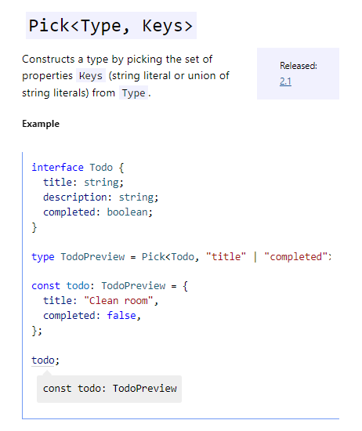

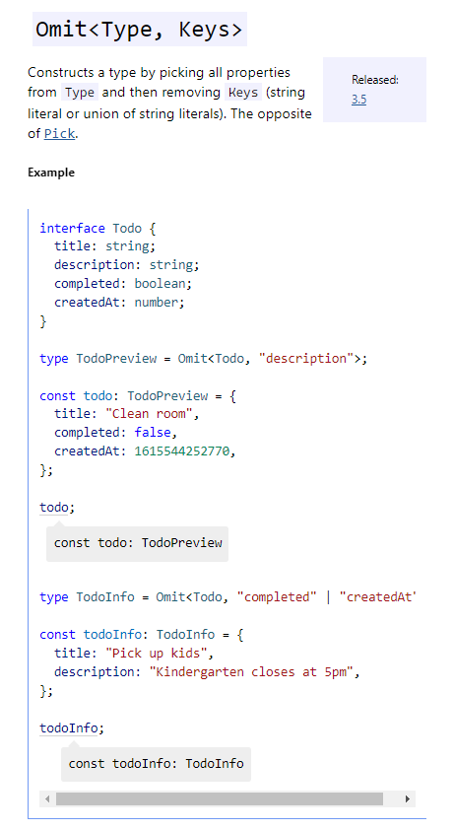

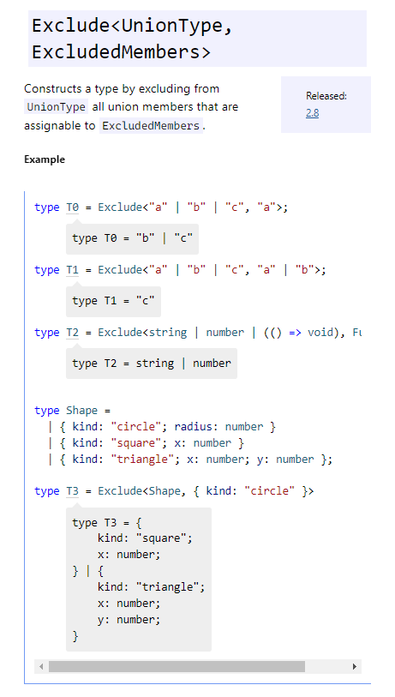

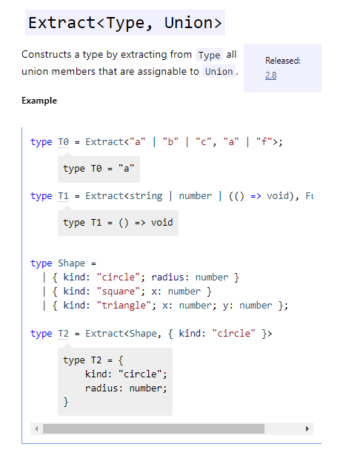

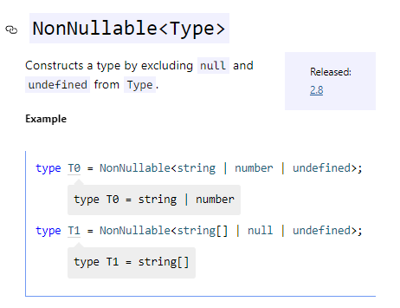

Generic Utility Types

Saturday, April 13, 2024

10:03 AM

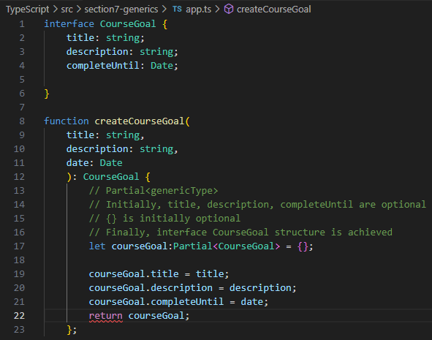

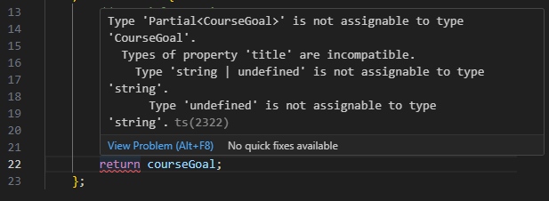

// use Type Casting to fix this type 'undefined' is not assignable to type 'string' issue

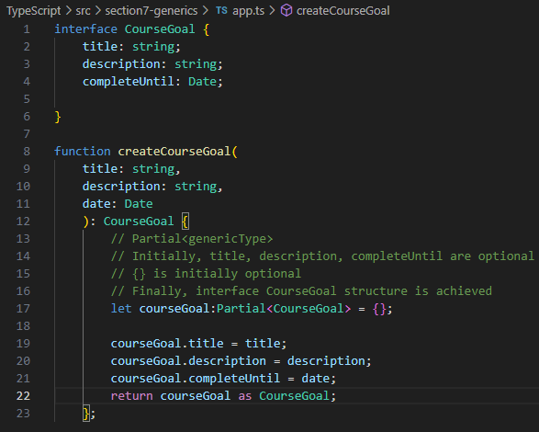

// Readonly type + Generic Type

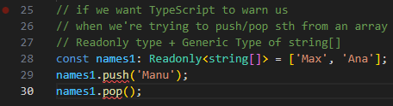

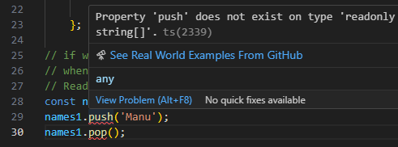

// **Partial<genericType> to open things up**

// **Readonly<genericType> to lock things up**

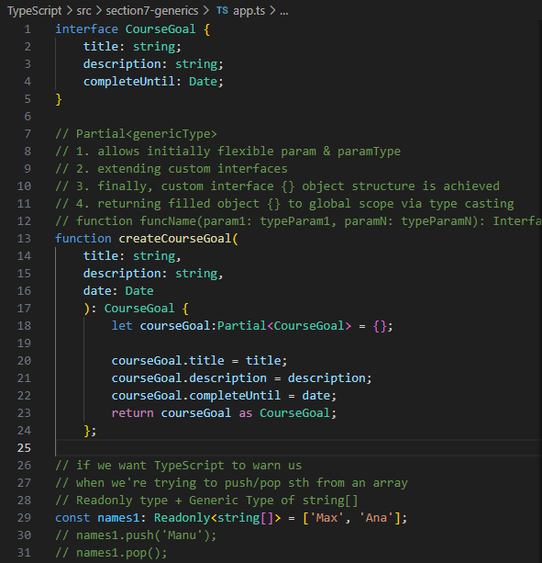

Generic Type vs Union Type

Saturday, April 13, 2024

8:24 PM

1

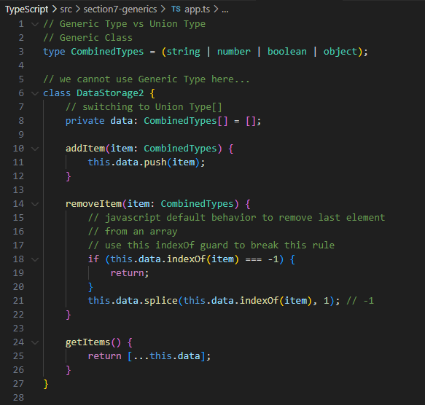

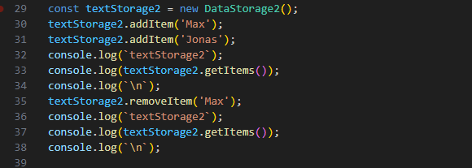

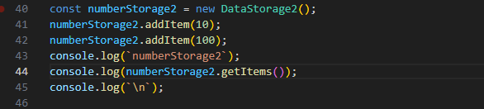

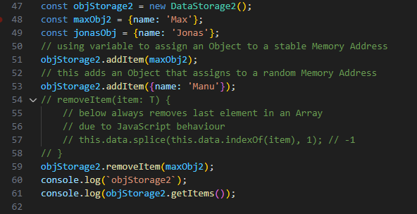

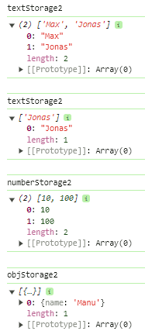

more exercises

Saturday, April 13, 2024

9:06 PM

// perfect case of Generics = flexible parsed arguments

// precise type mapping at the end ;)

// using custom Union Types can precisely address flexible types of parsed arrays

// Approach 1 => Union Types

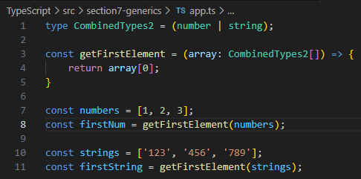

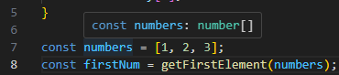

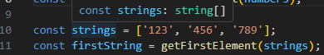

// Approach 2 => Generic Types

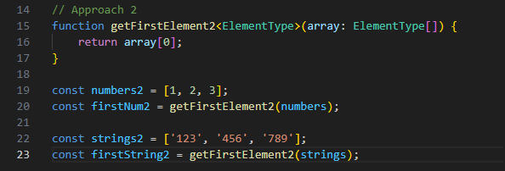

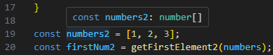

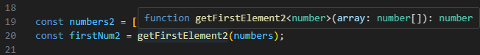

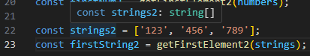

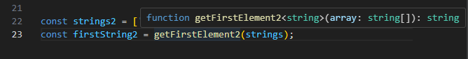

// using more Complicated yet Flexible Generic Functions

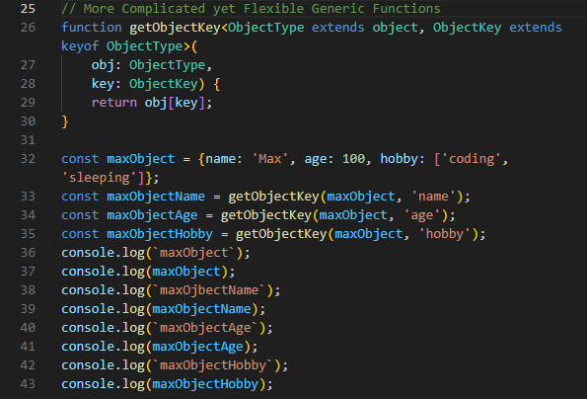

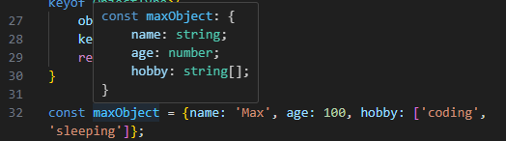

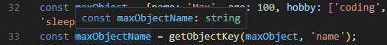

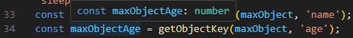

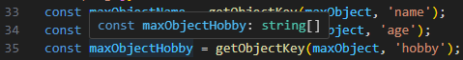

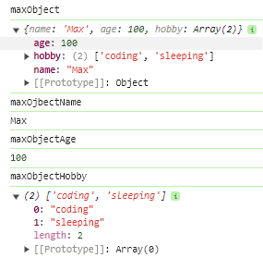

useful resources

Monday, April 15, 2024

5:13 PM

<https://www.typescriptlang.org/docs/handbook/generics.html>

=== Decorators

Saturday, April 13, 2024

10:07 PM

Meta-Programming

Not often use Decorators, particularly well suited for use by other developers

** Allow Use of Decorators in TypeScript

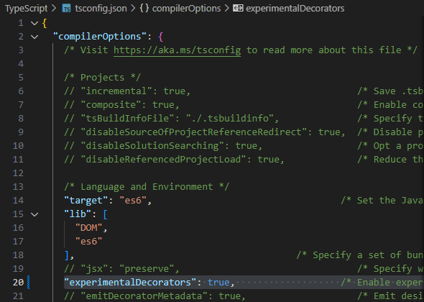

First Class Decorator

Saturday, April 13, 2024

10:09 PM

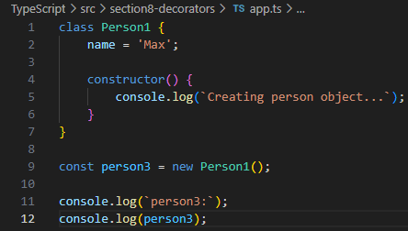

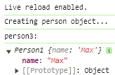

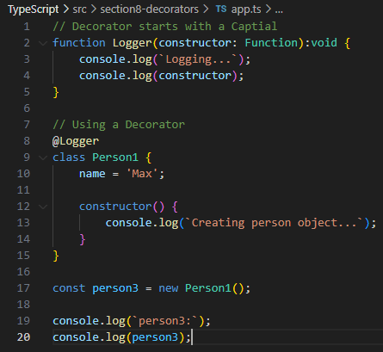

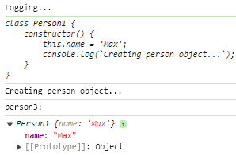

Decorator factories

Saturday, April 13, 2024

10:36 PM

// Decorator factories = a Decorator returning a function

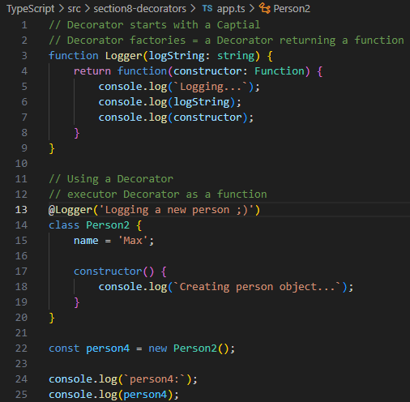

// this adds more power to a Decorator

// allow more specific configuration of what a decorator does internally

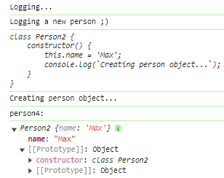

Templating Decorator

Saturday, April 13, 2024

10:42 PM

index.html:

// this should render an input element only

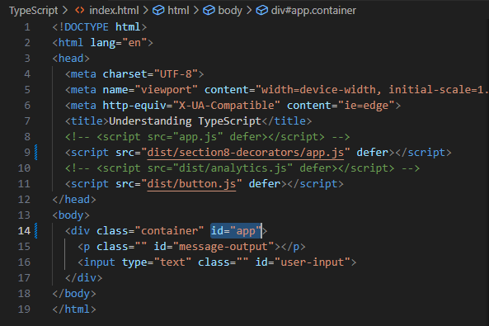

// using a Decorator for templating a webhook element to index.html

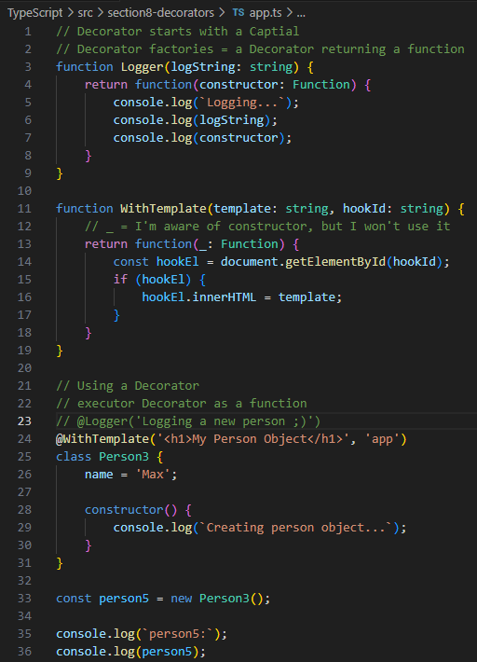

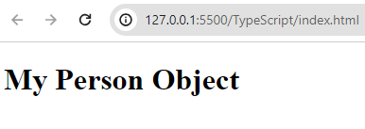

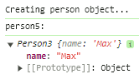

// we can even instantiate an Object => webhook object.name

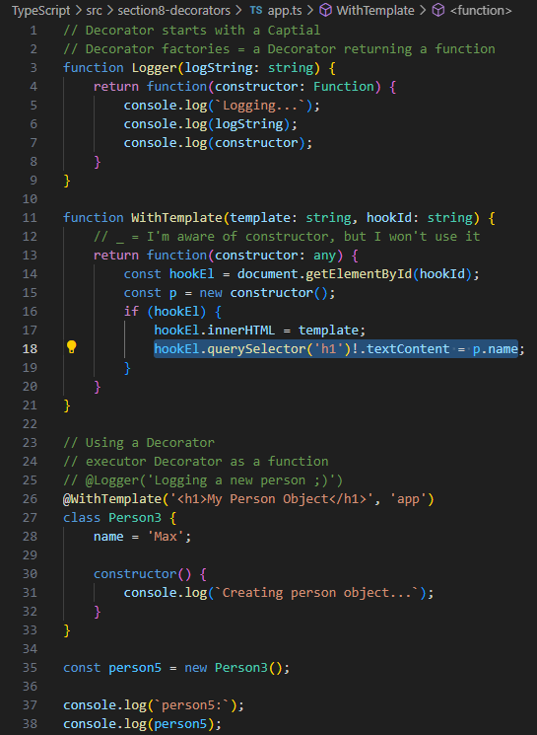

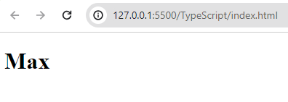

** similar usage = Angular Decorators

Multiple Decorators

Sunday, April 14, 2024

11:32 PM

** Decorators are executed bottom up

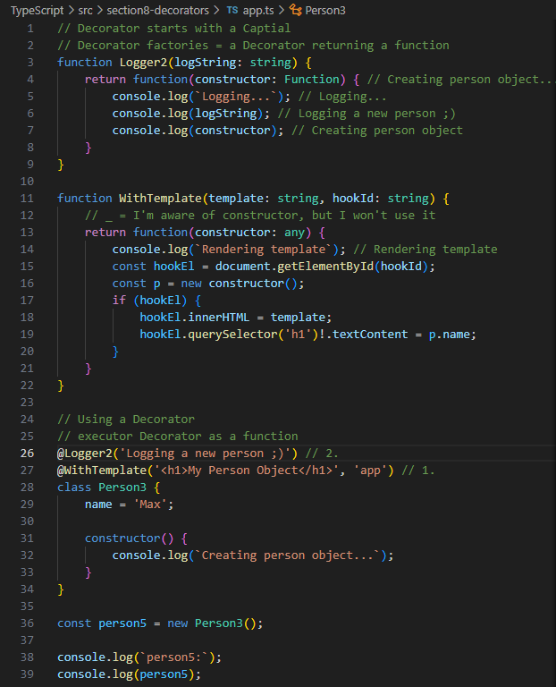

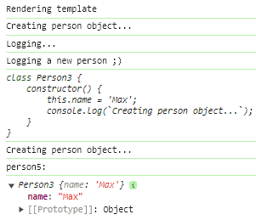

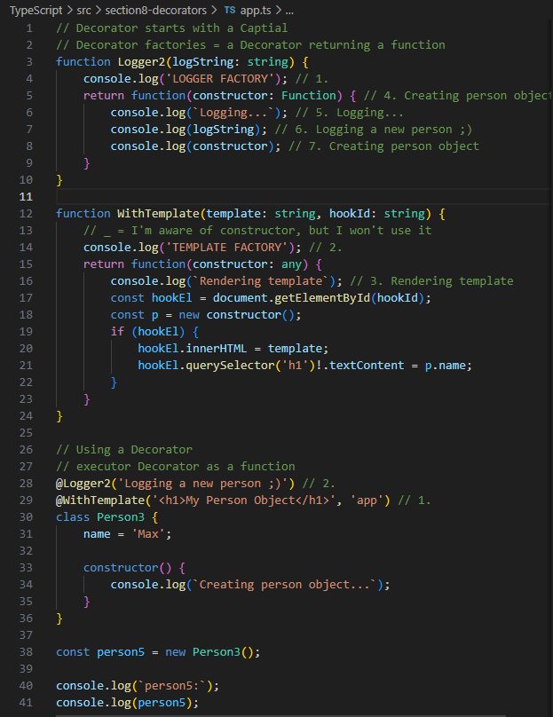

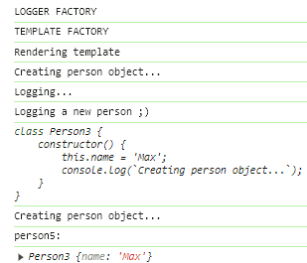

Property Decorator

Sunday, April 14, 2024

11:45 PM

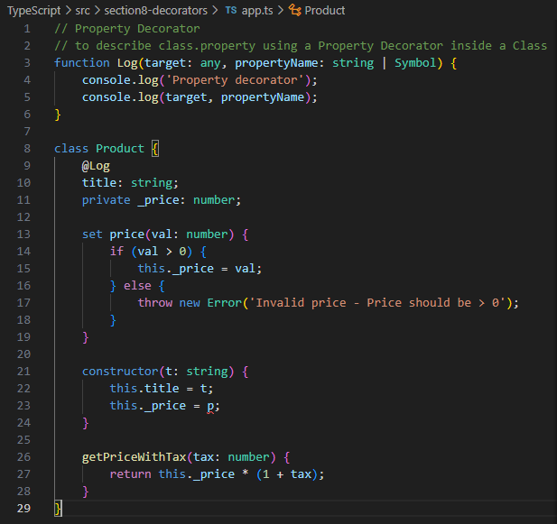

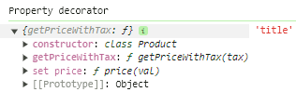

Property + Accessor + Method Decorators

Sunday, April 14, 2024

11:50 PM

// adding Accessor Decorator as Log2()

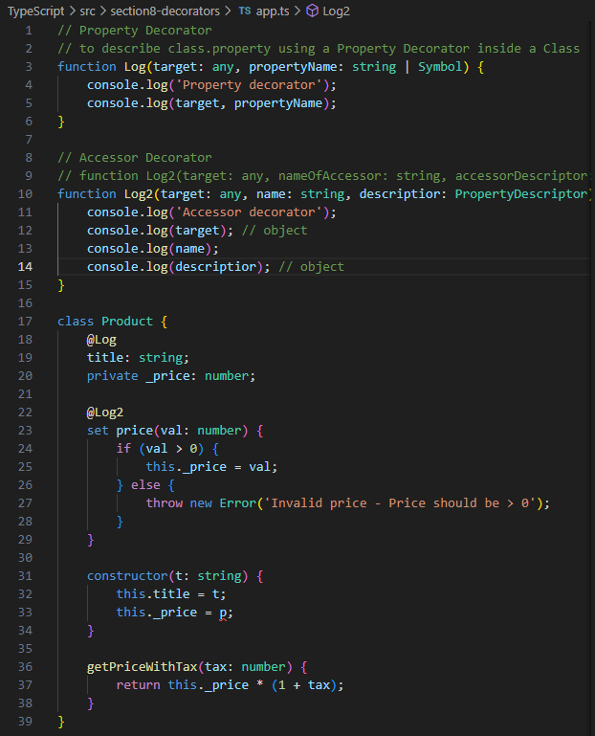

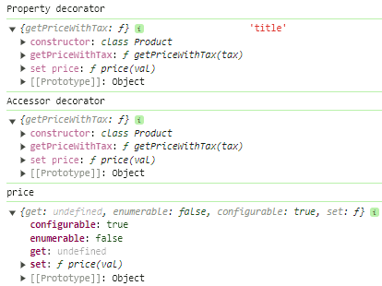

// adding Method Decorator as Log3()

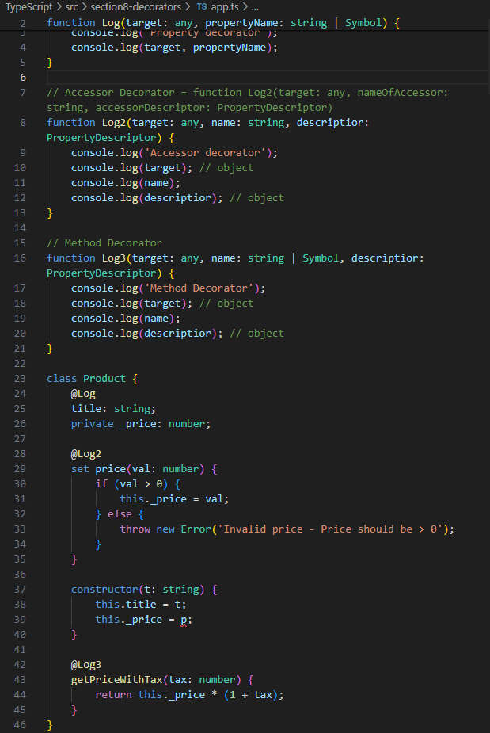

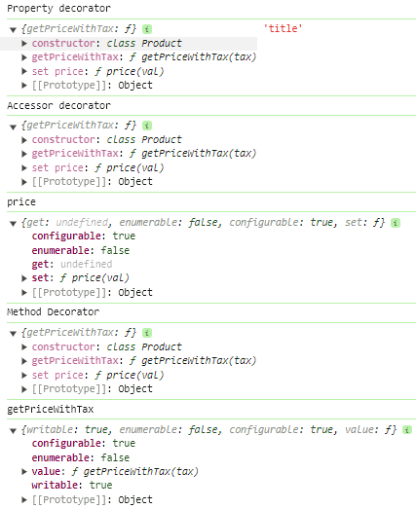

// adding position parameter as Log4()

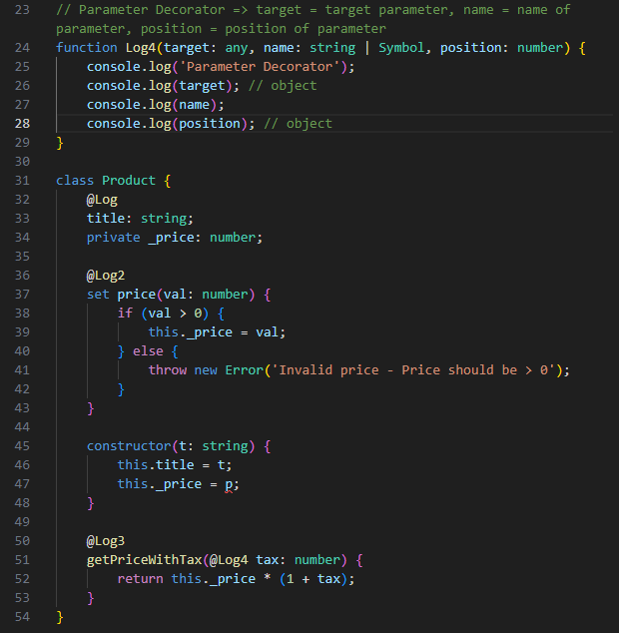

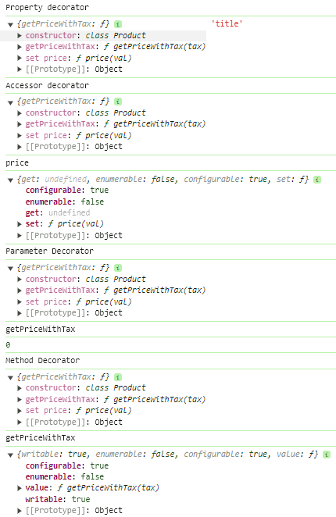

Instantiation of Class does NOT matter for Decorators

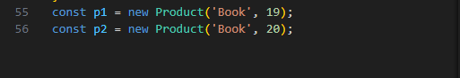

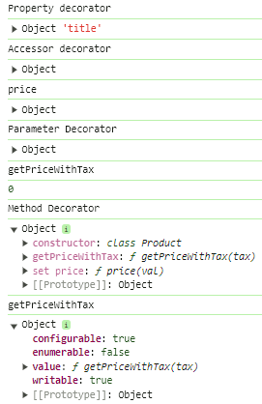

Returning & Changing a Class in a Class Decorator

Monday, April 15, 2024

11:48 AM

1

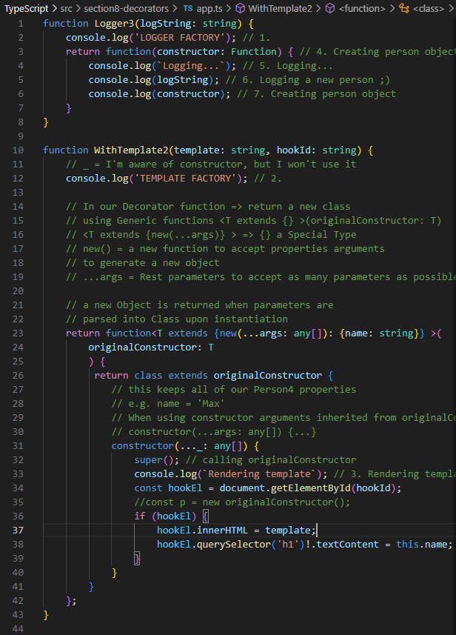

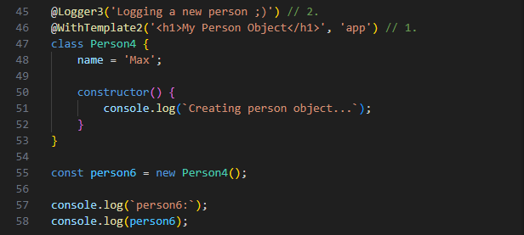

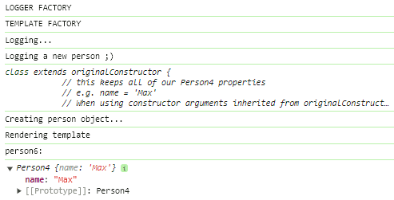

// now, if we do NOT instantiate a Class

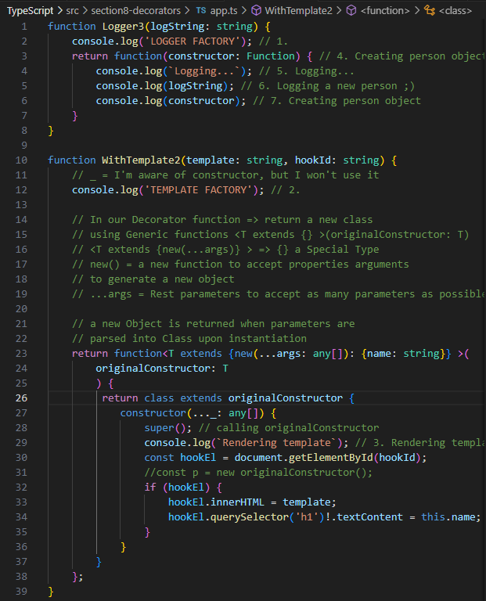

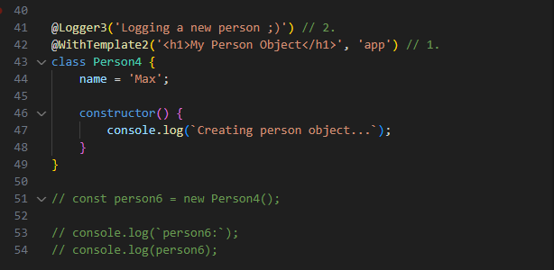

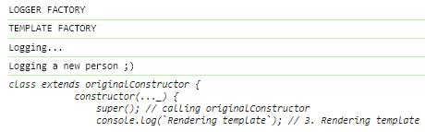

autobind Decorator

Monday, April 15, 2024

3:33 PM

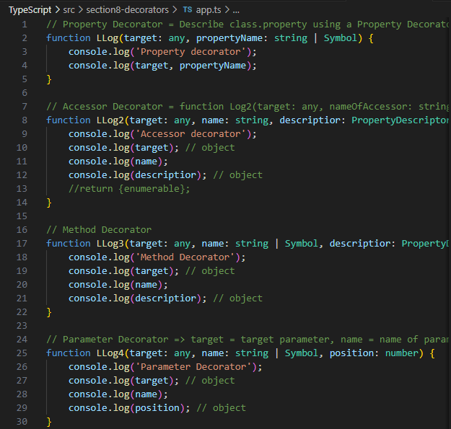

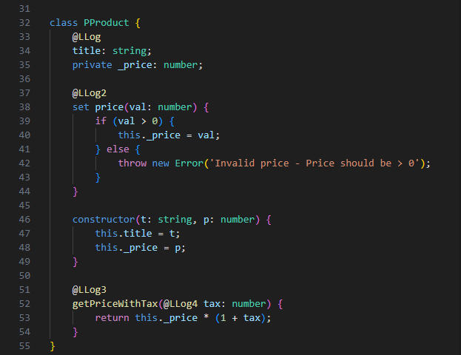

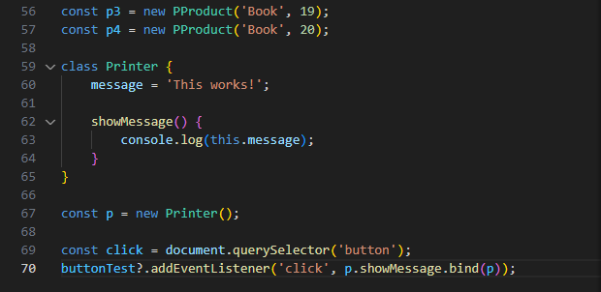

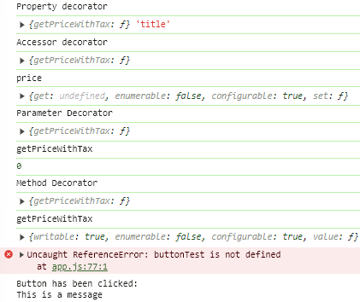

// create an Autobind Decorator()

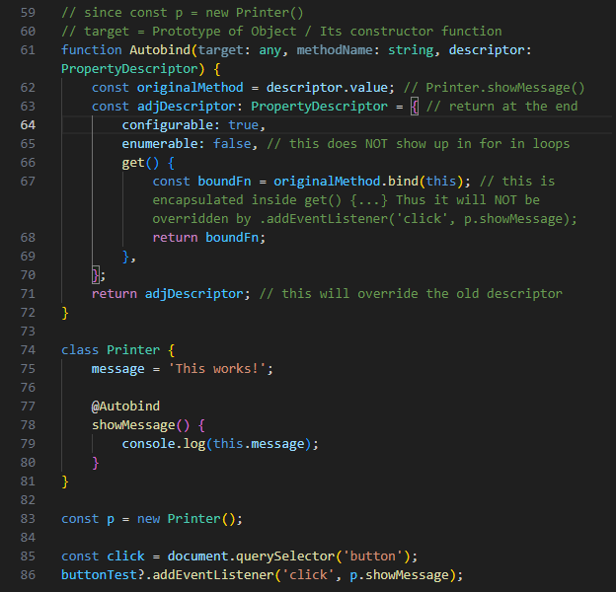

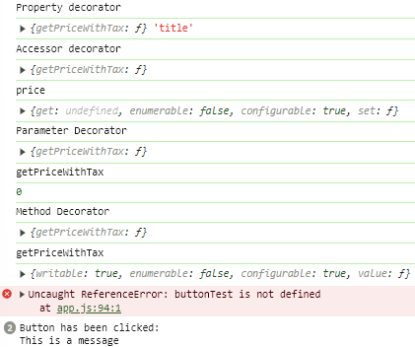

validation with Decorator - First Steps

Monday, April 15, 2024

4:04 PM

// schematic HTML validations using a Decorator

// let's create an ugly form for experiments :D

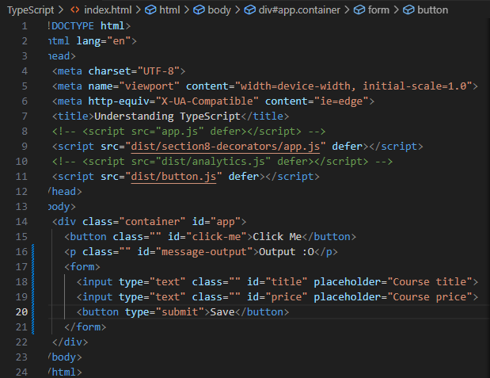

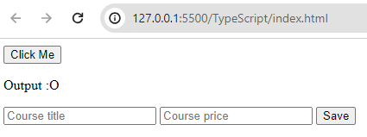

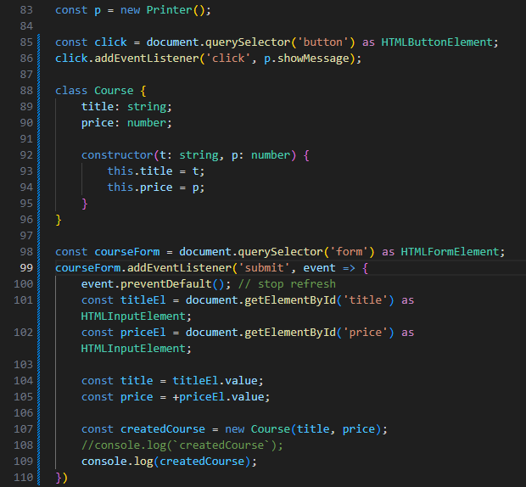

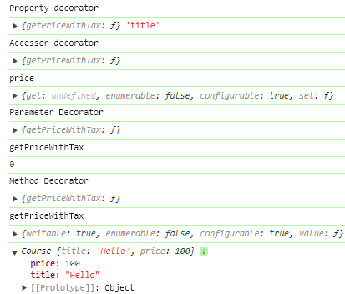

===

**High-level planning**

**we'd like to validate input.value != '' when Save is clicked**

// we'd like to create 3 Decorators for validating

// function RequiredString() {...} => Course.title: string

// function PositiveNumber() {...} => Course.price: number

// function validate(obj: object) {...} => const createdCourse = new Course(title, price);

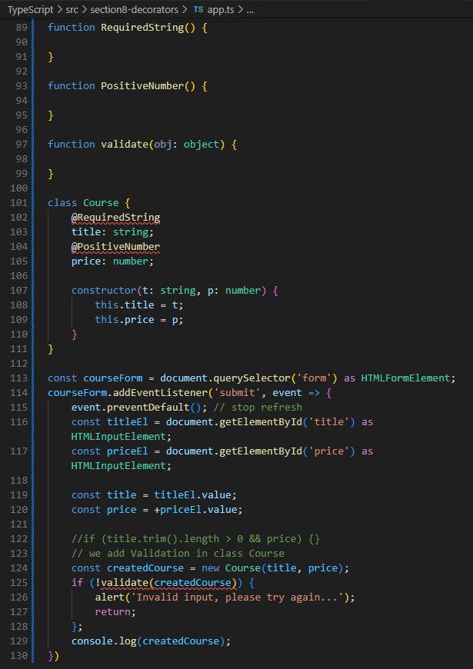

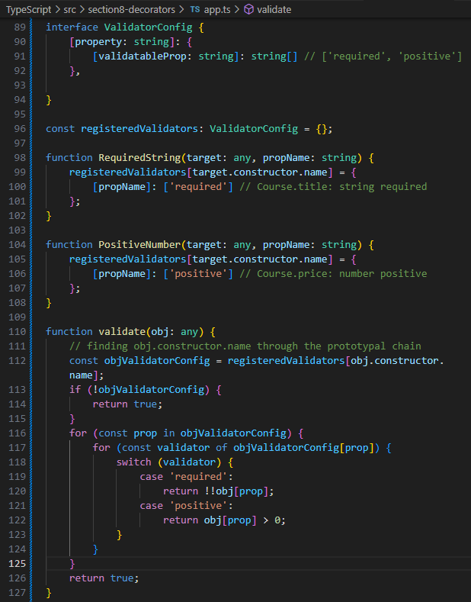

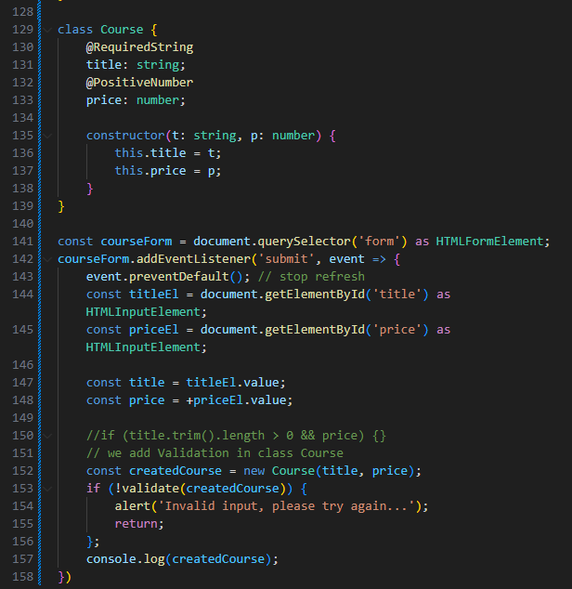

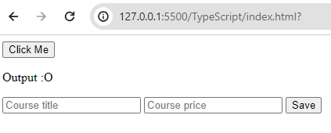

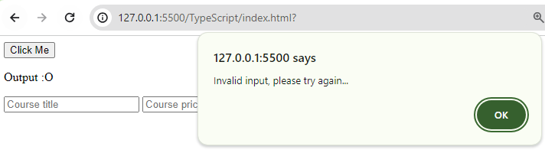

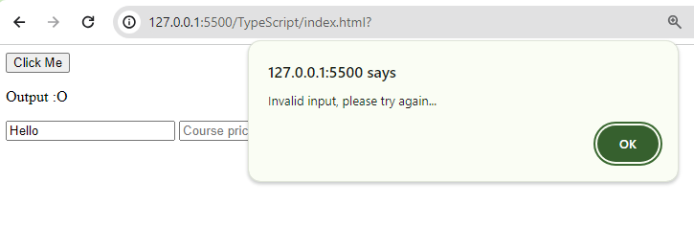

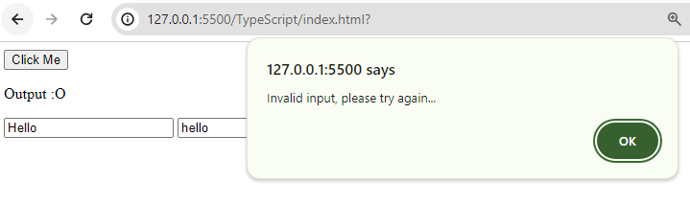

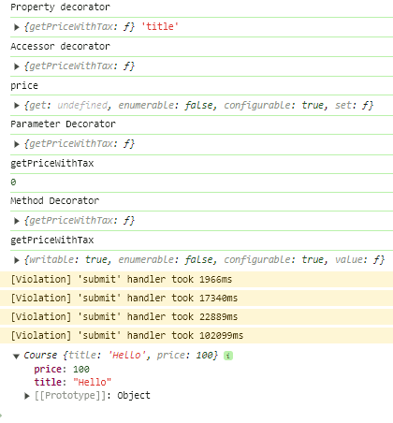

// however this function validate(obj: any) {...} does NOT check against each

// class.property

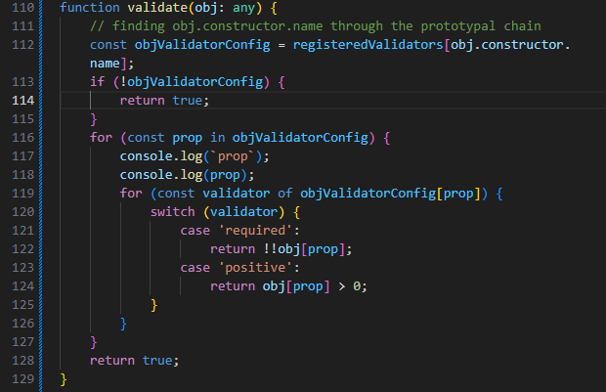

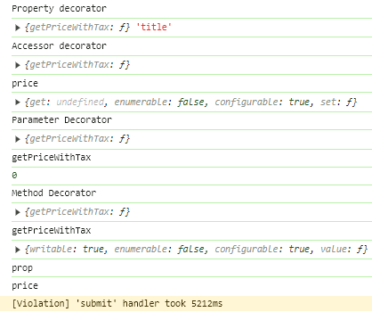

// ** this does check against each class.property before returning true/false

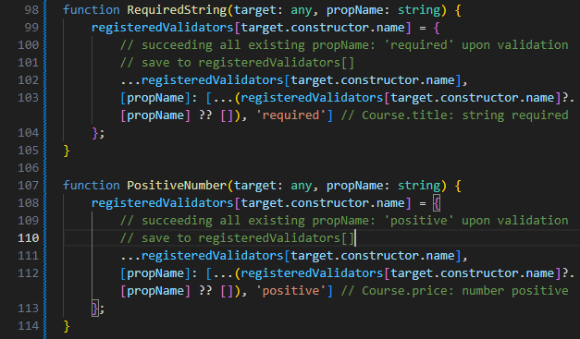

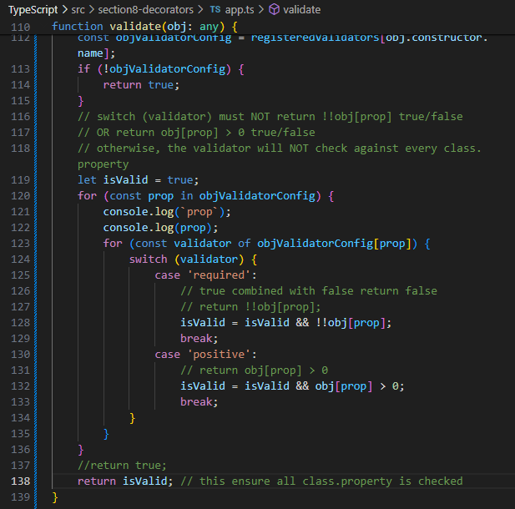

useful resources

Saturday, April 13, 2024

8:38 PM

<https://www.typescriptlang.org/docs/handbook/decorators.html>

=== Practice

Monday, April 15, 2024

5:13 PM

Using Vanilla TypeScript + JavaScript default methods to query select HTMLElements + OOP to render templates similar to Angular

DOM Element Selection + OOP Rendering

Monday, April 15, 2024

6:13 PM

index.html

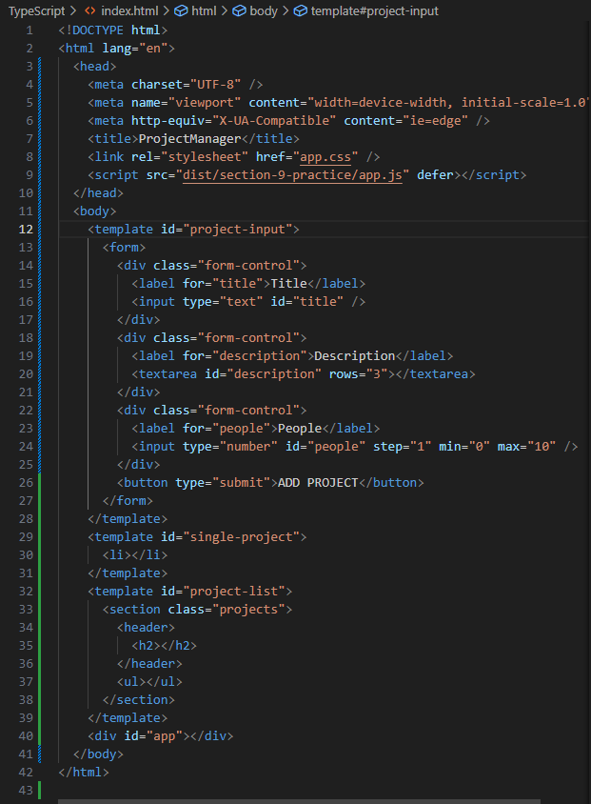

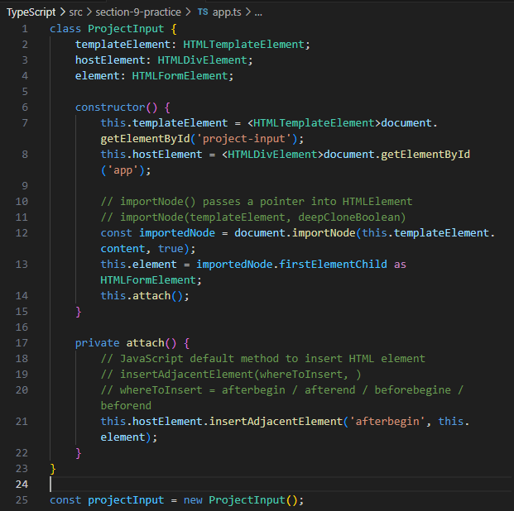

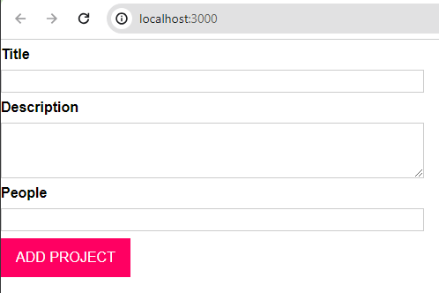

// to inject app.css #user-input styling using TypeScript DOM manipulation

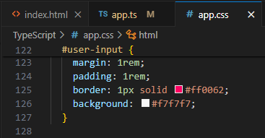

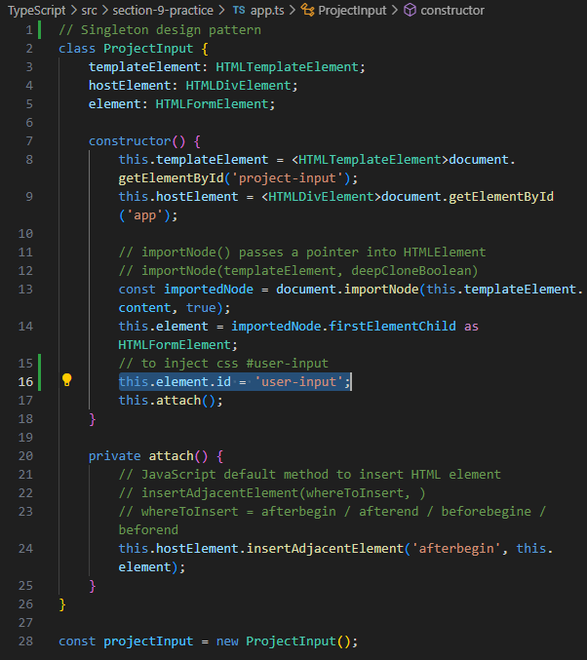

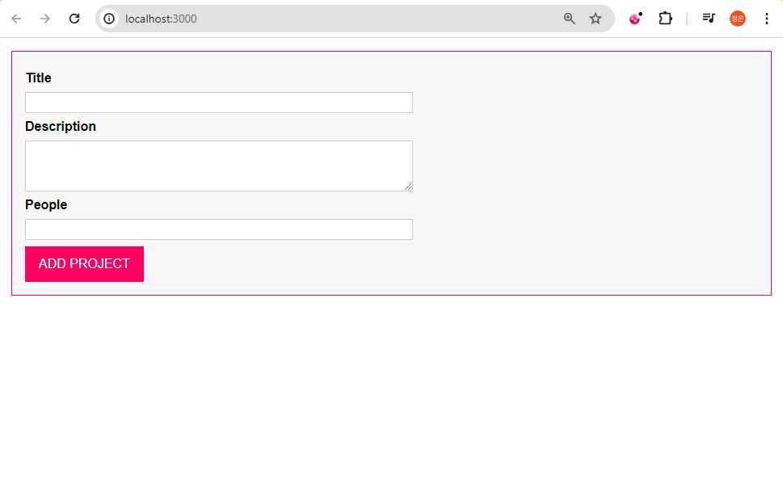

Interacting with DOM elements

Tuesday, April 16, 2024

10:34 AM

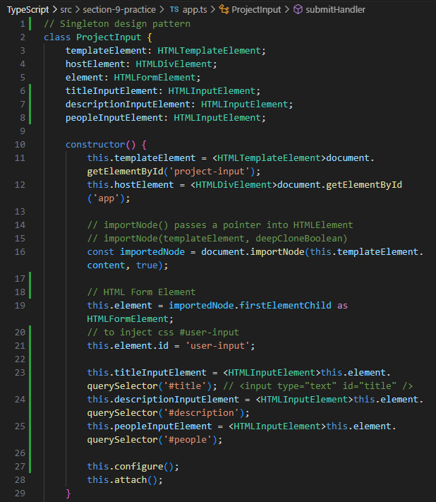

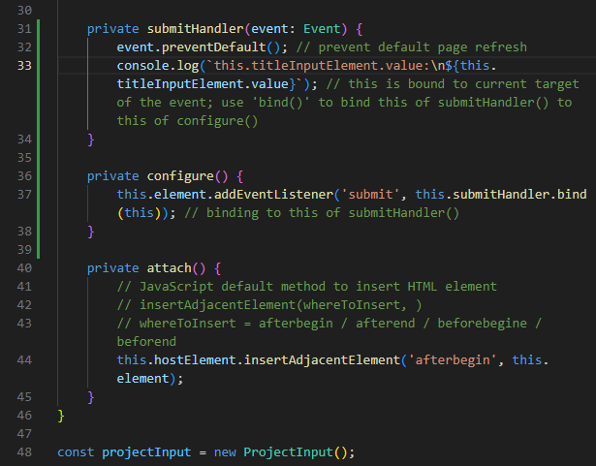

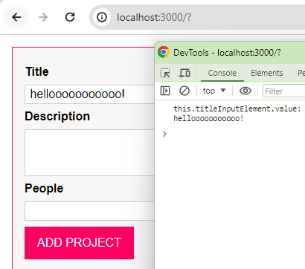

creating an Autobind Decorator

Tuesday, April 16, 2024

10:47 AM

// we need an Autobind Decorator to bind this of submitHandler() to this of configure()

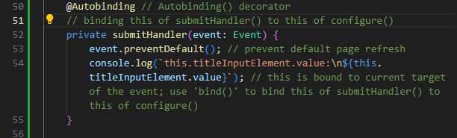

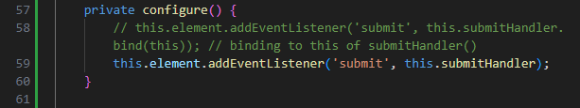

// creating our Autobind()

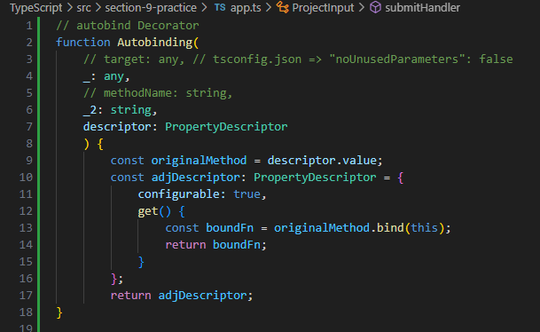

tsconfig.json:

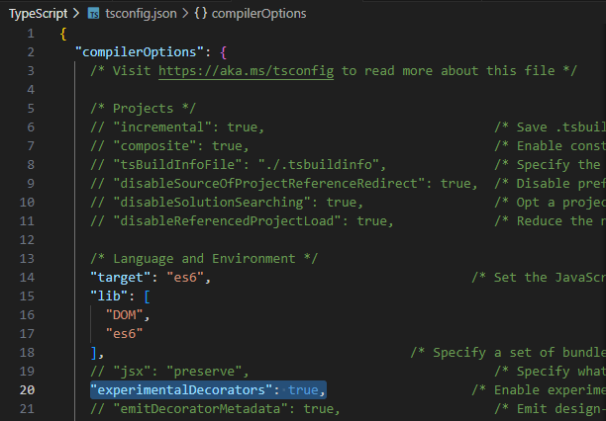

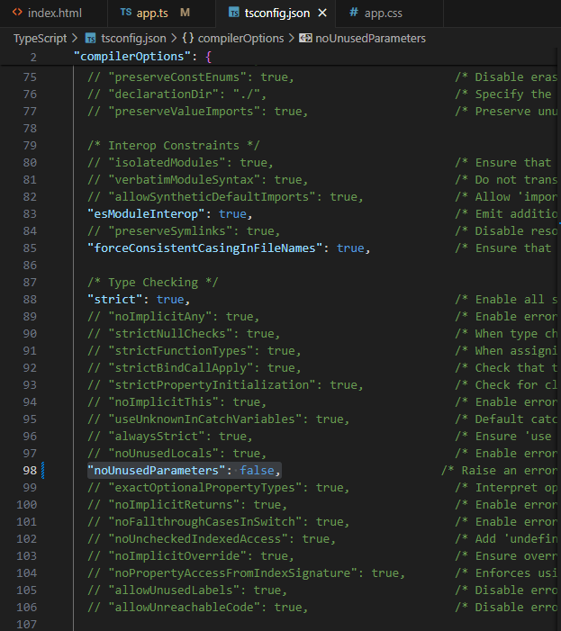

app.ts:

// autobind Decorator

function Autobinding(

    // target: any, // tsconfig.json => "noUnusedParameters": false

    _: any,

    // methodName: string,

    _2: string,

    descriptor: PropertyDescriptor

    ) {

        const originalMethod = descriptor.value;

        const adjDescriptor: PropertyDescriptor = {

            configurable: true,

            get() {

                const boundFn = originalMethod.bind(this);

                return boundFn;

            }

        };

        return adjDescriptor;

}

// Singleton design pattern

class ProjectInput {

    templateElement: HTMLTemplateElement;

    hostElement: HTMLDivElement;

    element: HTMLFormElement;

    titleInputElement: HTMLInputElement;

    descriptionInputElement: HTMLInputElement;

    peopleInputElement: HTMLInputElement;

    constructor() {

        this.templateElement = <HTMLTemplateElement>document.getElementById('project-input');

        this.hostElement = <HTMLDivElement>document.getElementById('app');

        // importNode() passes a pointer into HTMLElement

        // importNode(templateElement, deepCloneBoolean)

        const importedNode = document.importNode(this.templateElement.content, true);

        // HTML Form Element

        this.element = importedNode.firstElementChild as HTMLFormElement;

        // to inject css #user-input

        this.element.id = 'user-input';

        this.titleInputElement = <HTMLInputElement>this.element.querySelector('#title'); // <input type="text" id="title" />

        this.descriptionInputElement = <HTMLInputElement>this.element.querySelector('#description');

        this.peopleInputElement = <HTMLInputElement>this.element.querySelector('#people');

        this.configure();

        this.attach();

    }

    @Autobinding // Autobinding() decorator

    // binding this of submitHandler() to this of configure()

    private submitHandler(event: Event) {

        event.preventDefault(); // prevent default page refresh

        console.log(`this.titleInputElement.value:\n${this.titleInputElement.value}`); // this is bound to current target of the event; use 'bind()' to bind this of submitHandler() to this of configure()

    }

    private configure() {

        // this.element.addEventListener('submit', this.submitHandler.bind(this)); // binding to this of submitHandler()

        this.element.addEventListener('submit', this.submitHandler);

    }

    private attach() {

        // JavaScript default method to insert HTML element

        // insertAdjacentElement(whereToInsert, )

        // whereToInsert = afterbegin / afterend / beforebegine / beforend

        this.hostElement.insertAdjacentElement('afterbegin', this.element);

    }

}

const projectInput = new ProjectInput();

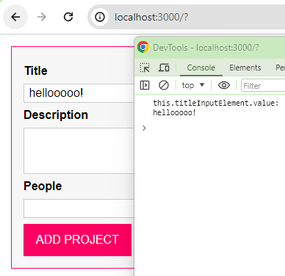

Fetching User inputs

Tuesday, April 16, 2024

11:31 AM

// creating a new private class that can only be used inside our class ProjectInput {...} to return either void OR return a Tuple [enteredTitle, enteredDescription, enteredPeople] to be called by our @Autobinding private submitHandler(event: Event) {...}

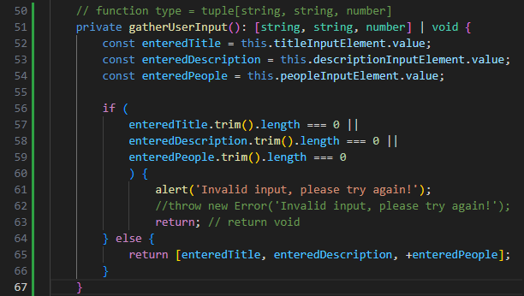

// @Autobinding private submitHandler(event: Event) {

// const userInput = this.gatherUserInput(); // call back gatherUserInput()

// if (Array.isArray(userInput) {

// using destructuring to retrieve individual parameter

// const [title, description, people] = userInput;

// }

// }

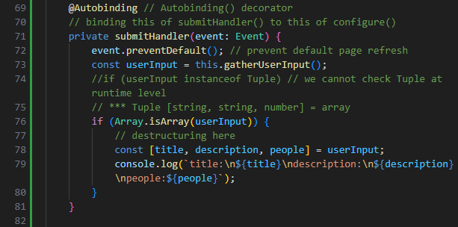

// autobind Decorator

function Autobinding(

    // target: any, // tsconfig.json => "noUnusedParameters": false

    _: any,

    // methodName: string,

    _2: string,

    descriptor: PropertyDescriptor

    ) {

        const originalMethod = descriptor.value;

        const adjDescriptor: PropertyDescriptor = {

            configurable: true,

            get() {

                const boundFn = originalMethod.bind(this);

                return boundFn;

            }

        };

        return adjDescriptor;

}

// Singleton design pattern

class ProjectInput {

    templateElement: HTMLTemplateElement;

    hostElement: HTMLDivElement;

    element: HTMLFormElement;

    titleInputElement: HTMLInputElement;

    descriptionInputElement: HTMLInputElement;

    peopleInputElement: HTMLInputElement;

    constructor() {

        this.templateElement = <HTMLTemplateElement>document.getElementById('project-input');

        this.hostElement = <HTMLDivElement>document.getElementById('app');

        // importNode() passes a pointer into HTMLElement

        // importNode(templateElement, deepCloneBoolean)

        const importedNode = document.importNode(this.templateElement.content, true);

        // HTML Form Element

        this.element = importedNode.firstElementChild as HTMLFormElement;

        // to inject css #user-input

        this.element.id = 'user-input';

        this.titleInputElement = <HTMLInputElement>this.element.querySelector('#title'); // <input type="text" id="title" />

        this.descriptionInputElement = <HTMLInputElement>this.element.querySelector('#description');

        this.peopleInputElement = <HTMLInputElement>this.element.querySelector('#people');

        this.configure();

        this.attach();

    }

    // function type = tuple[string, string, number]

    private gatherUserInput(): [string, string, number] | void {

        const enteredTitle = this.titleInputElement.value;

        const enteredDescription = this.descriptionInputElement.value;

        const enteredPeople = this.peopleInputElement.value;

        if (

            enteredTitle.trim().length === 0 ||

            enteredDescription.trim().length === 0 ||

            enteredPeople.trim().length === 0

            ) {

                alert('Invalid input, please try again!');

                //throw new Error('Invalid input, please try again!');

                return; // return void

        } else {

            return [enteredTitle, enteredDescription, +enteredPeople];

        }

    }

    @Autobinding // Autobinding() decorator

    // binding this of submitHandler() to this of configure()

    private submitHandler(event: Event) {

        event.preventDefault(); // prevent default page refresh

        const userInput = this.gatherUserInput();

        //if (userInput instanceof Tuple) // we cannot check Tuple at runtime level

        // *** Tuple [string, string, number] = array

        if (Array.isArray(userInput)) {

            // destructuring here

            const [title, description, people] = userInput;

            console.log(`title:\n${title}\ndescription:\n${description}\npeople:${people}`);

        }

    }

    private configure() {

        // this.element.addEventListener('submit', this.submitHandler.bind(this)); // binding to this of submitHandler()

        this.element.addEventListener('submit', this.submitHandler);

    }

    private attach() {

        // JavaScript default method to insert HTML element

        // insertAdjacentElement(whereToInsert, )

        // whereToInsert = afterbegin / afterend / beforebegine / beforend

        this.hostElement.insertAdjacentElement('afterbegin', this.element);

    }

}

const projectInput = new ProjectInput();

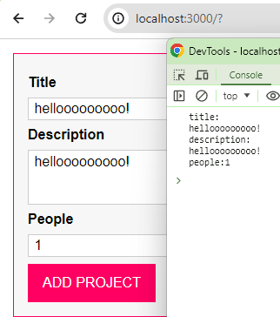

// we'd like to clear user inputs too upon form submit

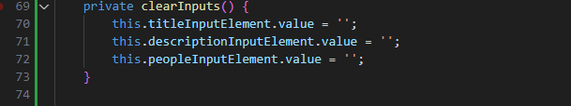

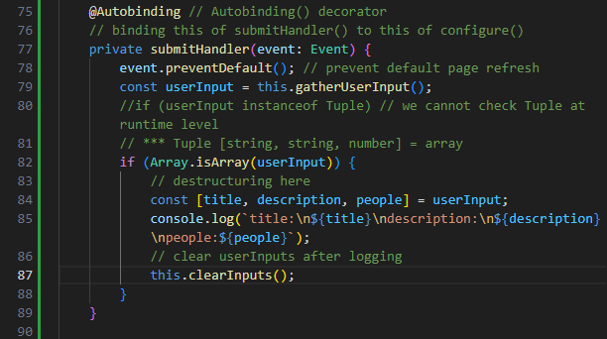

Creating a Re-usable Validation Functionality

Tuesday, April 16, 2024

12:04 PM

// first, we create a Validation Logic Interface

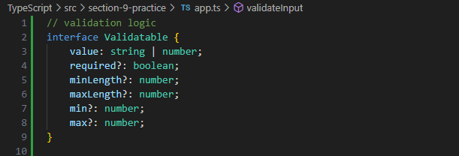

// then, create a validateInput function using interface Validate {...} as Blue-print

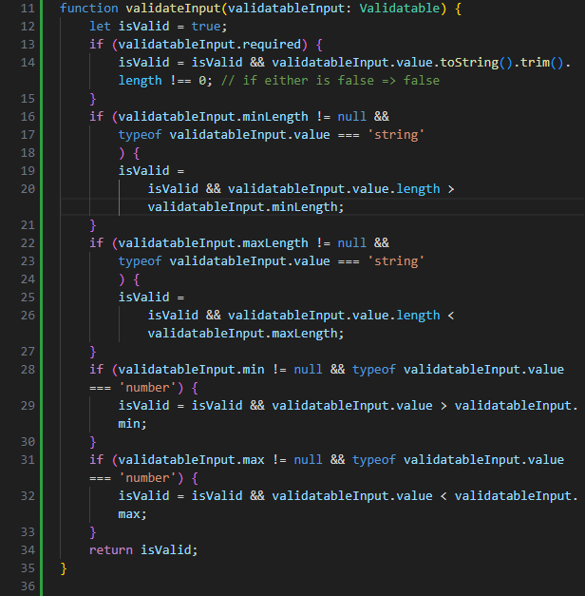

// we modify our previous private gatherUserInput(): returnType

// returnType can be [string, string, number] | void

// returnType = void

if any of below returns !(false) => true

!validateInput(titleValidatable) || !validateInput(descriptionValidatable) || !validateInput(peopleValidatable) returns false

alert('Invalid input, please try again!');

return;

else {

return [enteredTitle, enteredDescription, +enteredPeople];

}

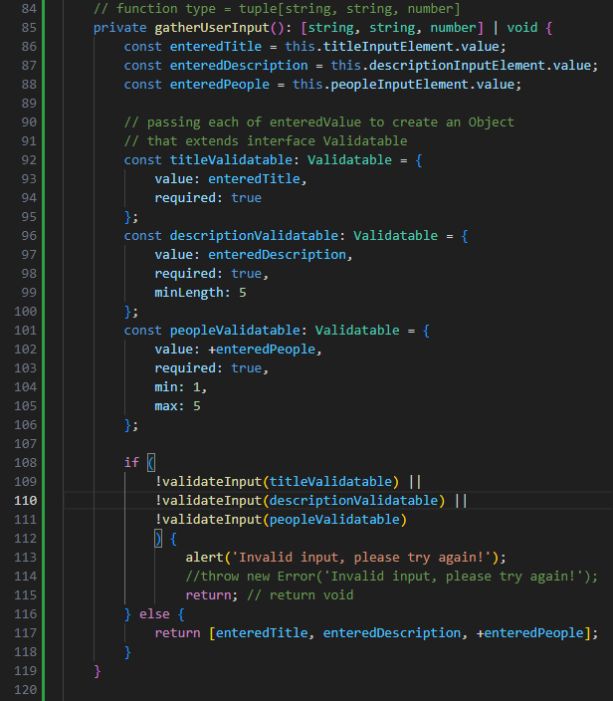

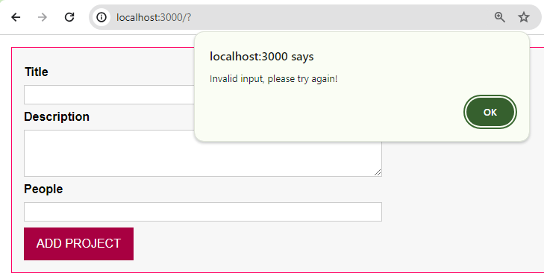

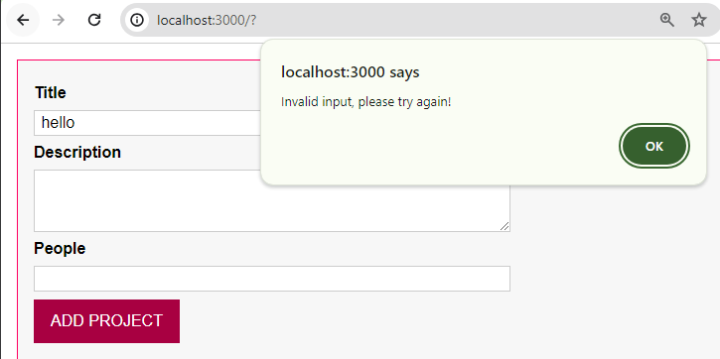

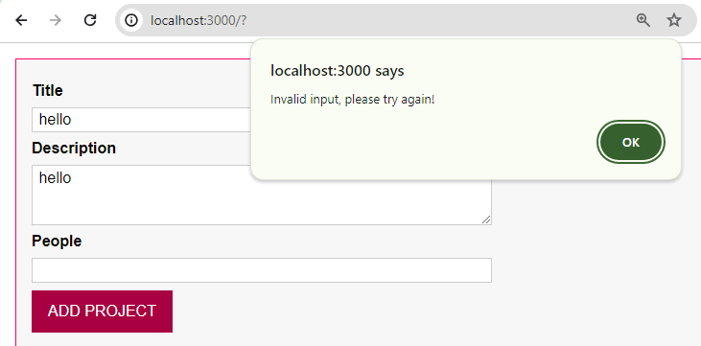

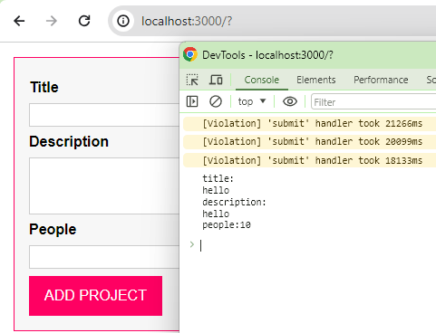

Rendering Project Lists

Tuesday, April 16, 2024

2:37 PM

app.ts:

// Project State Management similar to Redux for React || NgRx for Angular

class ProjectState {

    private listeners: any[] = []; // array of Functions

    private projects: any[] = [];

    private static instance: ProjectState;

    private constructor() {

    }

    // global only has 1 instance of ProjectState

    static getInstance() {

        if (this.instance) {

            return this.instance;

        }

        this.instance = new ProjectState();

        return this.instance;

    }

    // used whenever project changes e.g. adding a new project

    addListener(listenerFn: Function) {

        this.listeners.push(listenerFn);

    }

    addProject(title: string, description: string, numOfPeople: number) {

        const newProject = {

            id: Math.random().toString(),

            title: title,

            description: description,

            people: numOfPeople

        };

        this.projects.push(newProject);

        for (const listenerFn of this.listeners) {

            // only parse in a copy of this.projects

            // every listenerFn getting executed &

            // gets our brand new copy of projects

            listenerFn(this.projects.slice());

        }

    }

}

// global only has 1 instance of ProjectState

const projectState = ProjectState.getInstance();

// validation logic

interface Validatable {

    value: string | number;

    required?: boolean;

    minLength?: number;

    maxLength?: number;

    min?: number;

    max?: number;

}

function validateInput(validatableInput: Validatable) {

    let isValid = true;

    if (validatableInput.required) {

        isValid = isValid && validatableInput.value.toString().trim().length !== 0; // true && false => false

    }

    if (validatableInput.minLength != null &&

        typeof validatableInput.value === 'string'

        ) {

        isValid = isValid && validatableInput.value.length >= validatableInput.minLength;

    }

    if (validatableInput.maxLength != null &&

        typeof validatableInput.value === 'string'

        ) {

        isValid = isValid && validatableInput.value.length <= validatableInput.maxLength;

    }

    if (validatableInput.min != null && typeof validatableInput.value === 'number') {

        isValid = isValid && validatableInput.value >= validatableInput.min;

    }

    if (validatableInput.max != null && typeof validatableInput.value === 'number') {

        isValid = isValid && validatableInput.value <= validatableInput.max;

    }

    return isValid;

}

// autobind Decorator

function Autobinding(

    // target: any, // tsconfig.json => "noUnusedParameters": false

    _: any,

    // methodName: string,

    _2: string,

    descriptor: PropertyDescriptor

    ) {

        const originalMethod = descriptor.value;

        const adjDescriptor: PropertyDescriptor = {

            configurable: true,

            get() {

                const boundFn = originalMethod.bind(this);

                return boundFn;

            }

        };

        return adjDescriptor;

}

// ProjectList Class

class ProjectList {

    templateElement: HTMLTemplateElement;

    hostElement: HTMLDivElement;

    element: HTMLElement;

    assignedProjects: any[];

    constructor(private type: 'active' | 'finished') {

        this.templateElement = <HTMLTemplateElement>document.getElementById('project-list');

        this.hostElement = <HTMLDivElement>document.getElementById('app');

        this.assignedProjects = [];

        // importNode() passes a pointer into HTMLElement

        // importNode(templateElement, deepCloneBoolean)

        const importedNode = document.importNode(

            this.templateElement.content,

            true

            );

        // HTML Form Element

        this.element = importedNode.firstElementChild as HTMLElement; // <section class="projects">

        // need a dynamic value for a number of lists of projects

        // to inject relevant css based on type of listed projects

        this.element.id = `${this.type}-projects`;

        // to register a listener function

        projectState.addListener((projects: any[]) => {

            this.assignedProjects = projects;

            this.renderProjects();

        });

        this.attach();

        this.renderContent();

    }

    private renderProjects() {

        const listEl = <HTMLUListElement>document.getElementById(`${this.type}-projects-list`);

        for (const projectItem of this.assignedProjects) {

            const listItem = document.createElement('li');

            listItem.textContent = projectItem.title;

            listEl.appendChild(listItem);

        }

    }

    private renderContent() {

        // fill blank spaces in template with some lives

        const listId = `${this.type}-projects-list`;

        this.element.querySelector('ul')!.id = listId;

        // selecting <h2></h2>

        this.element.querySelector('h2')!.textContent = this.type.toUpperCase() + 'PROJECTS';

    }

    private attach() {

        // <ul></ul> is before end of </section>

        this.hostElement.insertAdjacentElement('beforeend', this.element);

    }

}

// Singleton design pattern

class ProjectInput {

    templateElement: HTMLTemplateElement;

    hostElement: HTMLDivElement;

    element: HTMLFormElement;

    titleInputElement: HTMLInputElement;

    descriptionInputElement: HTMLInputElement;

    peopleInputElement: HTMLInputElement;

    constructor() {

        this.templateElement = <HTMLTemplateElement>document.getElementById('project-input');

        this.hostElement = <HTMLDivElement>document.getElementById('app');

        // importNode() passes a pointer into HTMLElement

        // importNode(templateElement, deepCloneBoolean)

        const importedNode = document.importNode(

            this.templateElement.content,

            true

        );

        // HTML Form Element

        this.element = importedNode.firstElementChild as HTMLFormElement;

        // to inject css #user-input

        this.element.id = 'user-input';

        this.titleInputElement = <HTMLInputElement>this.element.querySelector('#title'); // <input type="text" id="title" />

        this.descriptionInputElement = <HTMLInputElement>this.element.querySelector('#description');

        this.peopleInputElement = <HTMLInputElement>this.element.querySelector('#people');

        this.configure();

        this.attach();

    }

    // function type = tuple[string, string, number]

    private gatherUserInput(): [string, string, number] | void {

        const enteredTitle = this.titleInputElement.value;

        const enteredDescription = this.descriptionInputElement.value;

        const enteredPeople = this.peopleInputElement.value;

        // passing each of enteredValue to create an Object

        // that extends interface Validatable

        const titleValidatable: Validatable = {

            value: enteredTitle,

            required: true

        };

        const descriptionValidatable: Validatable = {

            value: enteredDescription,

            required: true,

            minLength: 5

        };

        const peopleValidatable: Validatable = {

            value: +enteredPeople,

            required: true,

            min: 1,

            max: 10

        };

        if (

            !validateInput(titleValidatable) ||

            !validateInput(descriptionValidatable) ||

            !validateInput(peopleValidatable)

            ) {

                alert('Invalid input, please try again!');

                //throw new Error('Invalid input, please try again!');

                return; // return void

        } else {

            return [enteredTitle, enteredDescription, +enteredPeople];

        }

    }

    private clearInputs() {

        this.titleInputElement.value = '';

        this.descriptionInputElement.value = '';

        this.peopleInputElement.value = '';

    }

    @Autobinding // Autobinding() decorator

    // binding this of submitHandler() to this of configure()

    private submitHandler(event: Event) {

        event.preventDefault(); // prevent default page refresh

        const userInput = this.gatherUserInput();

        //if (userInput instanceof Tuple) // we cannot check Tuple at runtime level

        // *** Tuple [string, string, number] = array

        if (Array.isArray(userInput)) {

            // destructuring here

            const [title, description, people] = userInput;

            console.log(`title:\n${title}\ndescription:\n${description}\npeople:${people}`);

            projectState.addProject(title, description, people);

            // clear userInputs after logging

            this.clearInputs();

        }

    }

    private configure() {

        // this.element.addEventListener('submit', this.submitHandler.bind(this)); // binding to this of submitHandler()

        this.element.addEventListener('submit', this.submitHandler);

    }

    private attach() {

        // JavaScript default method to insert HTML element

        // insertAdjacentElement(whereToInsert, )

        // whereToInsert = afterbegin / afterend / beforebegine / beforend

        // because this.templateElement = <HTMLTemplateElement>document.getElementById('project-input');

        // thereform 'afterbegin' = <form></form>

        this.hostElement.insertAdjacentElement('afterbegin', this.element);

    }

}

const projectInput = new ProjectInput();

const activeProjectList = new ProjectList('active');

const finishedProjectList = new ProjectList('finished');

Managing Application State with Singletons

Wednesday, April 17, 2024

2:49 PM

1

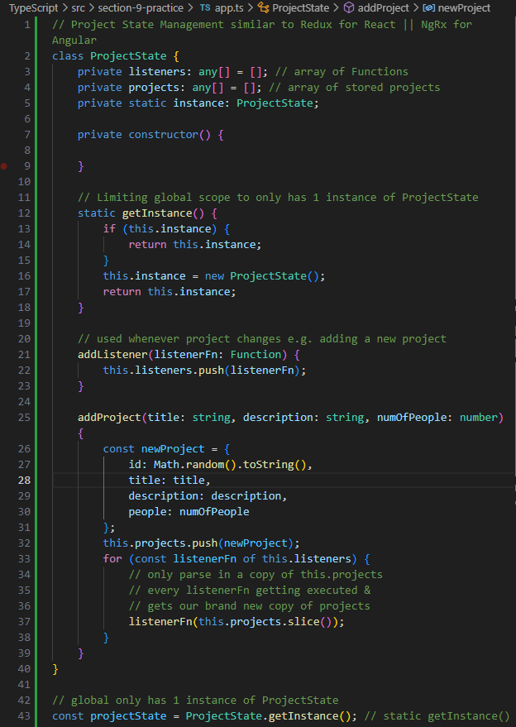

// after instantiaing ProjectState.getInstance() as an Object 'projectState'

// the global scope will only have 1 projectState object instance at one time

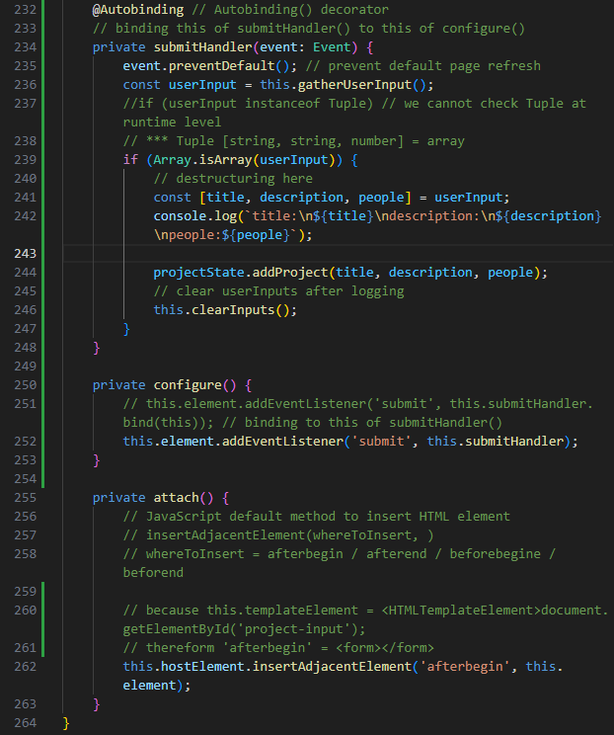

// instantiating this.gatherUserInput() method within class ProjectInput {} to retrieve 'userInput'

// if all validation of enteredTitle, enteredDescription, enteredPeople all passed validations in private gatherUserInput() method within class ProjectInput {}

// this.gatherUserInput() returns a tuple [enteredTitle, enteredDescription, +enteredPeople]; to class ProjectInput {} global scope

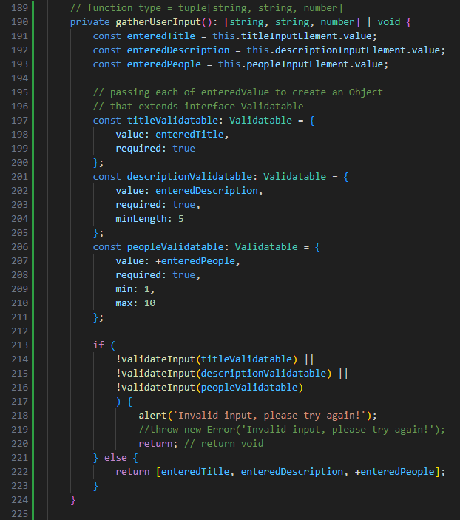

// projectState.addProject() will store parsed enteredTitle, enteredDescription, enteredPeople as an object

// then push to ProjectState private property 'projects' any[]

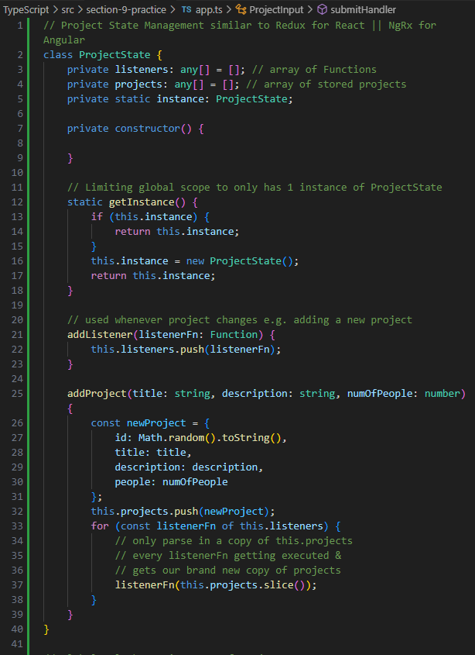

Filtering projects with Enum

Wednesday, April 17, 2024

3:02 PM

// working on class ProjectList property **assignedProjects: any[]**

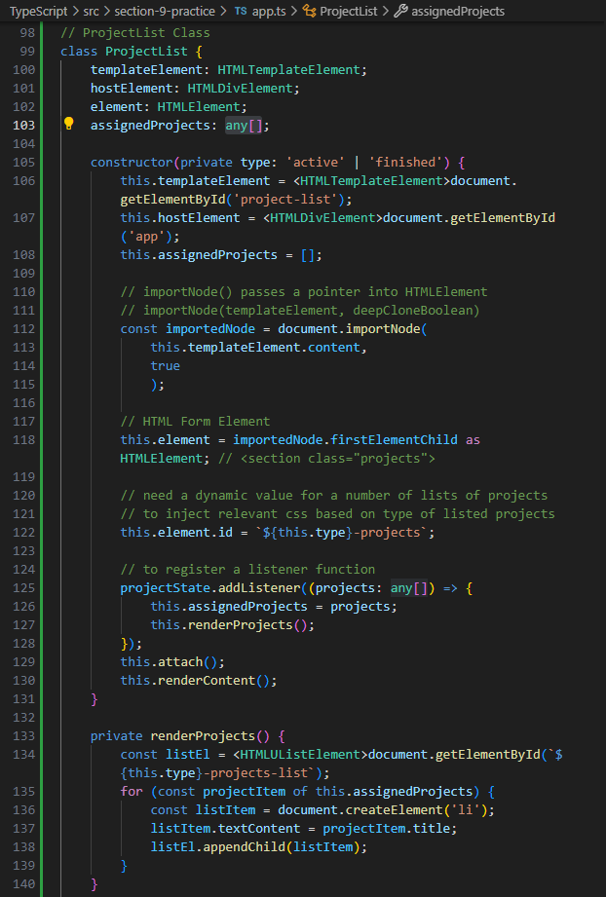

// and the private projects: any[] = [] in class ProjectState

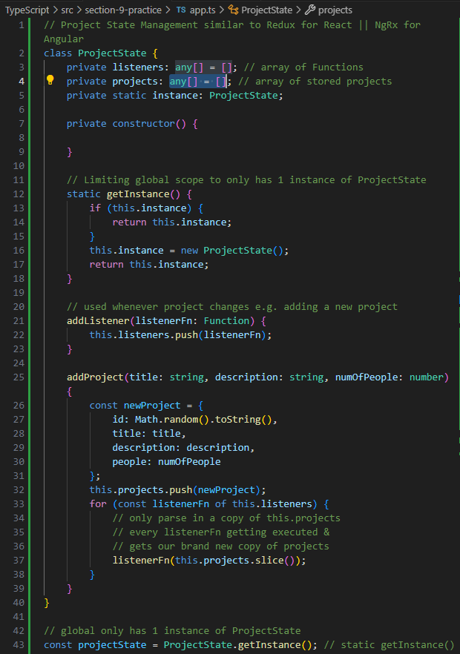

// build a class Project {} for class ProjectState.addProject()

// this we can instantiate each const newProject = Project(

id: Math.random().toString(),

title: title,

description: description,

people: numOfPeople,

**projectState[active/finished]**

)

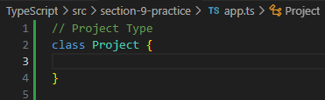

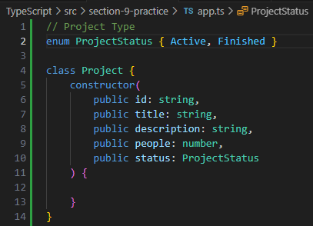

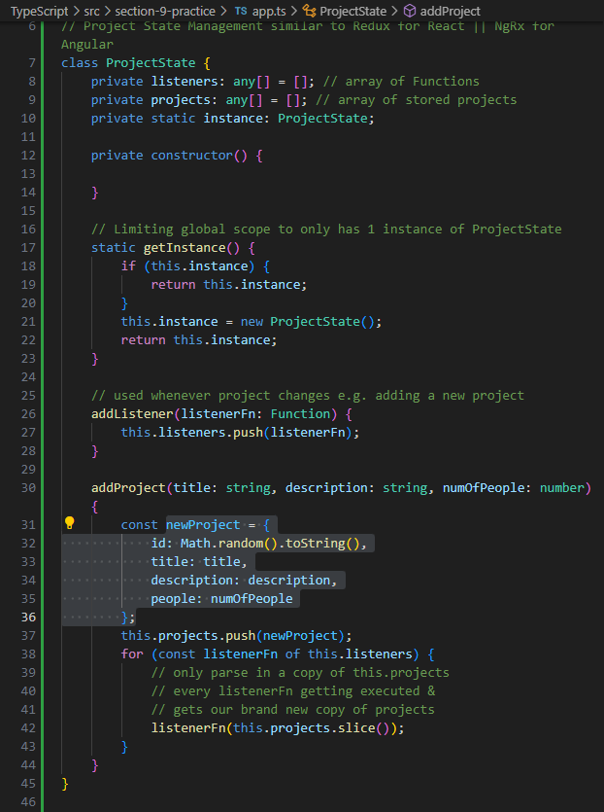

// now, we can swap ProjectState.private projects: **any[] = []**; to ProjectState.private projects: **Project[] = []**;



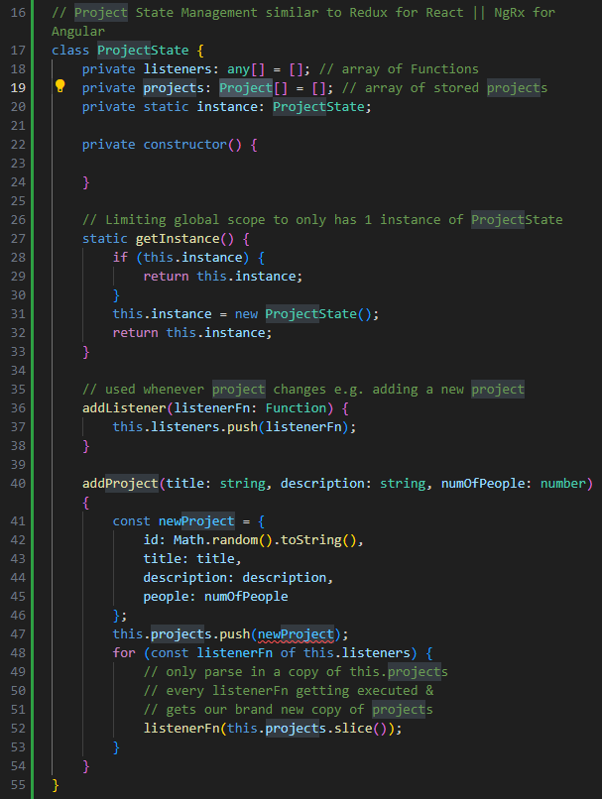

// also we can start instantiating newProject = new Project(id, title, description, people, projectStatus='active')

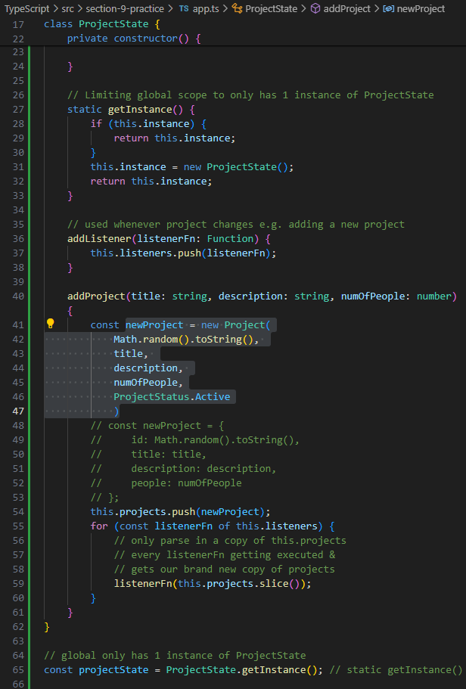

// also replace ProjectList.assignedProjects: **any[]**; to ProjectList.assignedProjects: **Project[]**;



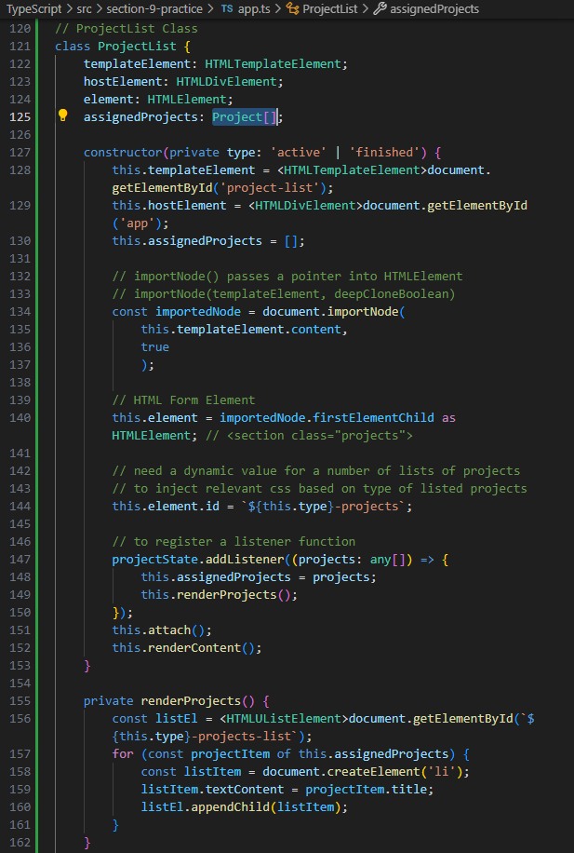

// now, we work on ProjectState.private listeners: **any[] = []**;

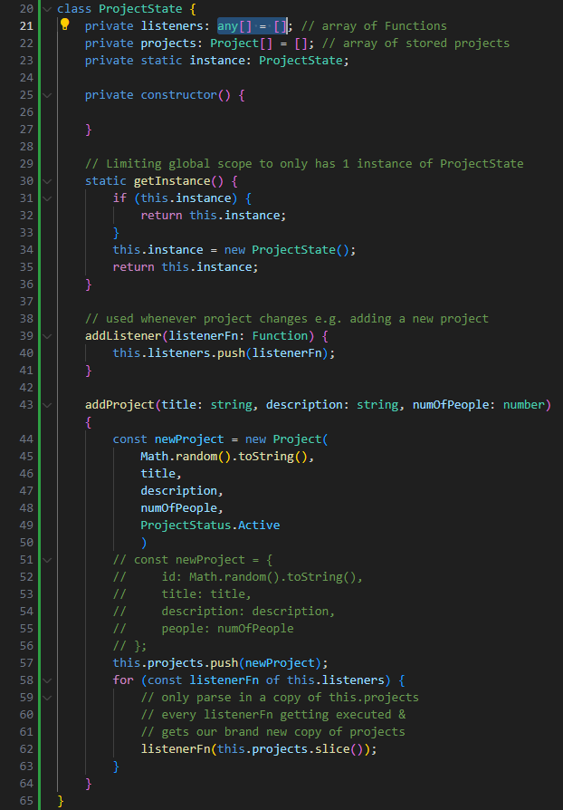

// and the listener has the essence of being a Function

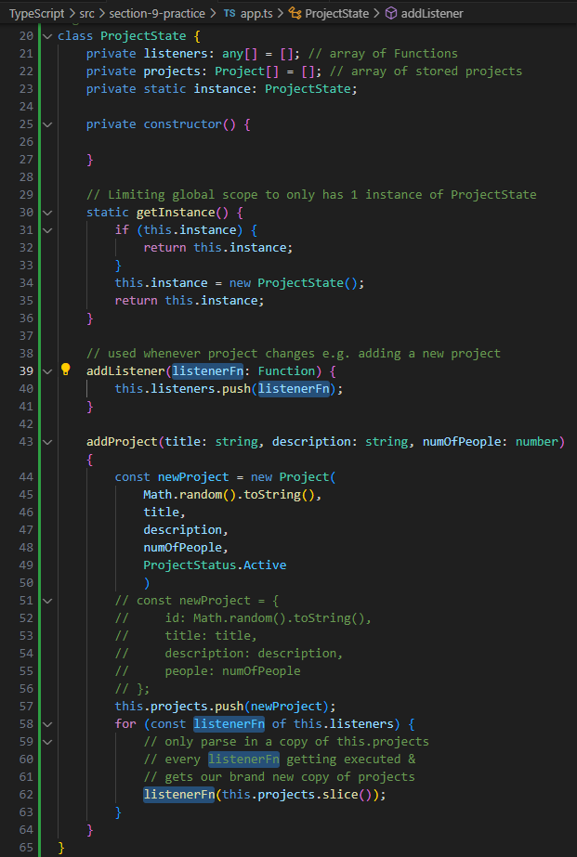

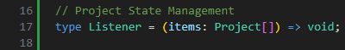

// addListener(listenerFn: **Function**) => addListener(listenerFn: **Listener**)

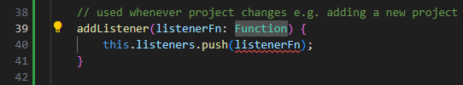

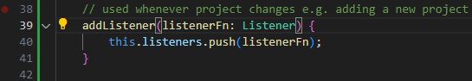

// replace projectState.addListener((projects: **any[]**)) => projectState.addListener((projects: **Project[]**))

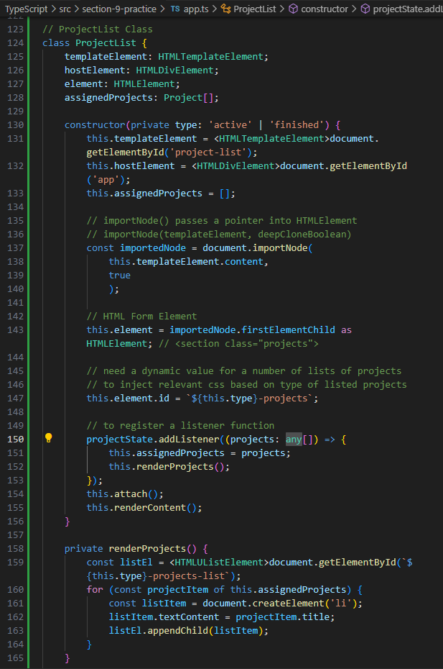

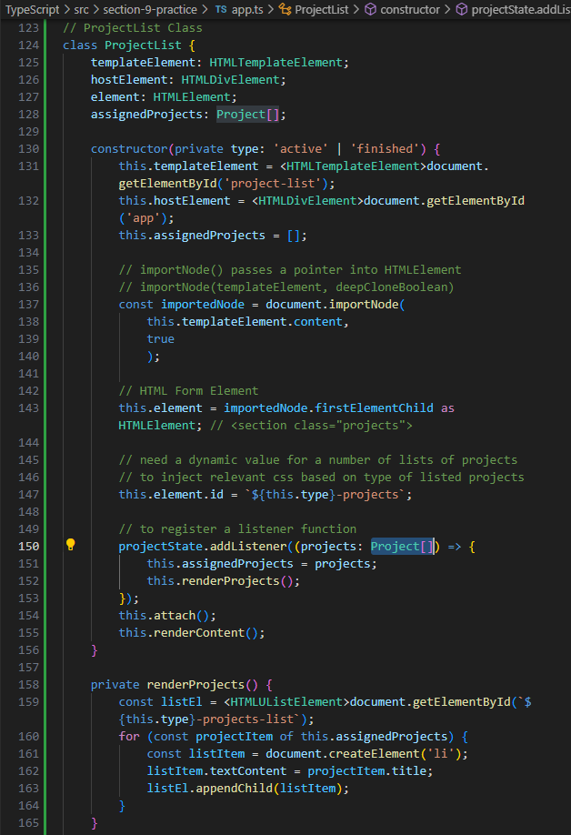

// let's test again if we add projects twice

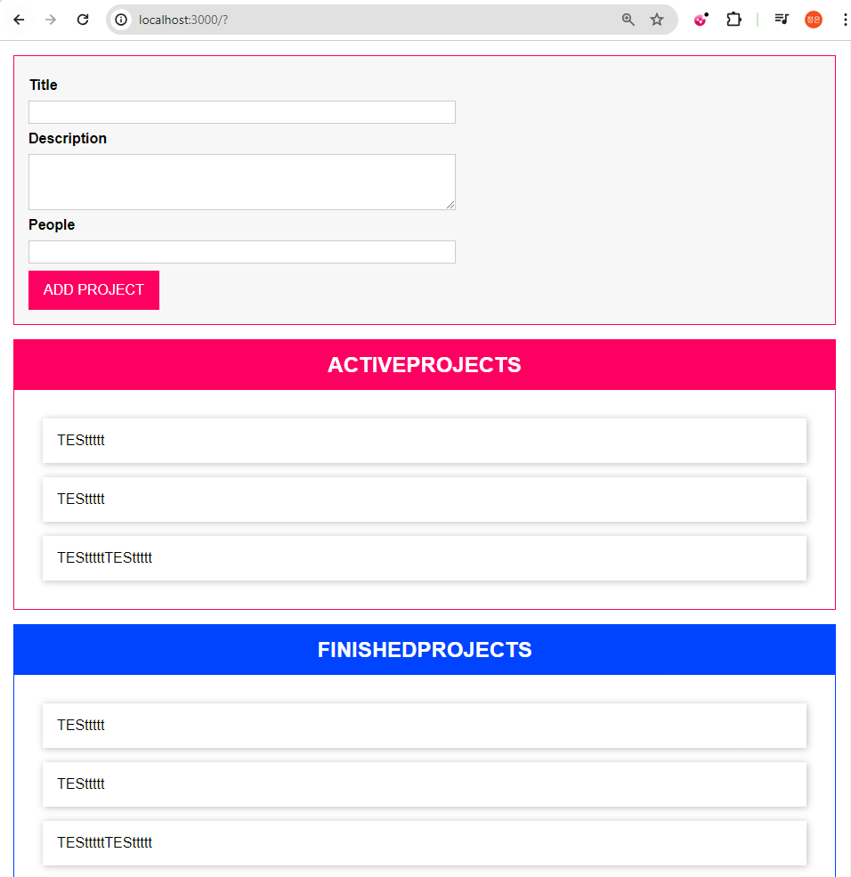

**Filtering Projects with Enum**

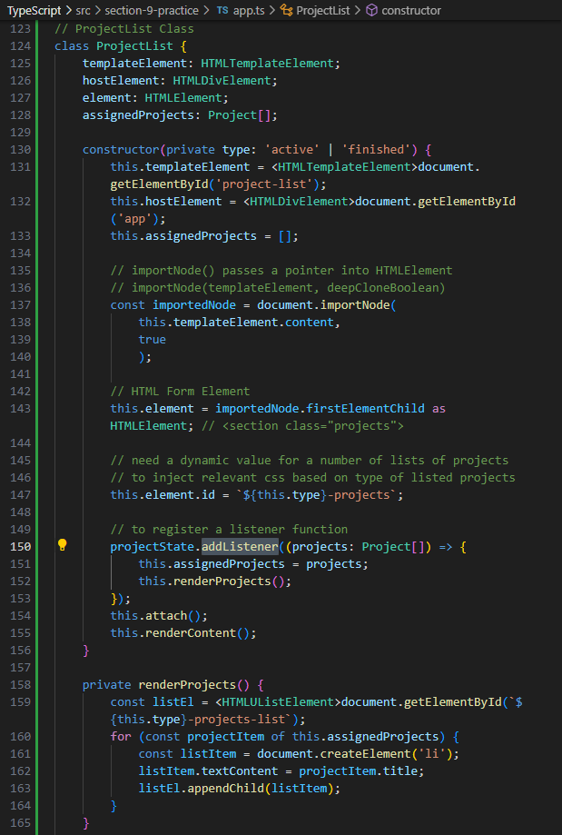

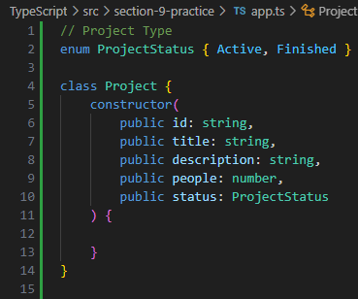

// we need to do filtering in class ProjectList constructor(private type: 'active' | 'finished') {

...

...

projectState.addListener((projects: Project[]) => {

**filteringConditions**

this.assignedProjects = projects;

this.renderProjects();

});

this.attach();

this.renderContent();

}

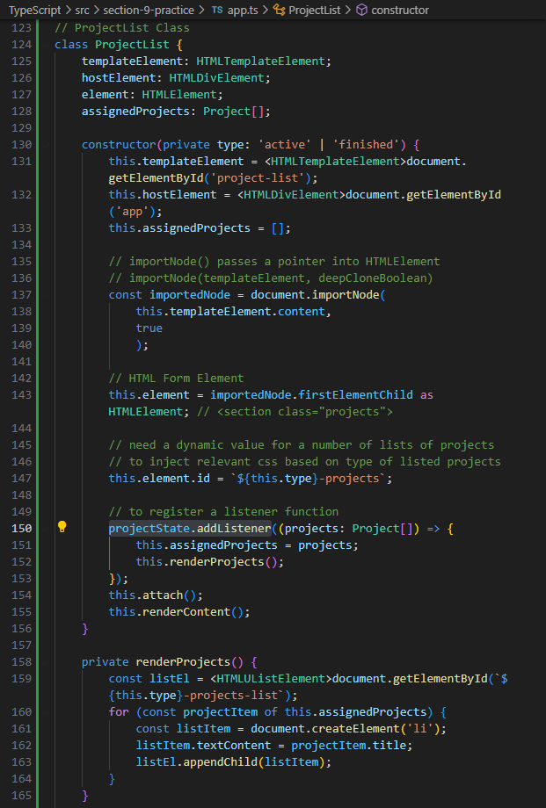

// inside class ProjectList

property

**assignedProjects: Project[]**;

constructor( projectState.addListener((projects: **Project[]**) => {...

We create filters in **projectState.addListener()** to return **Project[]** to class assignedProjects: **Project[]**

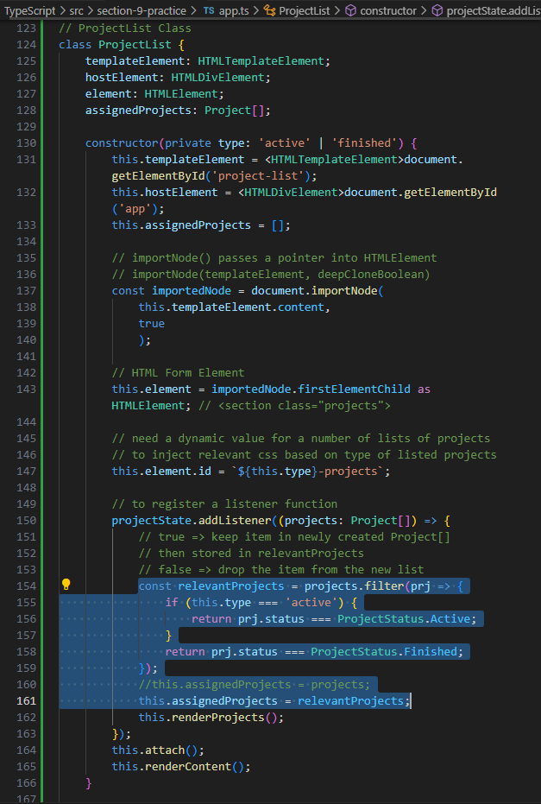

// we need to tackle ProjectList.private renderProjects() {...}

// to avoid rendering duplicated existing projects in the list

// each time we enter a new project to the list

// we get rid of existing rendered projects first

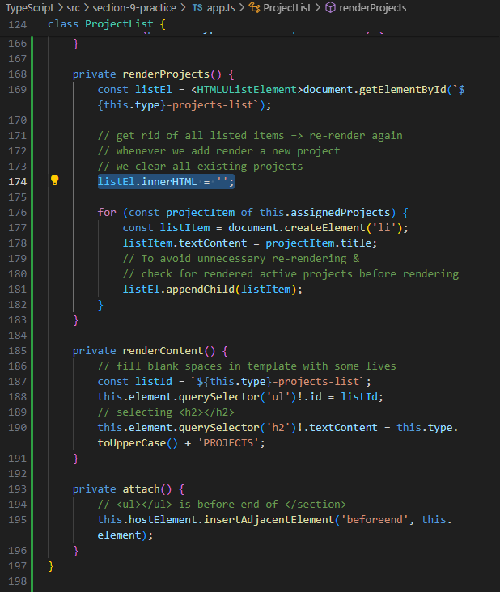

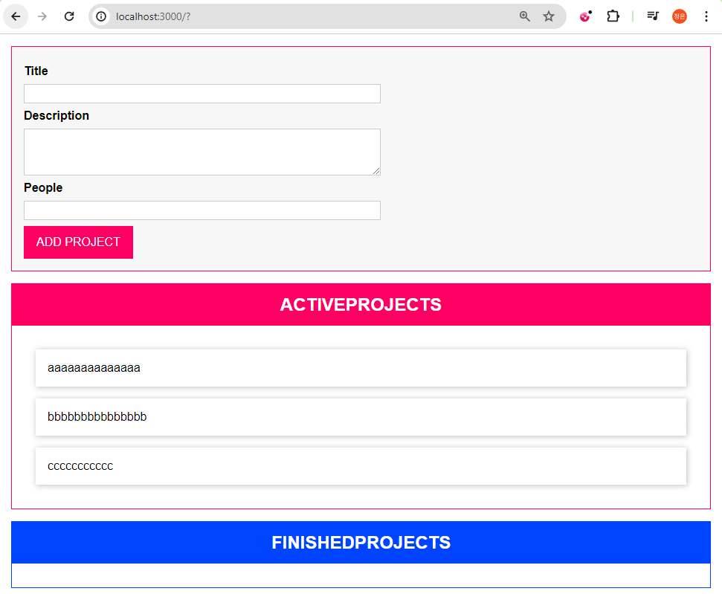

Adding Inheritance & Generics

Wednesday, April 17, 2024

3:59 PM

we're creating a class Component {} that is similar to React, { Component } from 'react' when using React.js

**hostElement** = **whereToRender**

<div id="app"></div> is NOT necessarily of type **HTMLDivElement**

**element** = **elementToRender**

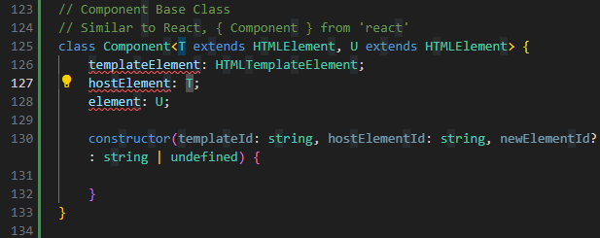

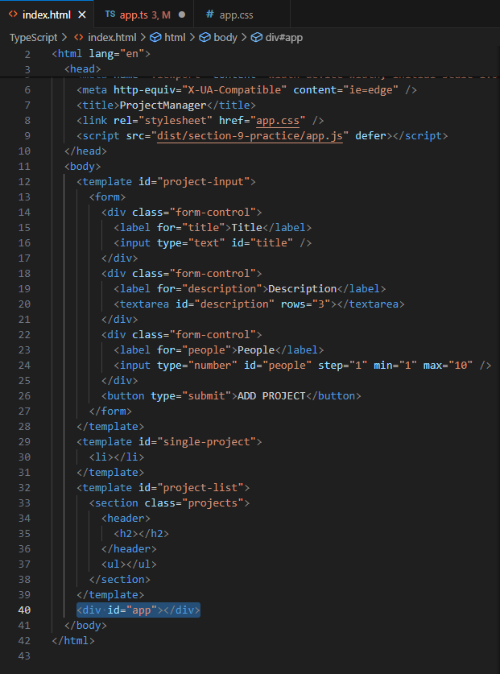

while **element** is always **HTMLElement**



yet in **class ProjectInput {}**

**element** is always **HTMLFormElement**

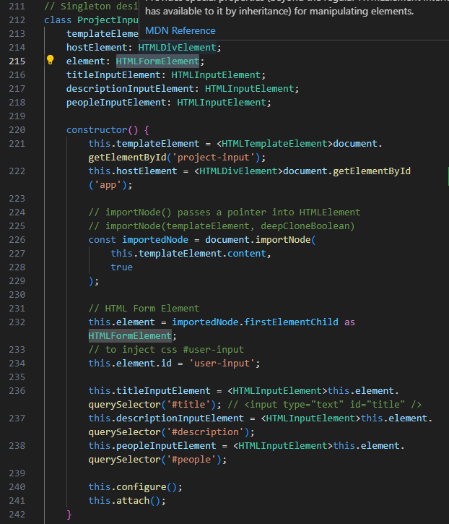

we need a constructor to store several important parameters

templateId: string => to know how to select a template using templateId

hostElementId: string => to know where to render this component

newElementId?: string=> to assign new **re-rendered elements** with **unique id** of **each state**

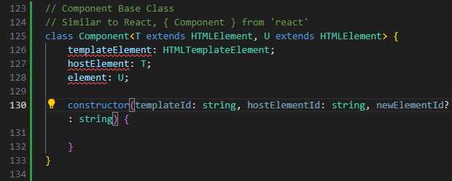

then we move ProjectList constructor(private type: 'active' | 'finished') {

this.templateElement selector into our class Component constructor

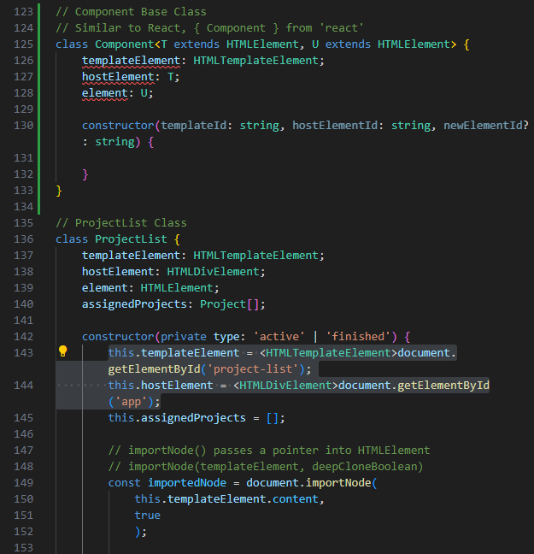

replace **this.templateElement selector** 'project-list' to **templateId**

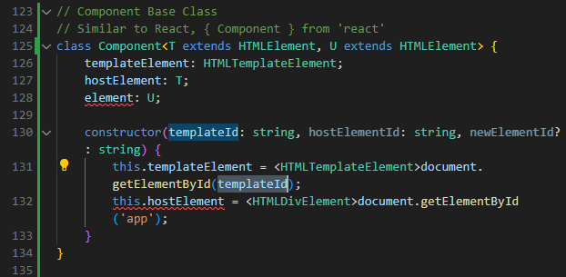

also replace **this.hostElement (whereToRender) selector** 'app' to **hostElementId**

Generic Type is **<T>** as specified in Component property **hostElement**: **T**

**for where about of the Rendering**

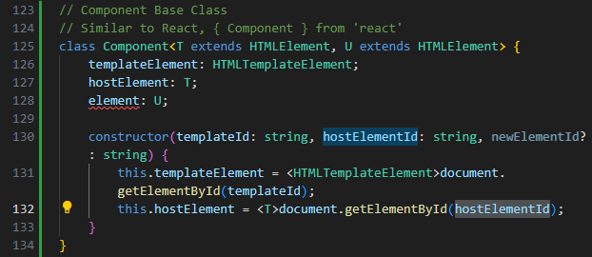

this element: **U** is referring to **dependency injection** to **render a new element** used in class ProjectList constructor(private type: 'active' | 'finished') {

**const importedNode = document.importNode(this.templateElement.content, true);**

**this.element = <HTMLElement>importedNode.firstElementChild;**

**this.element = elementToRender**

// <section class="projects">

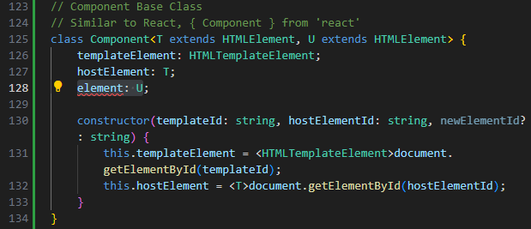

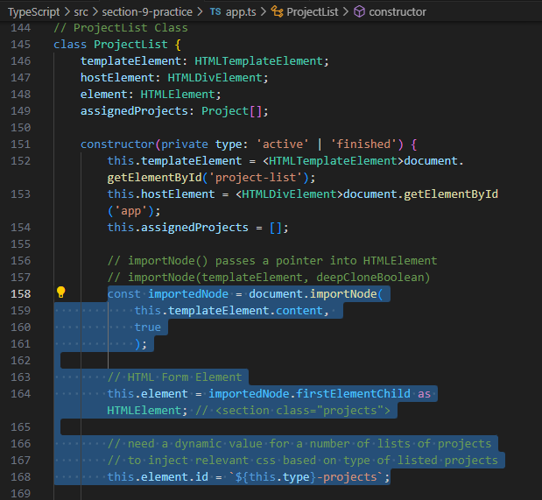

then, replacing **this.element.id** = **newElementId**;

[newElementId = ID of the elementToBeRendered]

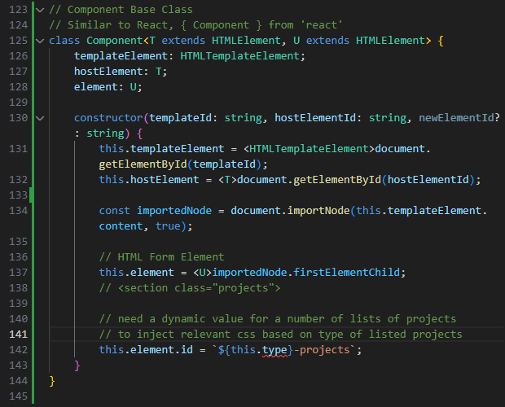

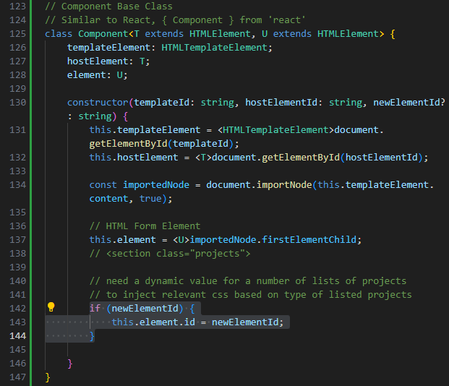

copy ProjectList.private attach() {} to class Component

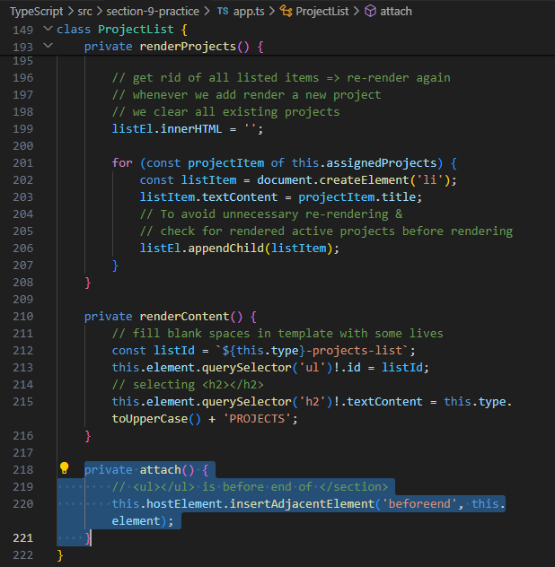

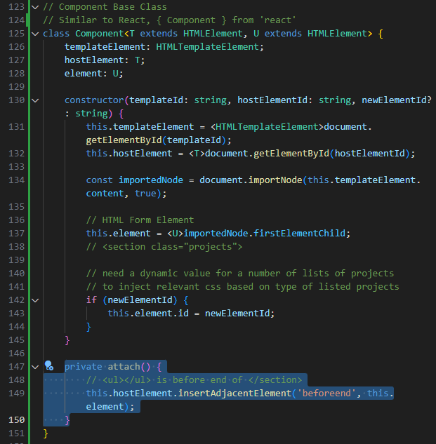

we also need this.attach() in our constructor & one more constructor property **insertAtStart: boolean**

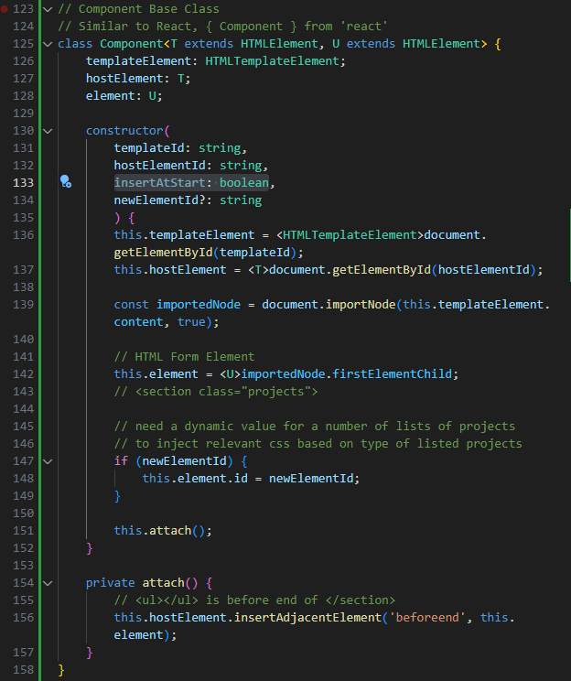

we also need a **boolean (true/false)** to determine whether **'afterbegin'** or **'beforeend'** is passed into **private attach()** {...} using tenary operator :

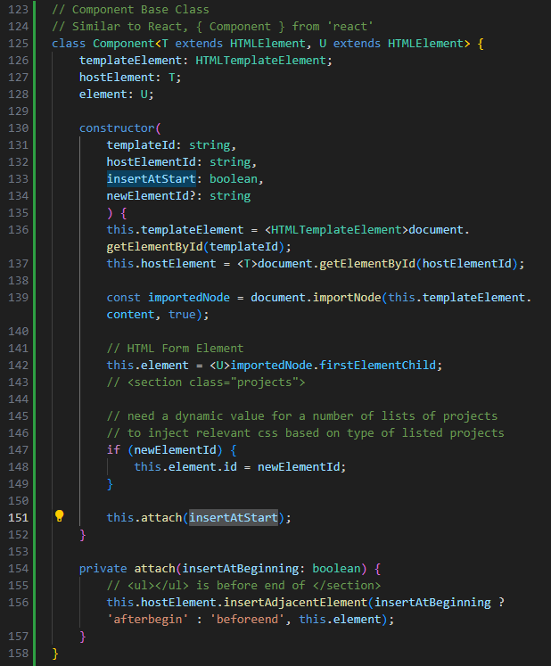

we also need 2 **abstract methods** configure() & renderContent()

recap **abstract method in a class** =

[missing concrete implementation at start to stay flexible]

[to be defined after class newComponent extends Component]

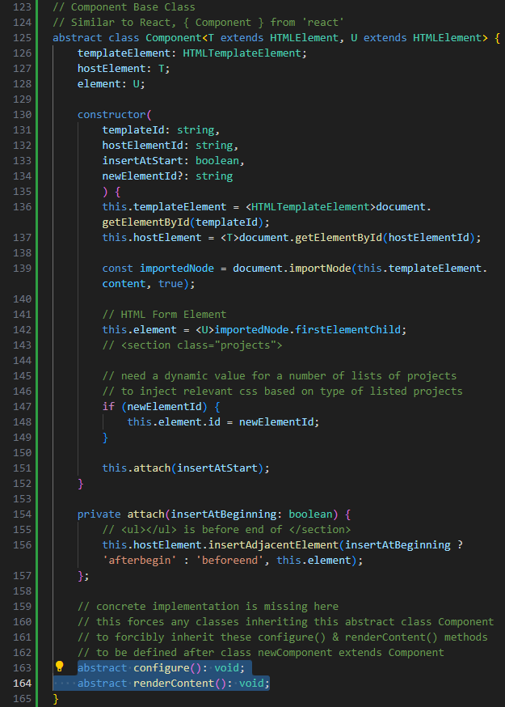

now, we can **class ProjectList extends Component** and **\*\* consider \*\***

abstract class Component <**T** extends **whereToRender**, **U** extends **elementToRender**>

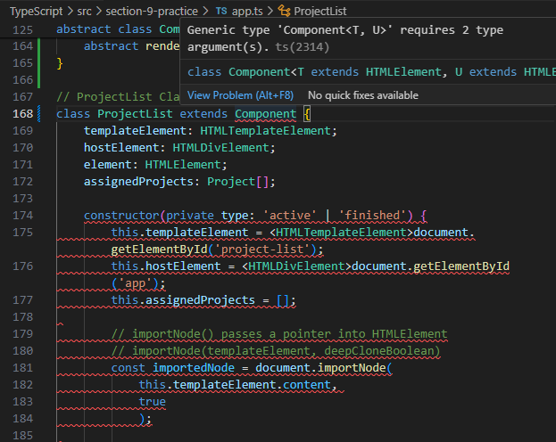

and now we **do NOT need** the **3 properties** of **class ProjectList**

**templateElement: HTMLTemplateElement;**

**hostElement: HTMLDivElement;**

**element: HTMLElement;**

**assignedProjects: Project[];**

as **these properties** have **duplicated properties** from **class Component** upon **extends**

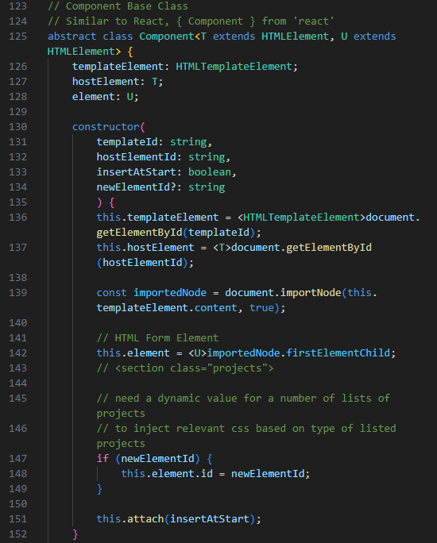

when working with class ProjectList

referring to index.html:

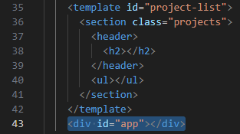

**class ProjectList** also needs

**Generic Types** of **<HTMLDivElement, HTMLElement>**

as class ProjectList are using these generics here:

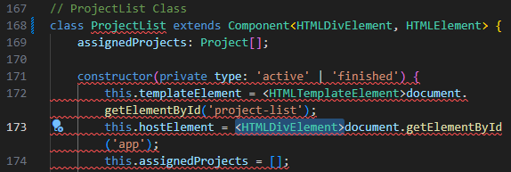

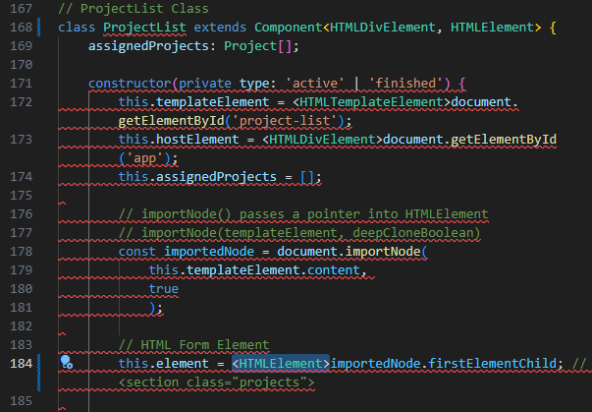

now we **super()** to **inherit** the **constructor** of **base class Component** inside our class ProjectList constructor

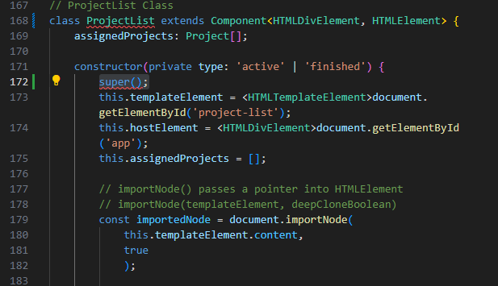

**hover** over **super()** to **show hints** for super() to **inherit** class Component **constructor parameters**

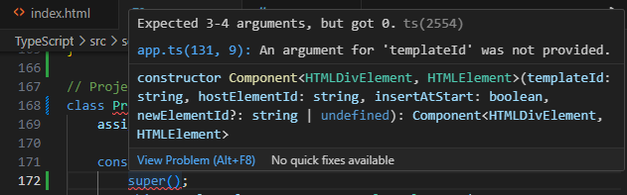

**Remove** this.templateElement & this.hostElement **selectors with Type Casting** as these are **already inherited** from **super()** [**extends Component**]

Leave only **this.assignedProjects = []** as required in class **ProjectList.assignedProjects: Project[]**;

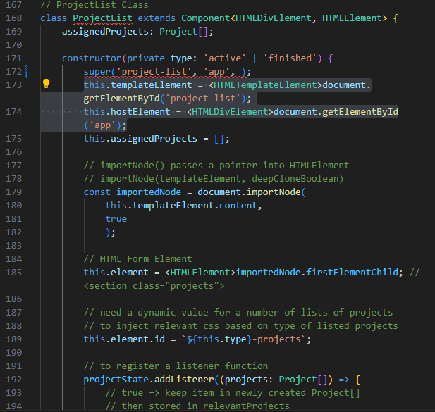

also **remove** this.element selector with Type Casting & its statement lines

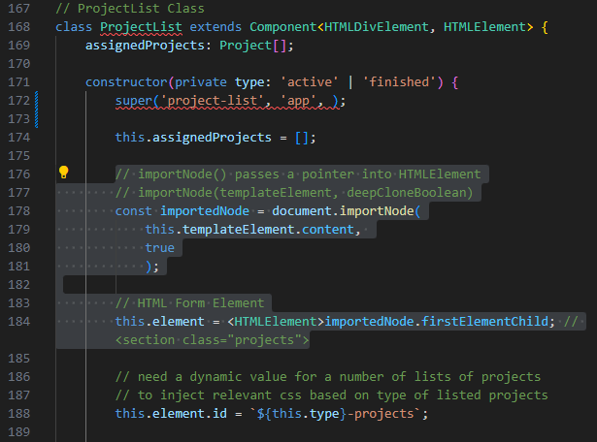

// passing this.element.id = **`${this.type}-projects`**; to our **super()** as 4th parameter as **`${type}-projects`**

// **remove this.attach()** as this method is **inherited from base class**

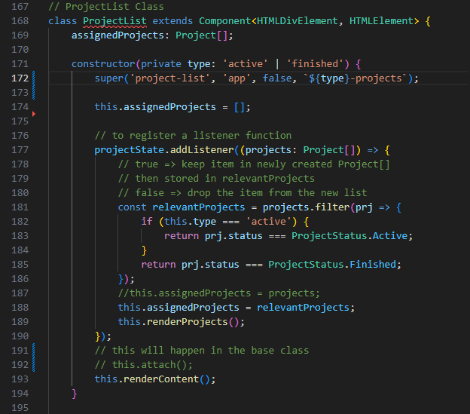

// **remove private attach() {...}**

// ProjectList still errors out

// **remove private** class ProjectList **private renderContent()**

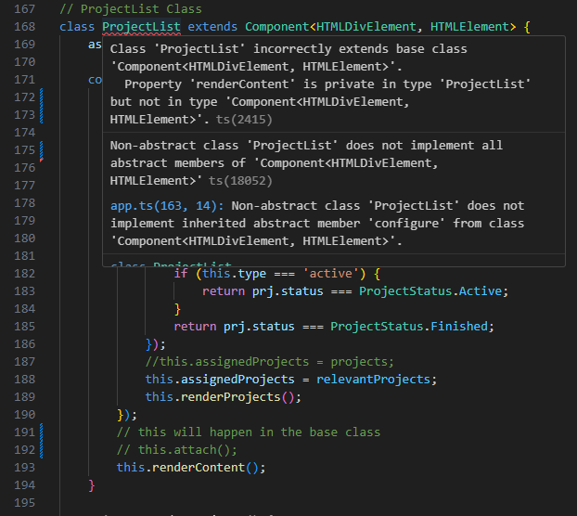

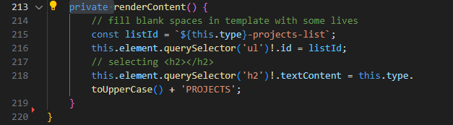

// now we're left with only 1 issue

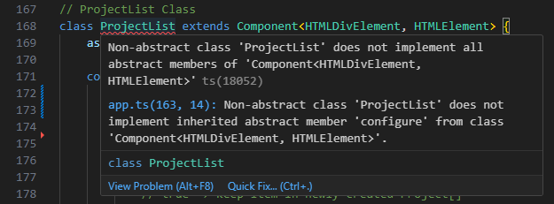

// this signals that we have to **implement abstract configure(): void;** in base class **abstract class Component** upon **extending** that this **abstract method** did **NOT have a concrete implementation** of the method at start

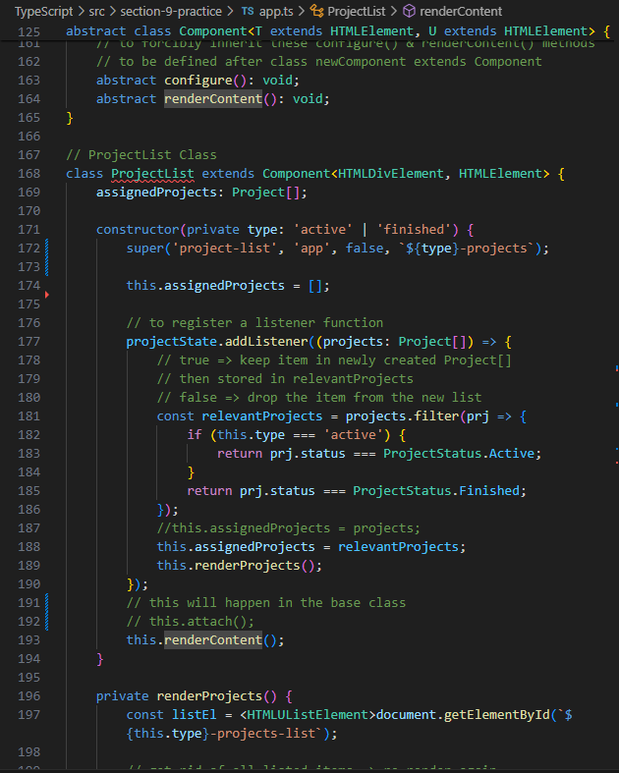

// we can pull all of our **implementation code** for projectState.addListener() into **configure()**

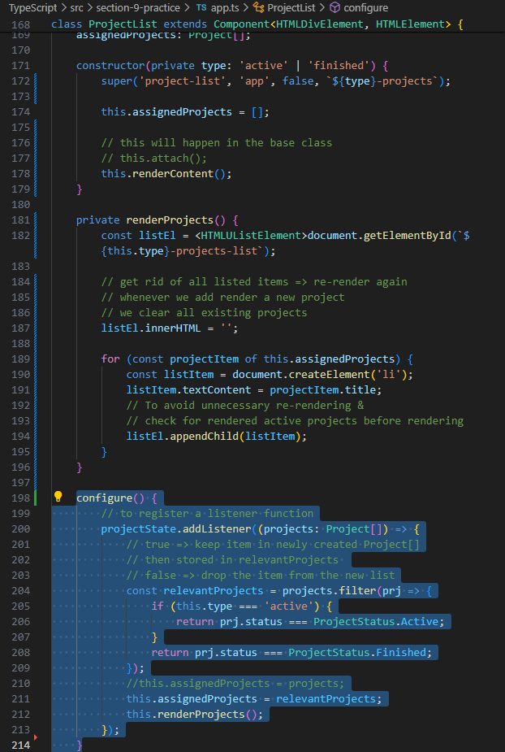

// then we **add back this.configure()** into our class ProjectList **constructor**

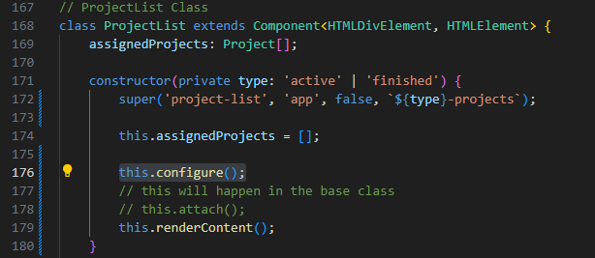

we'd like **class ProjectInput** to also **extend**

Component<**T** extends **whereToRender**, **U** extends **elementToRender**>

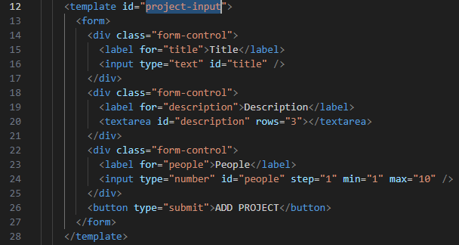

**Component<HTMLDivElement, HTMLElement>**



we will **super()** to **inherit** these **3 class properties** from

**abstract class Component** by **extends**



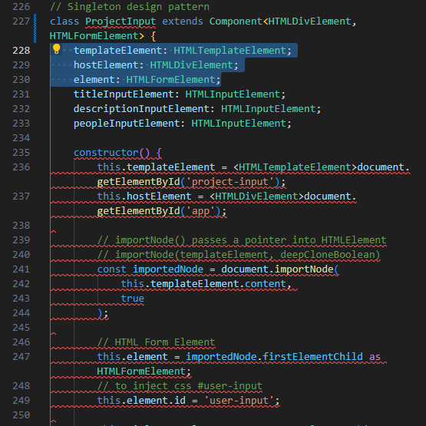

doing inheritance for class ProjectInput to extend Component with Generics<HTMLDivElement, HTMLFormElement>

right after super() => **remove** all this **selectors already inherited**

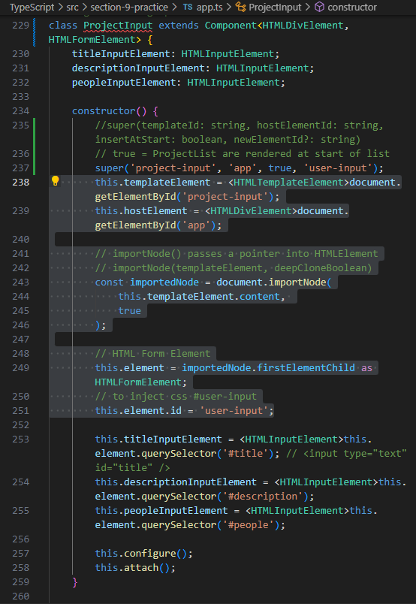

we can **transition** the **remaining** this. **selectors** to **this.configure()** method

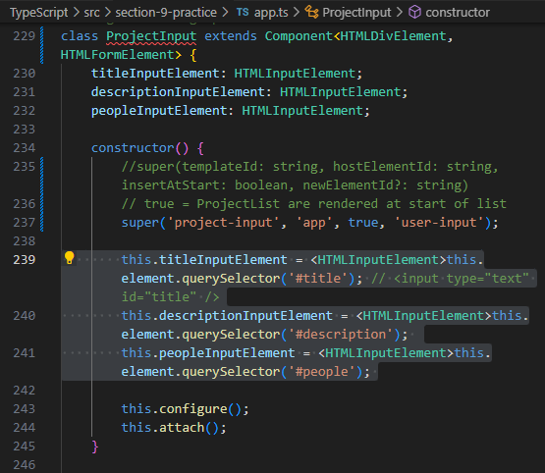

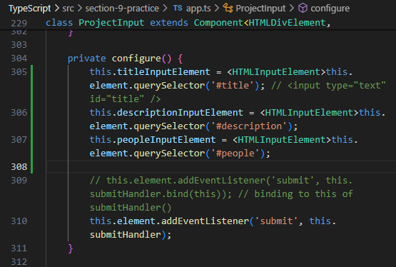

note that we also need to **remove** class **ProjectList private attach()**

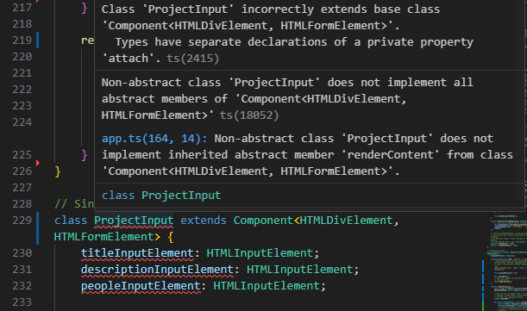

**remove** class ProjectInput private attach()

as class **ProjectInput** private **attach()**

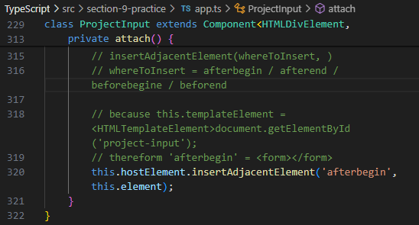

**duplicates** with class **Component** private **attach()**

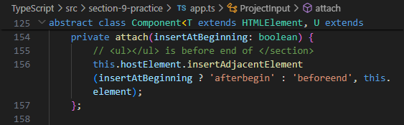

**upon removing** class ProjectInput **private attach()**

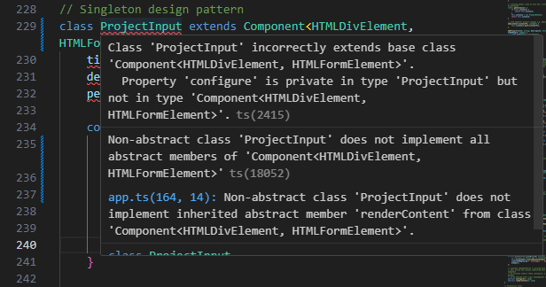

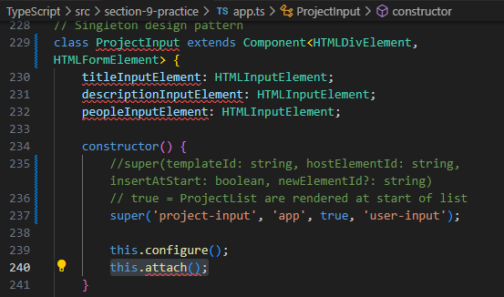

we should also **remove constructor()** { **this.attach();** }

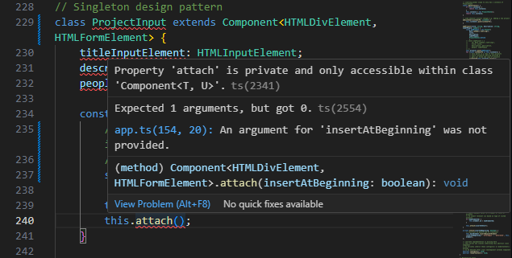

**upon removing** class ProjectInput **constructor()** {

this.configure();

**this.attach();**

}

we **still encounter** typescript **compiler error** message alerting

**private configure()** in class **ProjectInput** but **not in**

class **Component<HTMLDivElement, HTMLFormElement>**

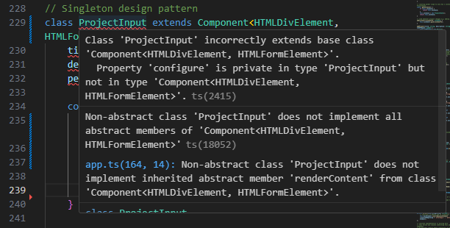

// thus, **let's** just **move back** these **selectors back** to

class **ProjectInput constructor()** { ... }

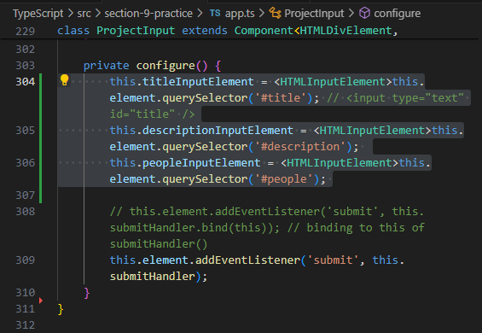

// now, **TypeScript compiler** just **complains** about class **ProjectInput NOT also complaining about** all the **properties**

titleInputElement: HTMLInputElement;

descriptionInputElement: HTMLInputElement;

peopleInputElement: HTMLInputElement;

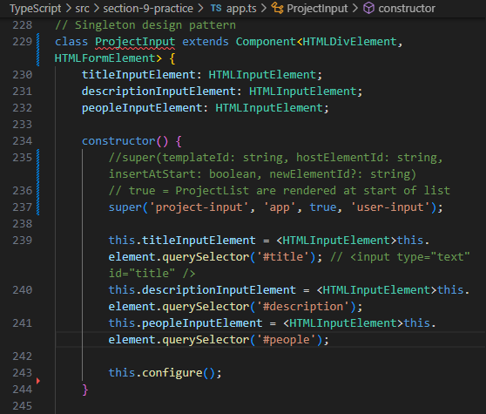

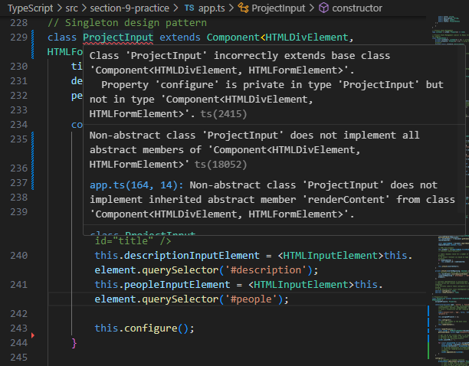

// we turn class **ProjectInput private configure()** to **public**

by **removing private** keyword

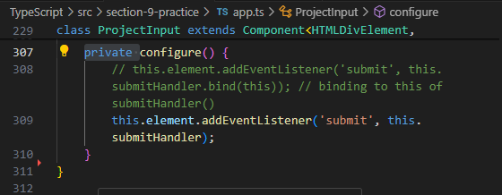

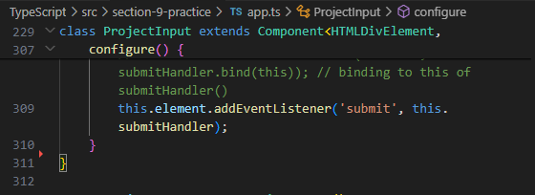

// now TypeScript compiler **complains less error** for class ProjectInput

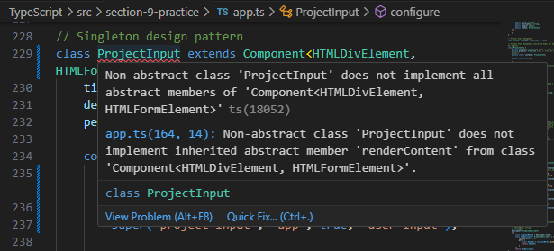

// as **abstract** method **abstract renderContent(): void;** is declared in

**base class** Component, it did **NOT have** a **concrete implementation** that **must be declared** in our **inheriting class** ProjectInput

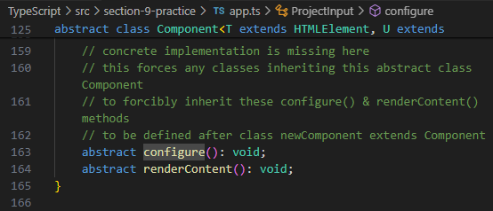

// best practice is that we also **move public methods** right below a constructor()

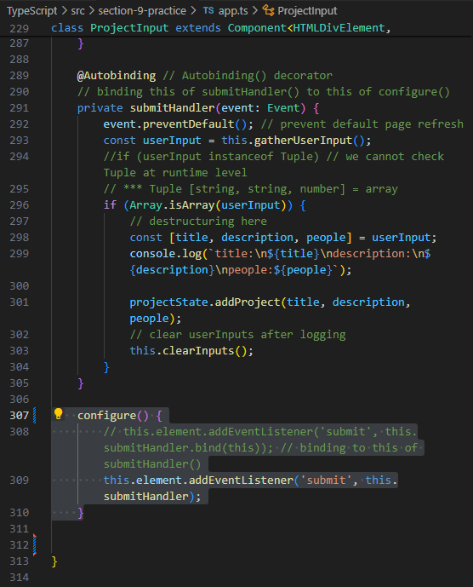

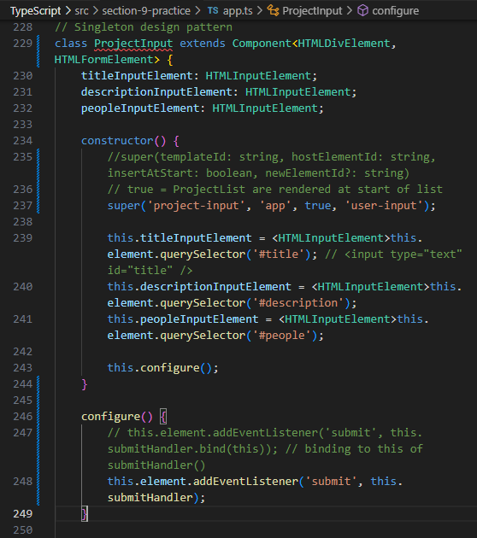

now we **declare abstract** method renderContent() {...} in base class Component in our **inheriting class ProjectInput**

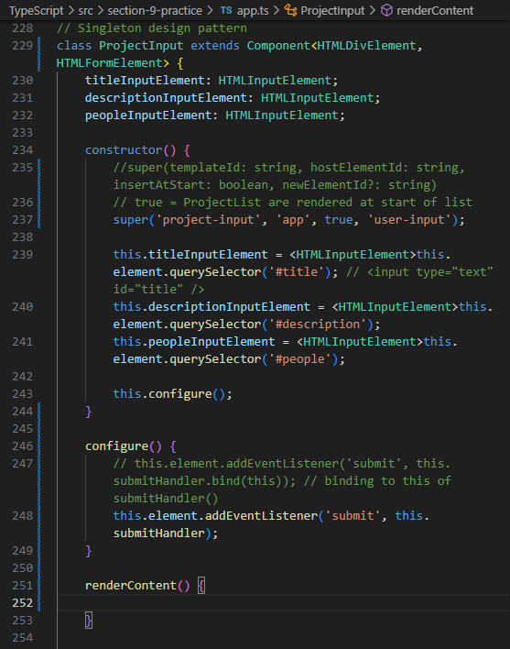

// we do **NOT need** to **do anything** in **renderContent() {}**

// now the abstract class Component for State Management works fine :D

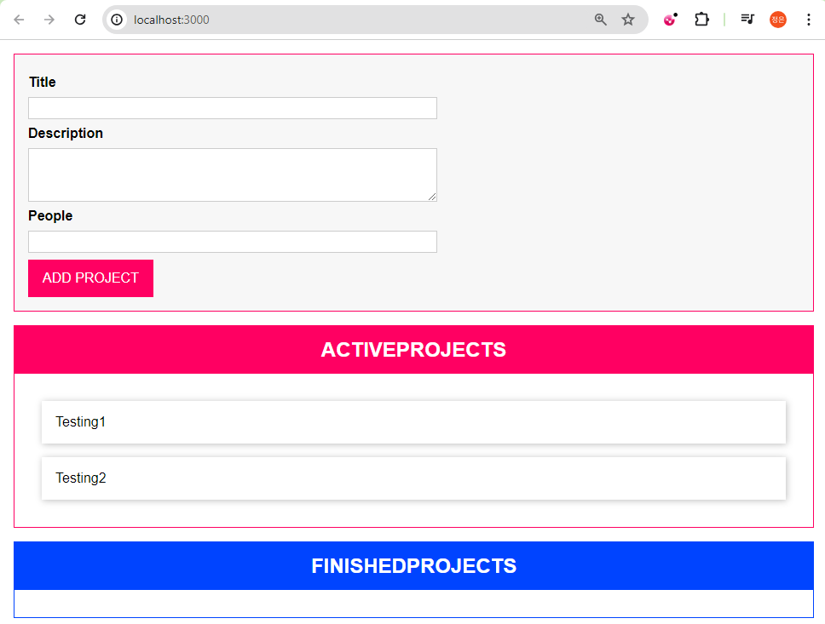

// we can also refactor our class ProjectState {...} targeting property **private listeners: Listener[] = []**;

and public method **addListener(listenerFn: Listener) {...}**

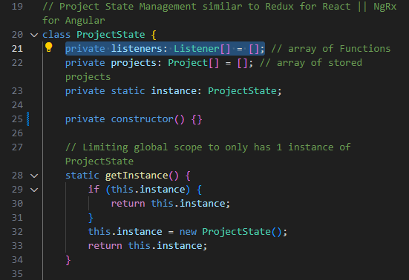

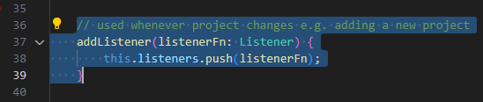

// this is the high level structure of base class State {...}

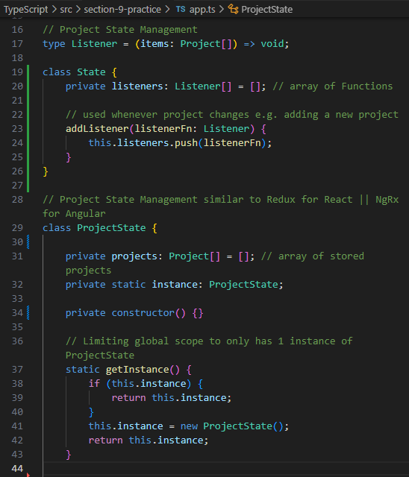

// let's also create a **Generic Type** for type Listener = () => void;

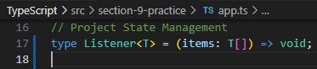

// and implement this **Generic** type **Listener<T>** = (items: **T[]**) => void;

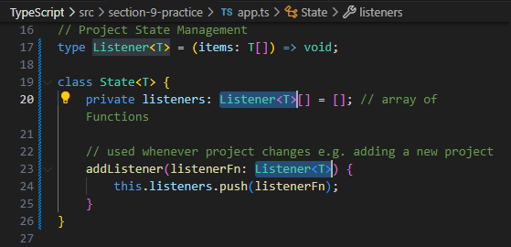

then **inheriting** class **ProjectState extends base** class **State** with

Generic Type <**Project**> to inherit **private listeners: Listener<T>[] = []**;

this Generic Type <**Project**> also bridges class ProjectState property private projects: **Project**[] = [];

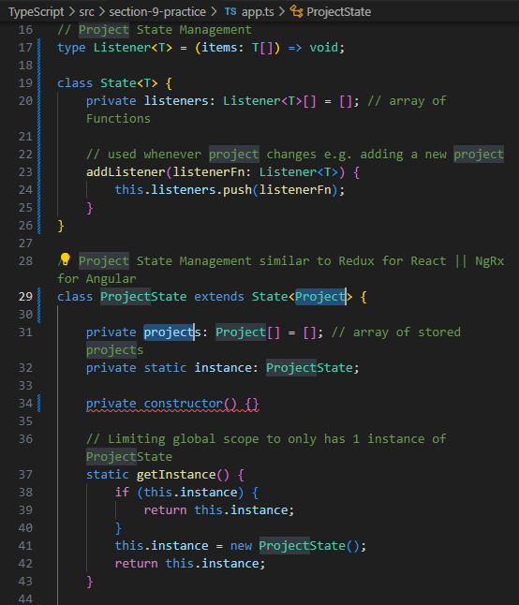

// now class ProjectState extends State<Project> private constructor() alerts errors

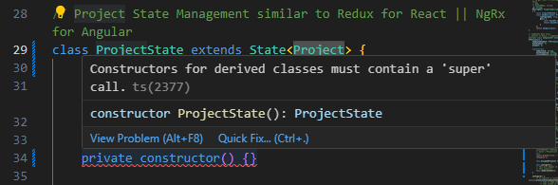

// now, for **class ProjectState**

to **inherit missing** class property

**private listeners: Listener<T>[] = [];**

do below:

private constructor() {

super();

}

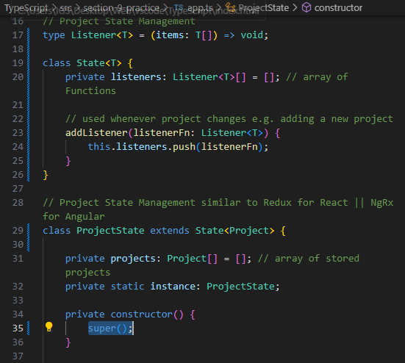

// this.**listeners** is alerting errors

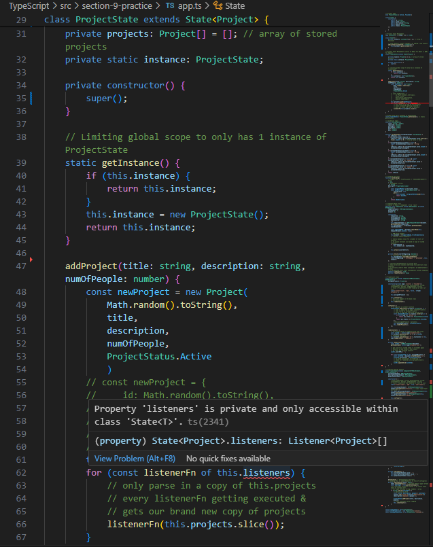

// we modify **private** to **protected** => **only inheriting classes** can **access property**

class State<T> {

**private** listeners: Listener<T>[] = [];

...

}

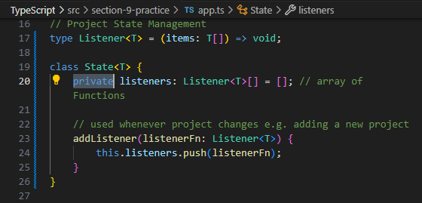

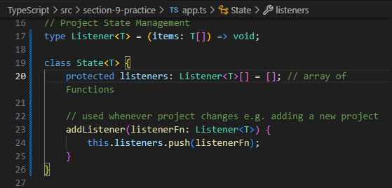

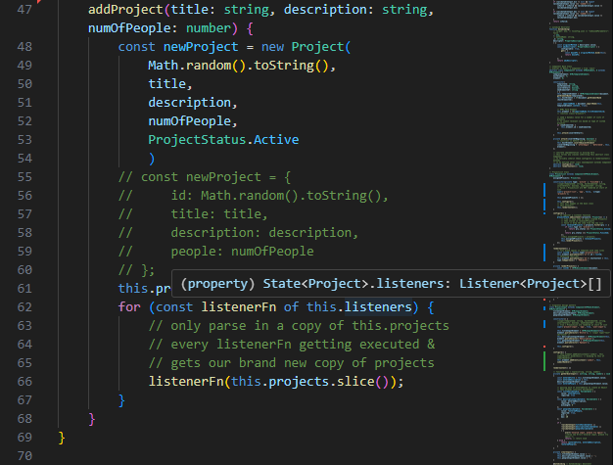

// now everyting still works fine :D

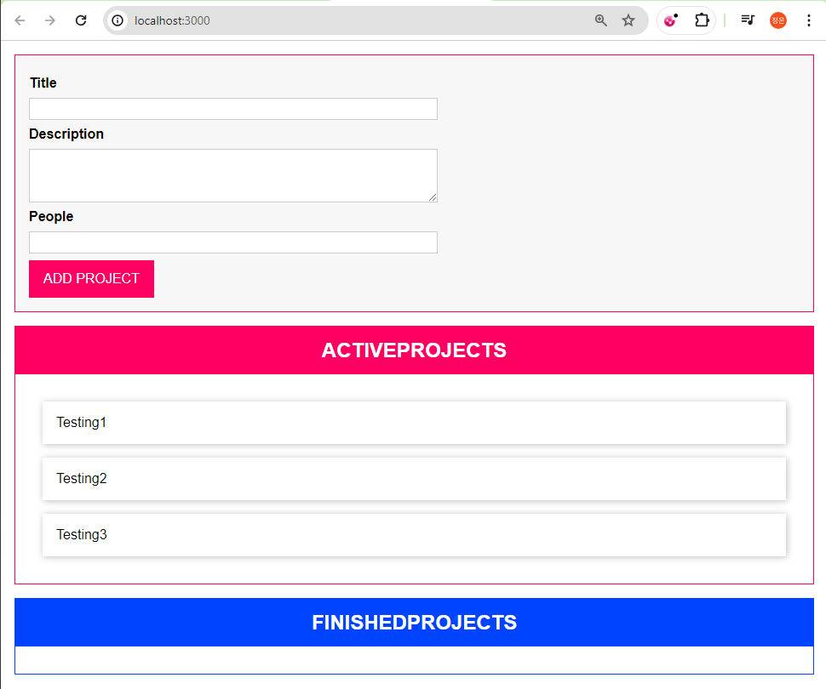

Rendering Project Items with a Class

Thursday, April 18, 2024

5:10 PM

// new projects are created on top of the current list



// instead of creating new projects using class ProjectList **private renderProject()** method

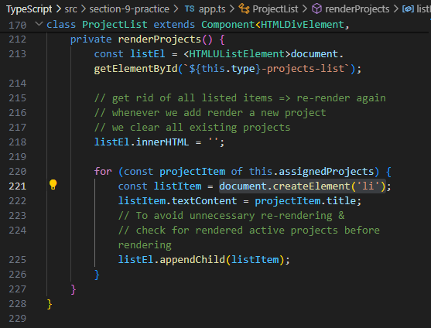

// let's **create** a **class ProjectItem extends Component {}** to render each Project Item separately

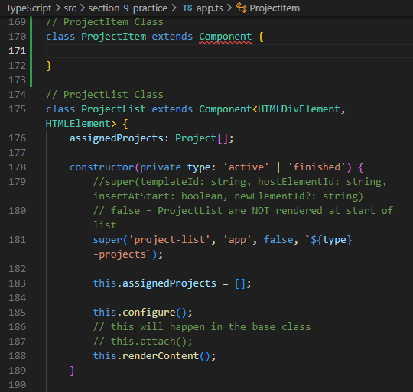

// let's always refer to class Component to always inherit properties & methods seamlessly

abstract class Component<**T** extends whereToRender, **U** extends **elementToRender**> { }

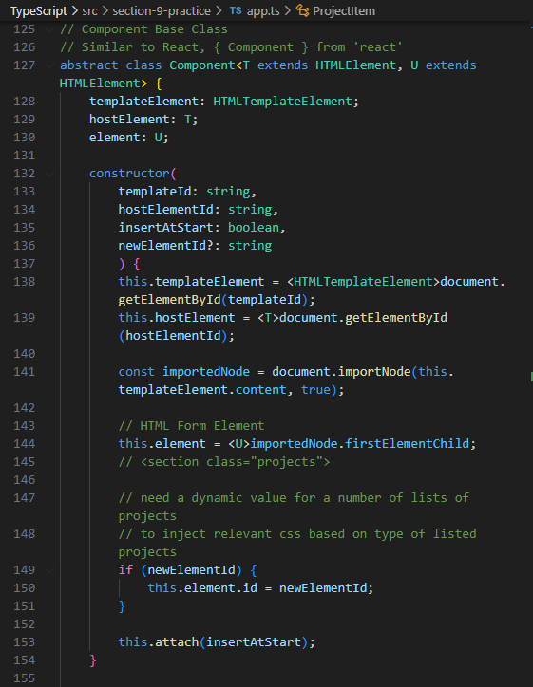

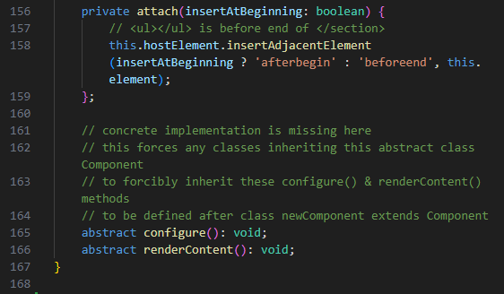

// considering our index.html <template id="project-list"> <ul></ul> element

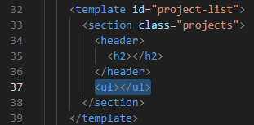

we expect each new project to be rendered as a <template id="single-project">**<li></li>**</template> element

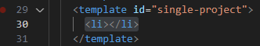

thus, we're gonna have Generic Types for class ProjectItem as <**HTMLUListElement**, **HTMLLIElement**>

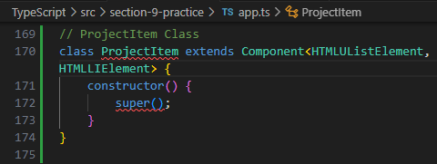

hover over super() when inheriting base class Component properties

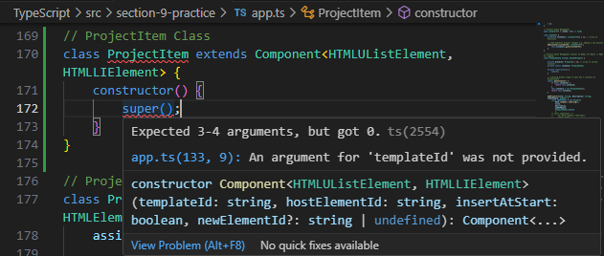

as **super('templateId')** is prompted

we're gonna parse super(**'single-project'**) for each new project as an <li></li> element



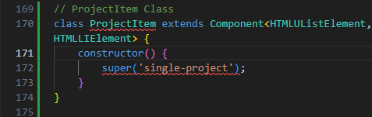

now we continue to work on the remaining super() parameters by hovering over to super('single-project') to see what are still missing

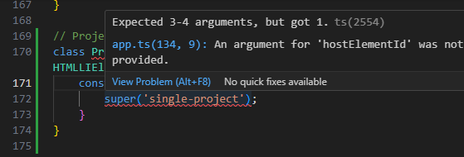

as it says '**hostElementId**' was not provided, we need to have

constructor(**hostId: string**) for super('single-project', **hostId**) to inherit

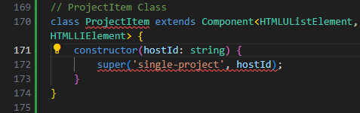

hover overing **super('single-project', hostId)** now to see what are still missing

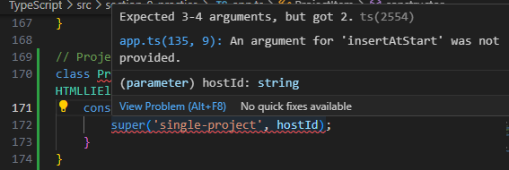

as 'insertAtStart' boolean is required

[true = each <li/> new project at start of <ul/> project-list]

[false = each <li/> new project at end of <ul/> project-list]

we're gonna parse in a **true** as **3rd parameter** into **super(**'single-project', hostId, 3rdParameter**)** to allow each newly rendered project to stay at top of our current list of projects

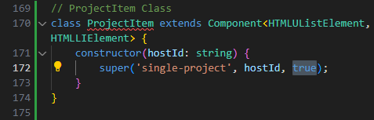

**although super(...) does NOT prompt** alerts for **missing parameters**, we **hover over** to **super()** to confirm any missing parameters for inheritance

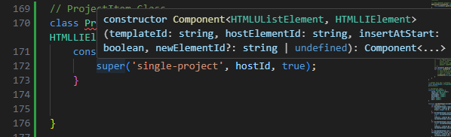

now it prompts '**newElementId?**: string' ... that we need to parse in this optional newElementId parameter into our class ProjectItem **constructor**(hostId: string, **newElementId**) then for **super**('single-project', hostId, false, **newElementId**)

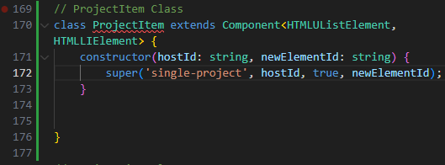

**referring** to **class Project** properties for **inspecting** the **necessary data** stored in each new project

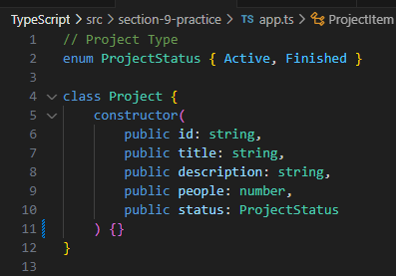

we **create** a private property **private project: Project;** in our

**class ProjectItem**

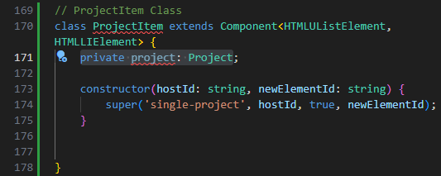

as **each new project has an id**, we parse

constructor(hostId: string, **project: Project**) {

private project: Project;

super('single-project', hostId, false, **project.id**)

this.project = **project**;

}

Gonna change rendering of each new element to beforeend of whereToRender element<ul></ul>

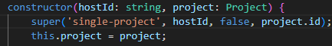

now we hover over class **ProjectItem** to see what errors are up

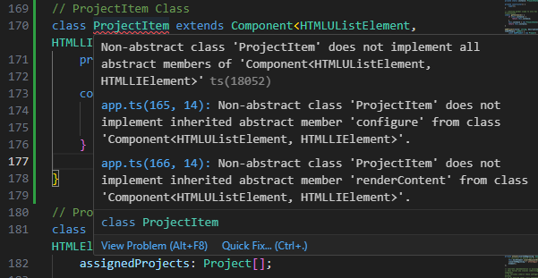

this means that **abstract methods** as

**abstract configure(): void;** & **abstract renderContent(): void;** in base class Component that do NOT have a concrete implementation are **NOT yet implemented** in our **inheriting class** ProjectItem

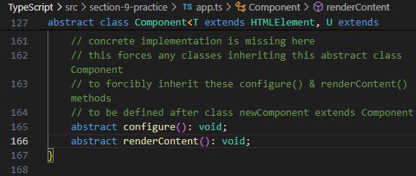

**add** these methods to our **class ProjectItem**

**configure() {}**

**renderContent() {}**

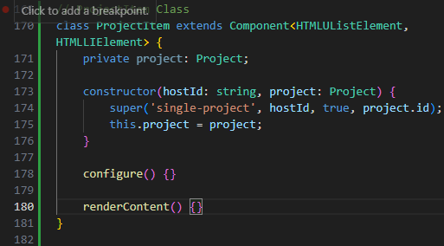

also call this.configure(); & this.renderContent(); in our constructor() {...}

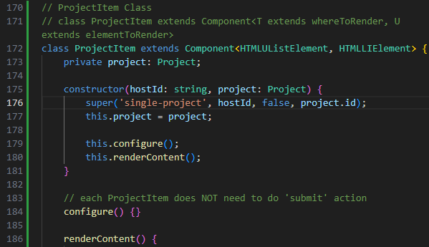

we first configure what renderContent() {...} does

trying to be more specific of what each new project holds

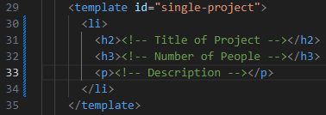

we need to make statements for by referring to global

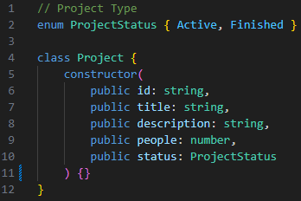

this.element.querySelector('h2')!.textContent = ...

this.element.querySelector('h3')!.textContent = ...

this.element.querySelector('p')!.textContent = ...

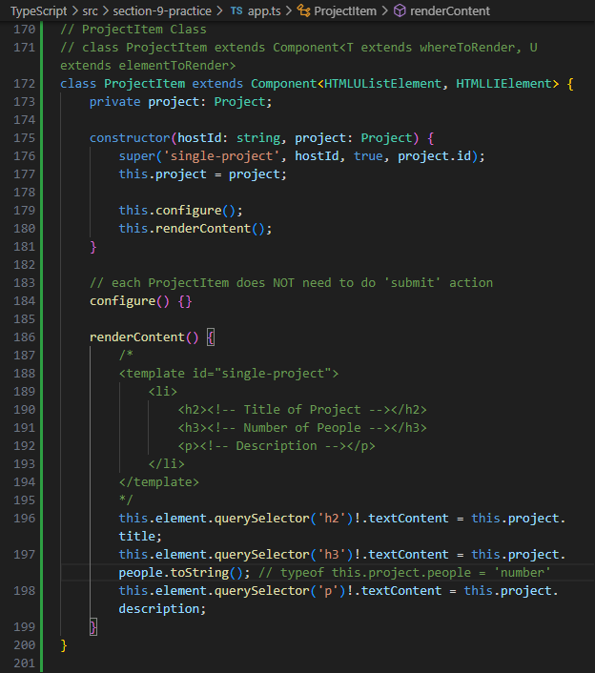

referring to index.html for where abouts of new projects rendering

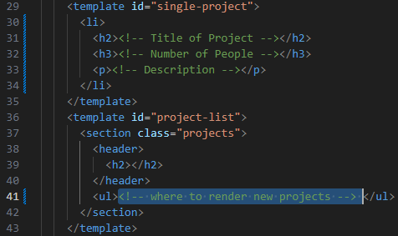

referring **class ProjectList** for each specific list of project

& private **renderProjects()** {...} method

consider the for of loop through each projectItem in

class ProjectList public property assignedProjects[]

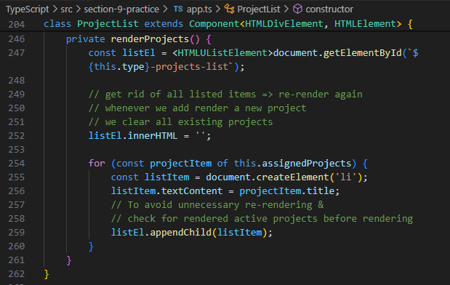

consider the for of loop through each projectItem in

class ProjectList public property assignedProjects[]

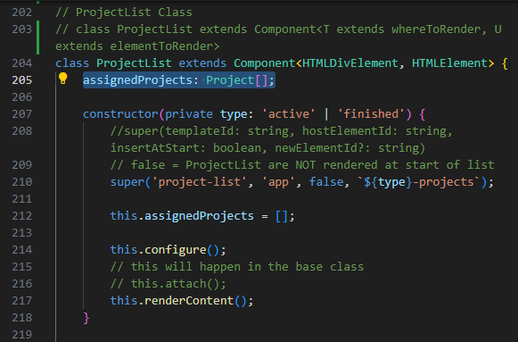

we then need to trigger **ProjectItem.renderContent() {...}** public method **inside** of **class ProjectList** private method **private renderProjects() {...}**

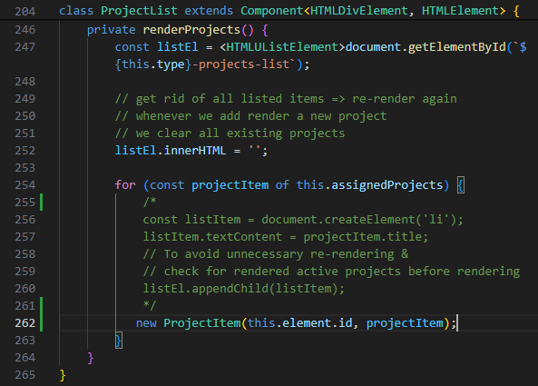

to render each new project with specifics (user's inputs) through

instantiating **new ProjectItem(this.element.id, projectItem)**;

testing again

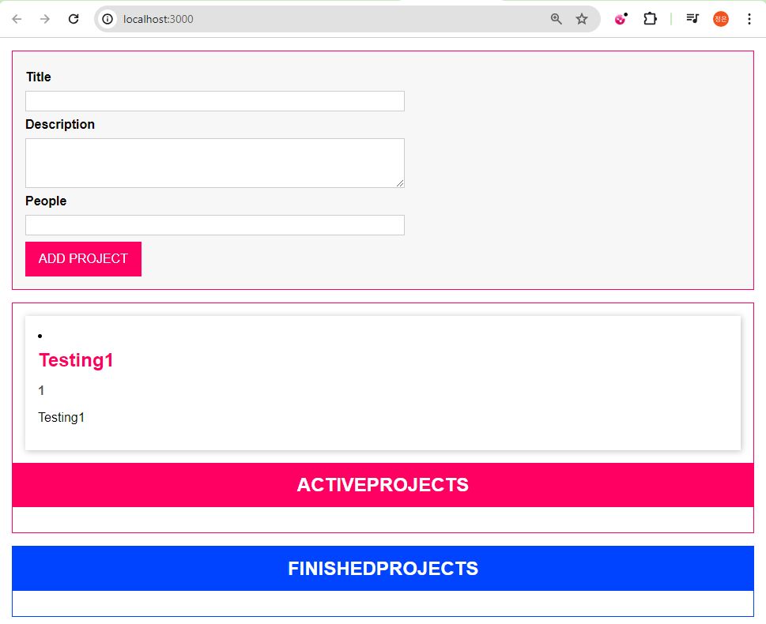

referring to DevTools

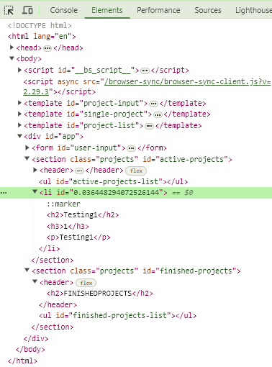

<li>...</li> is rendered outside of <ul></ul>

referring back to

class ProjectItem

the super('templateId', 'hostElementId', **insertAtStart: boolean**, project.id)

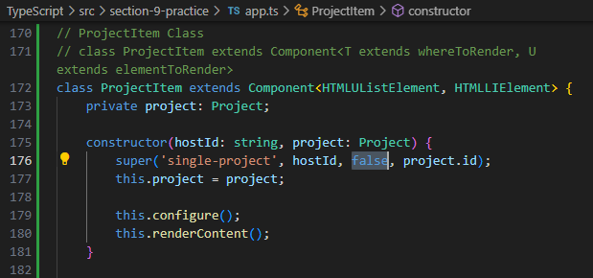

and then referring to base class Component

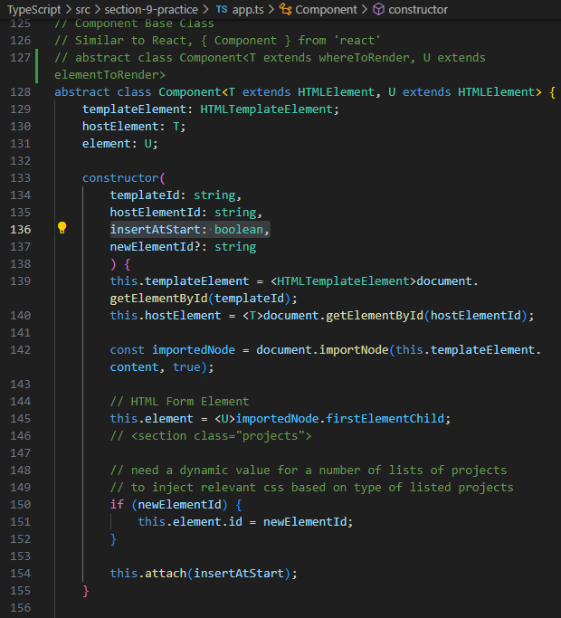

the **problem** is about the way **this.hostElement** [whereToRender element] **how this.hostElement behaves**

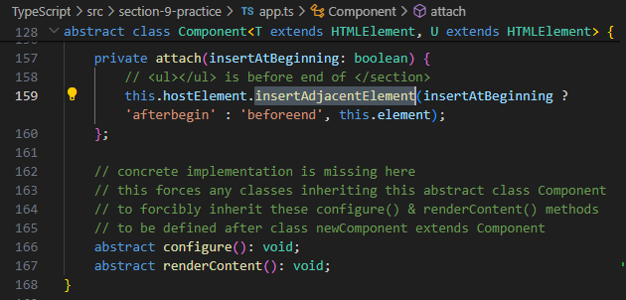

considering <li></li> must be rendered inside <ul></ul> index.html

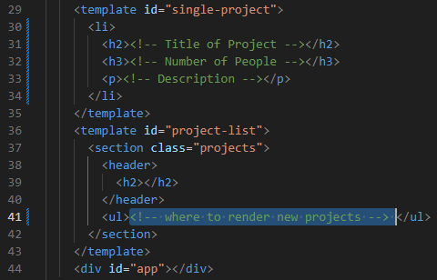

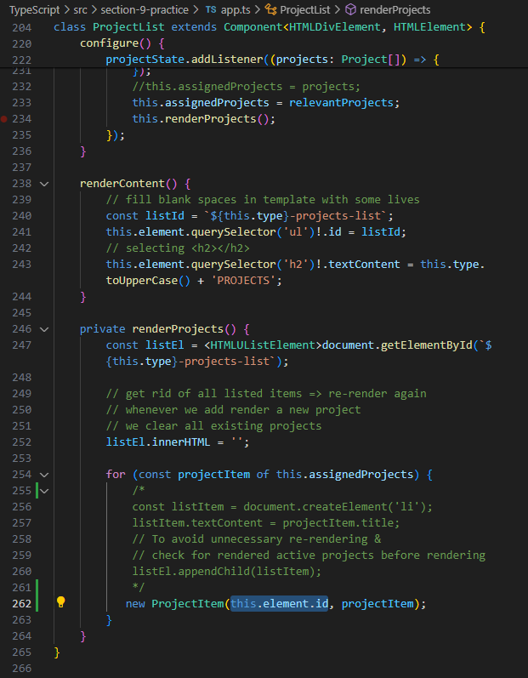

instead, we should grab this.element.querySelector('**ul**')!.id to properly locate whereToRender element

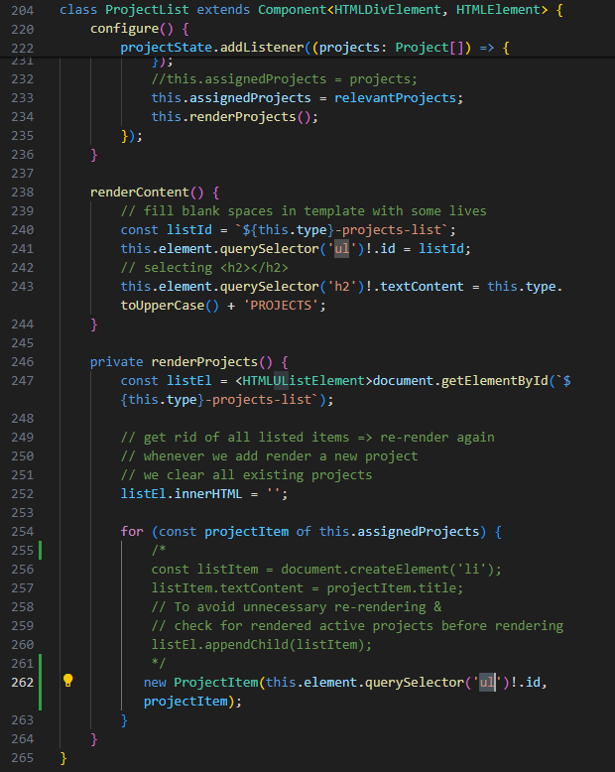

now it works fine :D

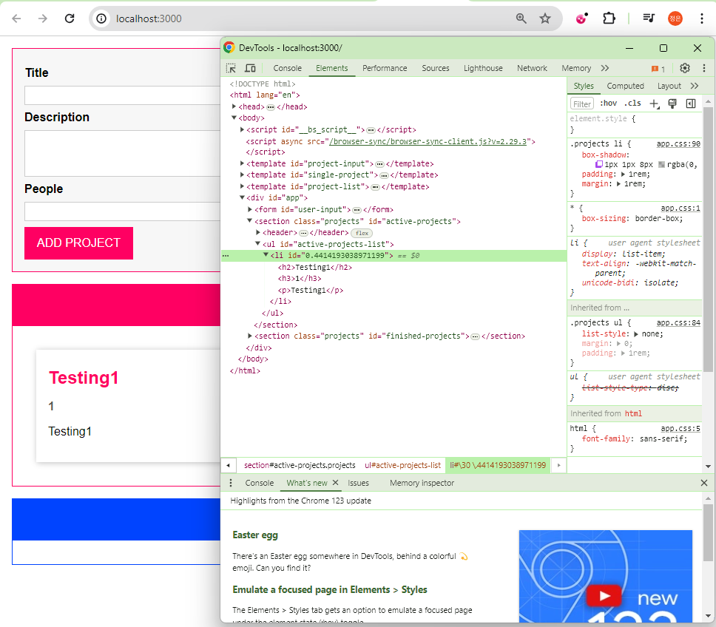

using a Getter

Friday, April 19, 2024

1:05 PM

for each project rendering

let's refresh to data flow of project rendering

see **private renderProjects()** {...} in class ProjectList

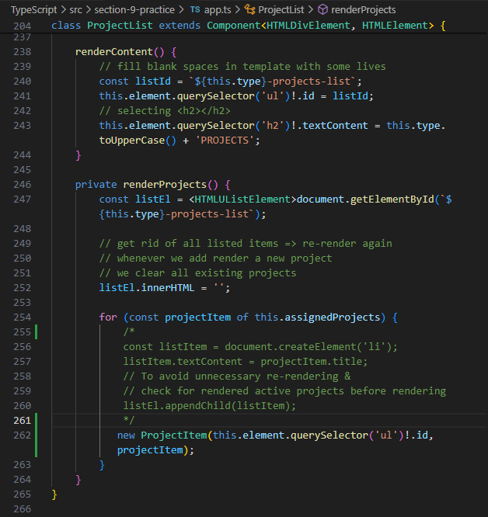

let's add a getter function to return this.project.people.toString & filters by number of people

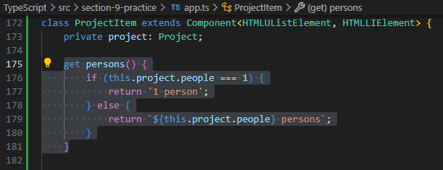

acessing the getter function like call a this.property when returning string if this.project.people === 1 && template string ${var} persons if this.project.people !== 1

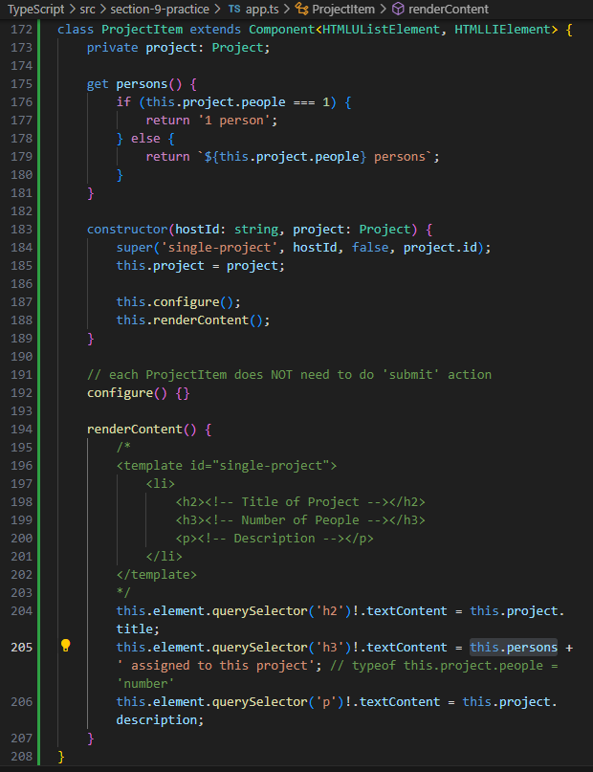

now, let's test again by entering numOfPeople = 1 & numOfPeople = 2

person vs persons are working fine

